UNDER STRICT EMBARGO UNTIL 00:01 (GMT), TUESDAY 19TH MARCH 2024

iFi Audio & K2 Technology: A collaboration to restore music to its original master
Southport, UK: iFi audio, a leader in high-fidelity audio components, has proudly collaborated with JVCKENWOOD’s renowned engineers behind K2 Technology to develop the first ultraportable DAC with K2HD built in, the GO Bar Kensei. Combining iFi’s expertise in audio circuitry with JVCKENWOOD’s world-leading high quality sound technology brings listeners closer to original recordings by restoring what was lost during digitalisation.
K2HD Technology
The latest version of K2 Technology is K2HD. Developed by JVCKENWOOD's sound engineers, K2HD Technology works to restore music to the same quality as the original master, infusing it with rich, natural harmonics lost during digitalisation. When mastering to match CD specifications, all data above 22kHz is cut off, and resolution is diminished by 256 times.​ The K2HD Processing technology was created by JVCKENWOOD’s engineers who compared countless completed original masters and K2HD restored sound by ear, relying only on feel and their extensive experience, bringing more life and emotion to digital recordings through this labor of love.
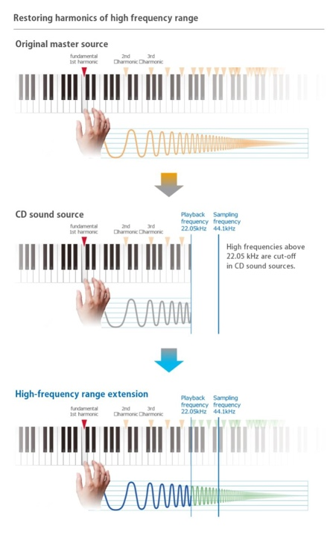
Visual explanation of K2HD Processing. Source: JVCKENWOOD website
K2HD’s advanced processing retrieves lost data and optionally upscales audio files to 192kHz/24-bit and applies their hand-selected K2 parameters for waveform shaping, which processes the time-domain, not the frequency domain.​ The unparalleled originality of K2HD lies in its advanced high-frequency extension, enabling the restoration of natural harmonics and overtones beyond 22kHz, delivering audio quality that is close to the original master.​
This advanced processing, coupled with the GO Bar Kensei's dedication to perfection, ensures that every note resonates with depth and clarity.
"We are thrilled to announce our partnership with JVCKENWOOD and the incredible K2HD Technology, marking a significant milestone in our journey towards delivering unparalleled audio experiences.” said Colin Farch, Head of R&D at iFi. “At iFi we pride ourselves on being at the forefront of innovation in sound technology and pushing our products and their components to set new standards in audio. This collaboration unites our engineering innovation with K2HD's renowned high sound quality technology excellence. Together, we are committed to redefining the listening experience for audio fans around the world, leveraging our shared passion for quality and precision in sound reproduction. The GO Bar Kensei marks the start of this partnership and we are excited to share further significant developments."
“The K2 parameter values provided by iFi this time are completely new K2 parameter values that have never been used before and were selected by JVCKENWOOD and passed a listening test by studio engineers at Victor Studios. While previous K2 parameter values were set with consideration of correcting the sound quality of the product itself, the K2 parameter values provided this time for iFi are purely the settings for the best K2 effect. In this sense, it can be said that the K2 parameter values allow you to hear the original ideal "K2 sound.” commented, JVCKENWOOD.
About iFi

iFi is the sister-brand of Abbingdon Music Research (AMR) and is headquartered in Southport, UK. The two brands respectively design and manufacture portable, desktop and lifestyle audio products and high-end hi-fi components. Combined in-house hardware and software development teams and a ‘music first’ approach enable iFi and AMR to create advanced audio products that deliver new levels of design, functionality and performance at their respective price points. Since iFi’s formation in 2012, its products have earned many awards around the world, helping it to become one of the fastest-growing brands in its field.

www.ifi-audio.com

Media Contacts
Shelby Coppola
Hummingbird Media
+1 (203) 598-8167
shelby@hummingbirdmedia.com

Jeff Touzeau
Hummingbird Media
+1 (914) 602-2913
jeff@hummingbirdmedia.com

