

COSMETICS GIANT, MORPHE, OPEN AT LENOX SQUARE IN
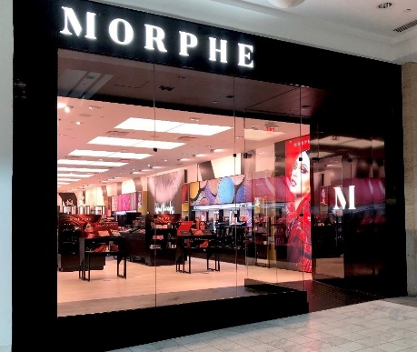
ATLANTA, GEORGIA - OCTOBER 7, 2019

ATLANTA, GA -- (October 7, 2019) -- It was announced that powerhouse cosmetics brand, MORPHE, opened at Lenox Square (3393 Peachtree Rd. NE, Atlanta, GA 30326) October 4, 2019. Morphe is known for their full spectrum of professional quality tools and makeup, including over 300 brushes and their highly coveted palettes, as well as best-selling influencer collaborations such as the newly launched Jeffree Star eyeshadow palette, setting spray, and brush collection; and Jaclyn Hill and James Charles eyeshadow palettes. Morphe also features highly sought-after brands, such as Jeffree Star Cosmetics, Iconic London, Lunar Beauty, and House of Lashes. For more event details, see Morphe Brushes on Facebook.

“Atlanta is home to such a vibrant group of #morphebabes. We are thrilled to partner with the world-class Lenox Square with our first Morphe store in Georgia, “said Emine ErSelcuk, Vice-President Global Retail for Morphe.

Morphe is currently distributed in 41 retail stores throughout the United States, Canada, and the United Kingdom and will be available in 50 retail stores by the end of 2019.

Morphe is also distributed Online as well, in all ULTA stores throughout the United States, and in select Sephora stores in Canada. Keep up with Morphe on Instagram, Facebook and Twitter.

###

About Morphe:
Founded by brother and sister duo, Linda and Chris Tawil, Morphe has developed an ever-growing, loyal fan-following, delivering professional quality makeup and artistry tools at accessible prices. The Tawil’s recognized the power of social media in the early stages of building their company and aligned with beauty makeup artists and bloggers who consistently shared their love of Morphe products with their own growing fans and followers. With 9.8M Instagram followers, the brand continues to elevate beauty fans and influencers on its social feeds.

About Lenox Square:
Located in the heart of Buckhead, Lenox Square is an Atlanta landmark. Founded in 1959, Lenox Square is one of the largest shopping centers in the Southeast. Anchored by Bloomingdale’s, Macy's and Neiman Marcus, shoppers have more than 250 store choices, including exclusive brands such as FENDI, Prada and Louis Vuitton. Stores range from designer boutiques such as Cartier and Salvatore Ferragamo to casual staples such as J.Crew and Banana Republic. Five full-service restaurants including True Food Kitchen and Zinburger Wine and Burger Bar; the extensive Lenox Fashion Café food court; and casual dining options including Corner Bakery Café and Cousins Maine Lobster make the center a popular dining and entertainment destination. Each year, Lenox Square is home to the annual Macy’s Tree Lighting, an Atlanta holiday tradition. For a map and store listings, as well as directions, events and job listings, visit simon.com. For additional information, visit Lenox Square on Facebook, Twitter and Instagram.

CONTACT: Morphe - Alexandra Duff morphe@metropublicrelations.com
+1 310 601-3211
CONTACT: Lenox Square: Brave PR – Alison Wentley awentley@emailbrave.com
+1 404 233 3993

