THE WIRELESS AUDIOPHILE EXPERIENCE YOU’VE BEEN WAITING FOR
Sennheiser introduces audiophile Bluetooth in-ear headphones IE 80S BT

Wedemark/Hong Kong, August 9, 2019 – Sennheiser introduces its first audiophile Bluetooth in-ear headphones at the Hong Kong High End Audio Visual Show. The IE 80S BT builds on the sonic achievements of the audio specialist’s much-loved IE 80S ear-canal headphones to create a wireless model that supports hi-res audio for outstanding accuracy and a breathtaking soundstage. As well as offering wireless listening, the new model introduces connected features such as customization via the Sennheiser Smart Control App and one-touch access to virtual assistants such as Siri or Google Assistant. A smart audiophile product that can be enjoyed anywhere, the sleek neckband headphones are the perfect wireless companion for the sophisticated listener on the move.

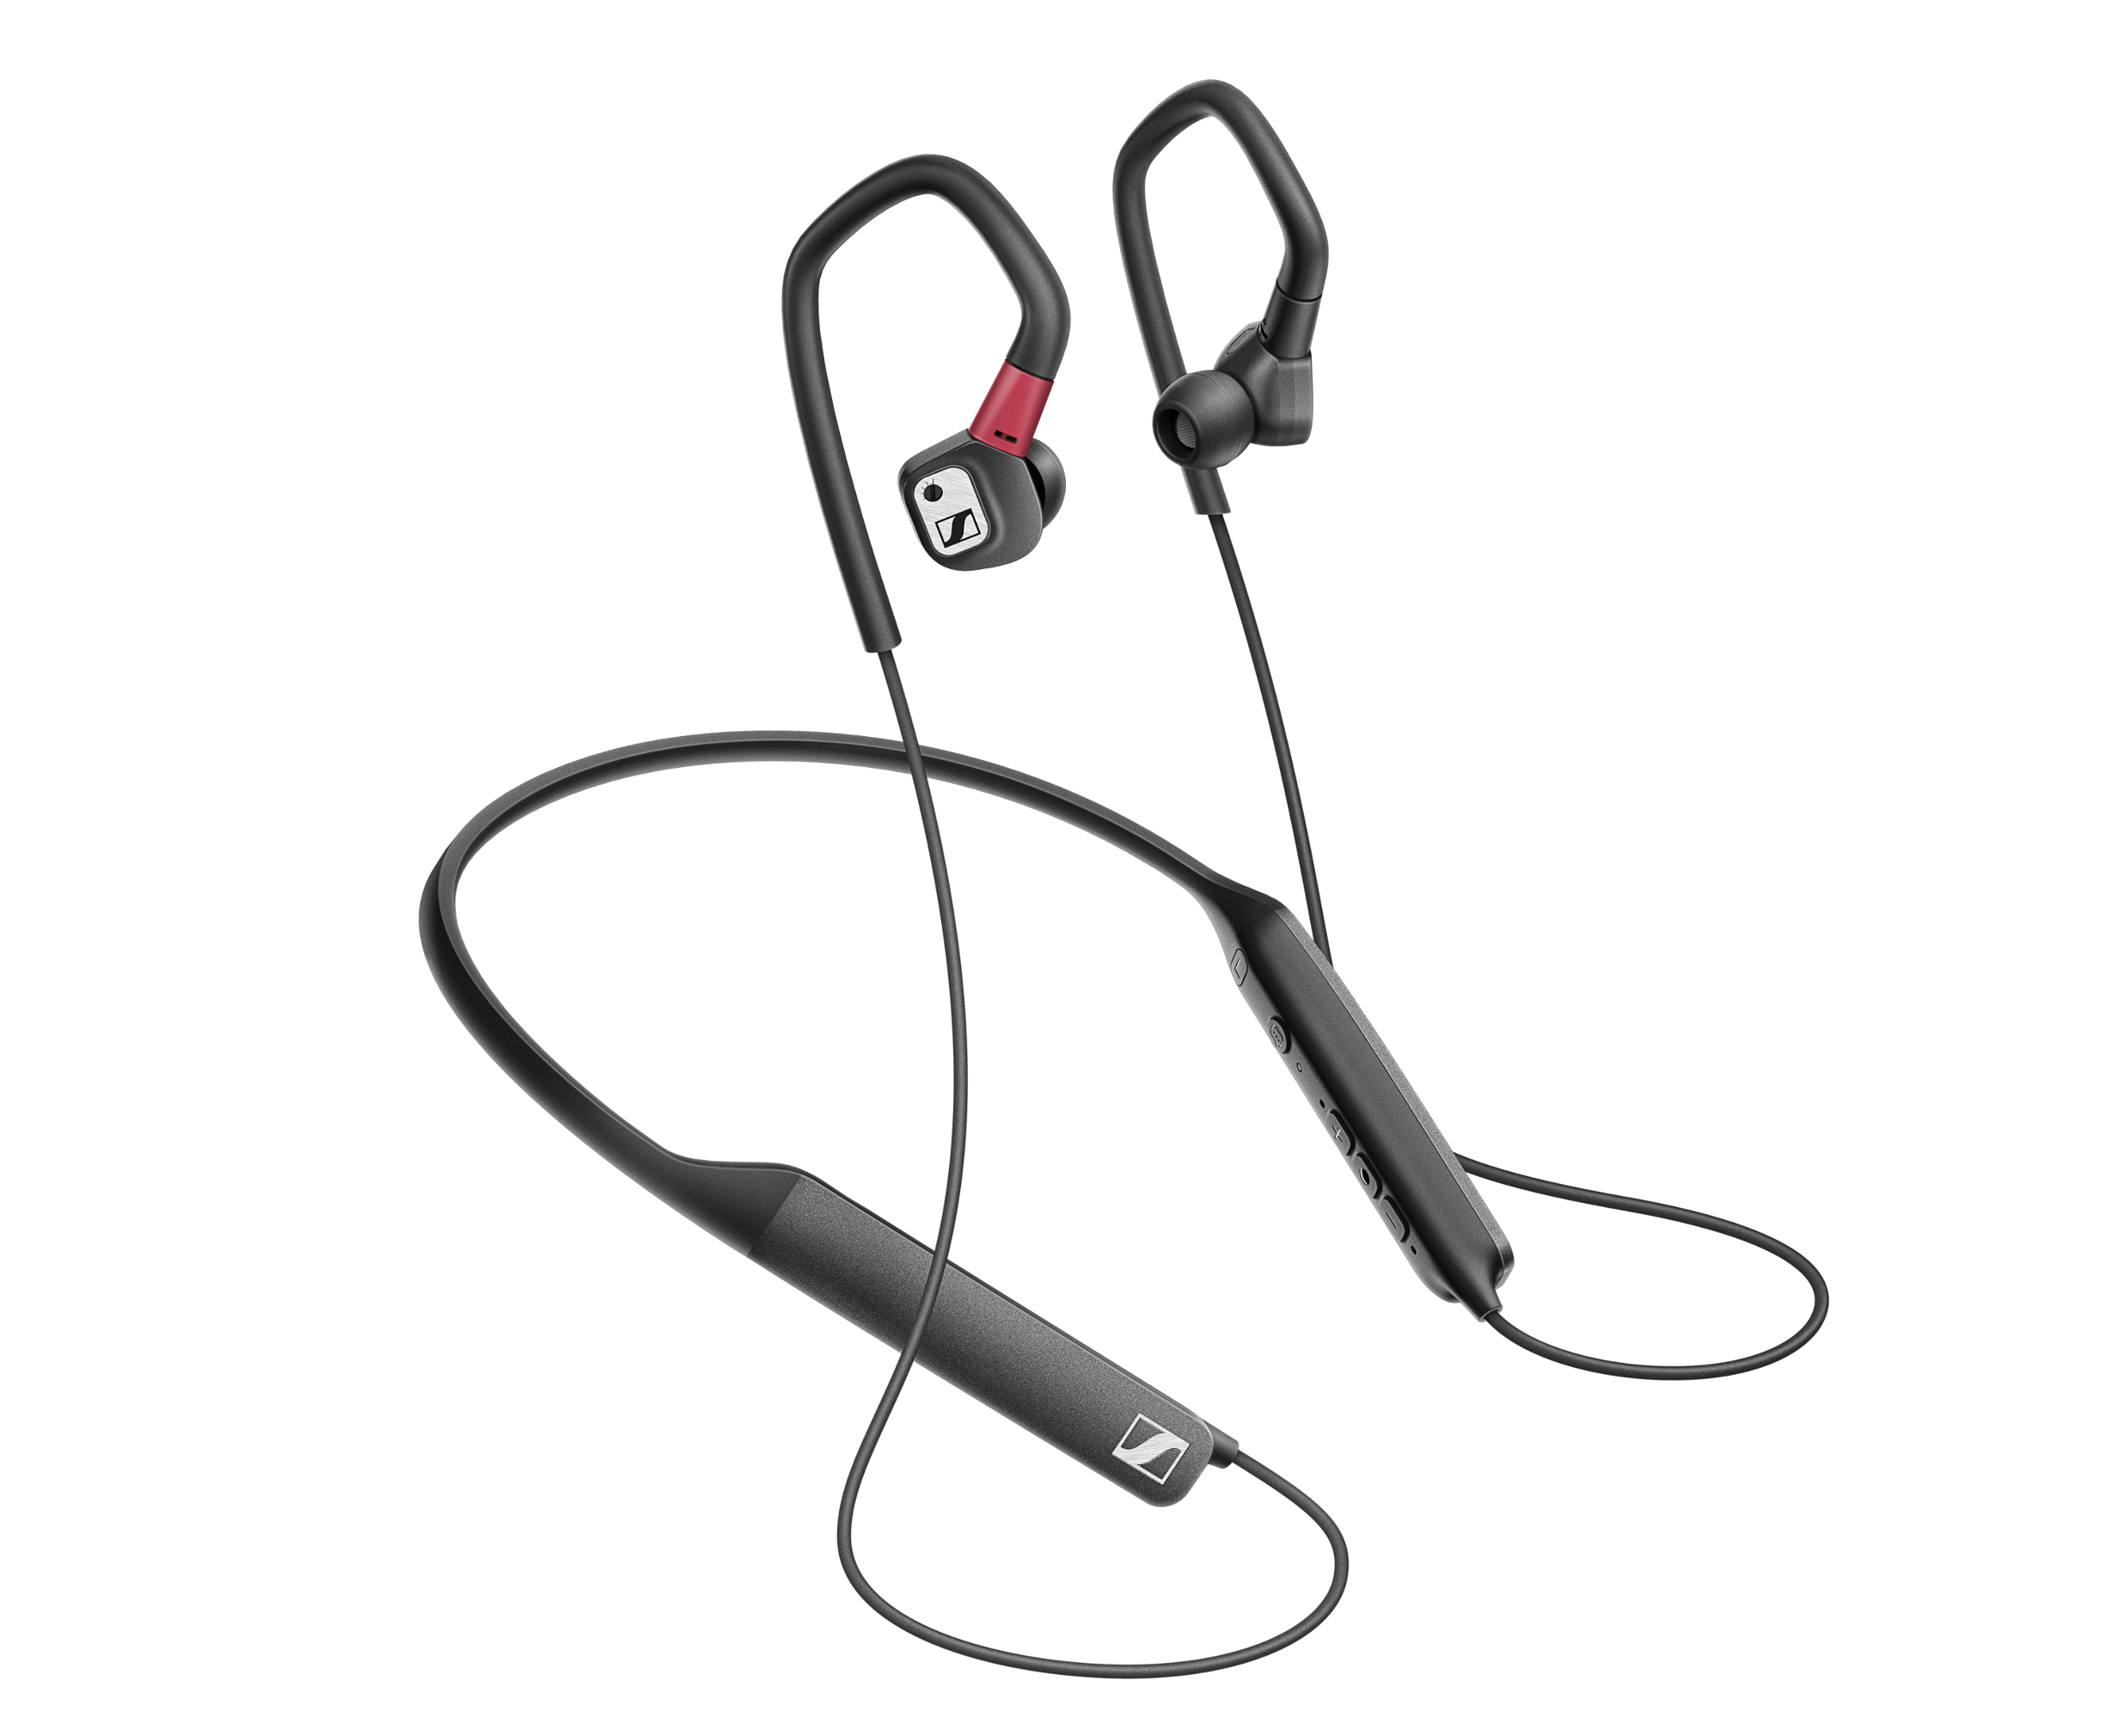
“The IE 80S BT earphones have been meticulously crafted to the most demanding standards,” explains Ronja Harste, Product Manager Audiophile at Sennheiser. “They not only meet Sennheiser’s exacting criteria for a high-end audio product and match the exceptional performance of their wired predecessor, but also offer a real wireless option for refined audiophiles who don’t wish to compromise on sound quality.”

A smart audiophile product that can be enjoyed anywhere, the IE 80S BT ear-canal headphones are the perfect wireless companion for the sophisticated listener on the move.

Enjoy high-resolution sound on the move
Support for hi-res codecs including LHDC, aptX HD, and AAC allows the IE 80S BT to process high bit rates so the listener can enjoy uncompressed music formats on par with wired performance. Audiophile sound quality is also guaranteed by a top-of-the-line AKM DAC that lets listeners experience the full performance of Sennheiser’s dynamic speaker system which features 10mm drivers and powerful neodymium magnets for brilliant sonic accuracy and clarity. For supreme versatility, support for aptX Low Latency also allows for perfect synchronization with video content.

The IE 80S BT has been carefully tuned to deliver the tonally balanced sound characteristic of Sennheiser’s audiophile headphones. However, the listening experience can still be tailored according to taste, either by using the bass adjustment tool to boost the bass on the earphone directly, or using the Sennheiser Smart Control App which provides an intuitive 5-band equalizer.

Stay effortlessly connected
Created for a connected, always-on age, the IE 80S BT offers at-a-touch interaction with all common voice assistants such as Siri and Google Assistant via a dedicated voice assistant access button. Utilizing Sennheiser’s expertise in microphone technology, the headphones feature high-quality microphones with noise reduction technology that are optimally positioned to ensure crystal clear capture of speech for undisturbed telephone calls and communication with voice assistants.

Engineered to impress
The latest addition to Sennheiser’s audiophile range, the IE 80S BT earphones display all the meticulous attention to detail, durable high-quality materials, and aesthetic refinement for which the audio specialist is famed. The sleek design also offers exceptional versatility as the Bluetooth neckband component can be detached so the earphones can be used with an optional cable accessory for those occasions when wired listening may be desired.

The supplied selection of ear adapters made from silicone, silicone lamellar and ComplyTM Memory Foam in a choice of three sizes each helps to ensure a perfect fit for excellent passive attenuation of external noise. A secure fit is also assured by the flexible ear hooks, which have a soft touch finish to enhance the wearing experience. These ergonomic refinements let the user enjoy the longer listening sessions made possible by the 6-hour battery life in perfect comfort. When on the go, Sennheiser’s IE 80S BT earphones provide the wireless listening experience audiophiles have been waiting for.

The IE 80S BT will be available from mid-August for 499 EUR/499.95 USD (MSRP).

About Sennheiser
Shaping the future of audio and creating unique sound experiences for customers – this aim unites Sennheiser employees and partners worldwide. Founded in 1945, Sennheiser is one of the world’s leading manufacturers of headphones, loudspeakers, microphones and wireless transmission systems. Since 2013, Sennheiser has been managed by Daniel Sennheiser and Dr. Andreas Sennheiser, the third generation of the family to run the company. In 2018, the Sennheiser Group generated turnover totaling €710.7 million. www.sennheiser.com

Global Press Contact
Sennheiser electronic GmbH & Co. KG
Jacqueline Gusmag
Comunications Manager Consumer
T +49 (0)5130 600-1540
jacqueline.gusmag@sennheiser.com

