**For immediate release**

**To the beat of your own drums**

**These headphones have an eye for equalization.**

***Wedemark, October 1st, 2024* – The Sennheiser MOMENTUM 4 Wireless Pride Edition amplifies the spirit of inclusion, diversity, and equality through music.**

**Giving acceptance a little momentum**

Inspired by the transformative power of music, the Sennheiser MOMENTUM 4 Wireless headphones now come in an additional colorway to support the GLAAD (Gay & Lesbian Alliance Against Defamation) organization’s mission to challenge discrimination against the LGBTQ+ community. By doing so, these headphones aim to amplify these unique voices and ensure correct representation in media.

The headphone’s aesthetic merges the anthemic rainbow badging with MOMENTUM 4’s sleek silhouette, giving the wearer a thoughtful reminder of support every time they want to take a deep dive into their music. The travel case adorns similar accents—a tribute to Gilbert Baker who in 1978 pioneered the rainbow flag movement, later cultivating its roots and evolution into the symbol it is today.

*“For so many in the LGBTQ+ community, their favorite artists have been the soundtrack of discovery, a gateway to acceptance and a platform for equality.” says Christian Ern, Sennheiser Principal Product Manager, “As proud, year-round sponsors of GLAAD and their enduring commitment to fair representation in the media, we can support these shared values through the world’s most inspirational medium—music.”*

The hardware itself retains all the features and sound quality that have made the MOMENTUM series favorite among audio and technology enthusiasts. The Sennheiser brand has partnered with GLAAD, sharing a united passion for the music industry and its commitment to challenging prejudice.

**More than music**

The Sennheiser MOMENTUM 4 Pride Edition campaign will also feature a duet of talented models from the LGBTQ+ community, reflecting the authenticity and empowerment that the cause is built around. All MOMENTUM 4 Wireless models feature advanced performance and customization options using the free Smart Control App (App Store and Google Play). The MOMENTUM 4 Wireless Pride Edition colorway is available now exclusively from sennheiser-hearing.com and Amazon.com, at an MSRP of $369.95 USD.

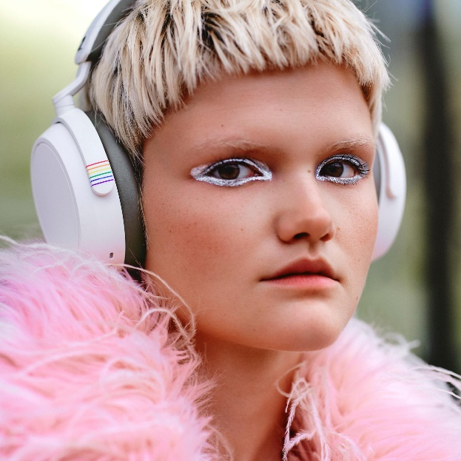 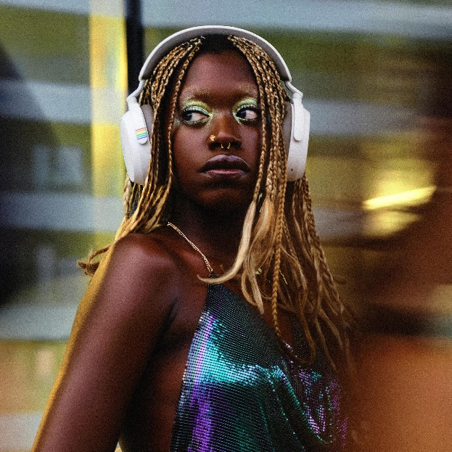

**About the Sennheiser** **brand**

We live and breathe audio. We are driven by the passion to create audio solutions that make a difference. Building the future of audio and bringing remarkable sound experiences to our customers – this is what the Sennheiser brand has represented for more than 75 years. While professional audio solutions such as microphones, meeting solutions, streaming technologies and monitoring systems are part of the business of Sennheiser electronic GmbH & Co. KG, the business with consumer devices such as headphones, soundbars and speech-enhanced hearables became part of the Sonova Holding AG group of companies in 2022, who have licensed the Sennheiser trademark for this purpose.

[www.sennheiser.com](http://www.sennheiser.com/)

www.sennheiser-hearing.com

**About Sonova Consumer Hearing**  
Sonova Consumer Hearing offers premium headphones and hearables – primarily in the true wireless segment – as well as audiophile headphones, hearing solutions and soundbars under the Sennheiser brand. The business is part of the Sonova Group, a global leader in innovative hearing care solutions with headquarters in Switzerland and more than 17,000 employees worldwide.

**Press contact**

Sonova Consumer Hearing USA

Eric Palonen

eric.palonen@sonova.com