NAB 2019: Xytech Launches New Web UI for MediaPulse Sky, Increasing Workflow Efficiency for Broadcasters

The version 9 update of MediaPulse features a reimagined user interface tailoring the system for all users, from light touch to full mode

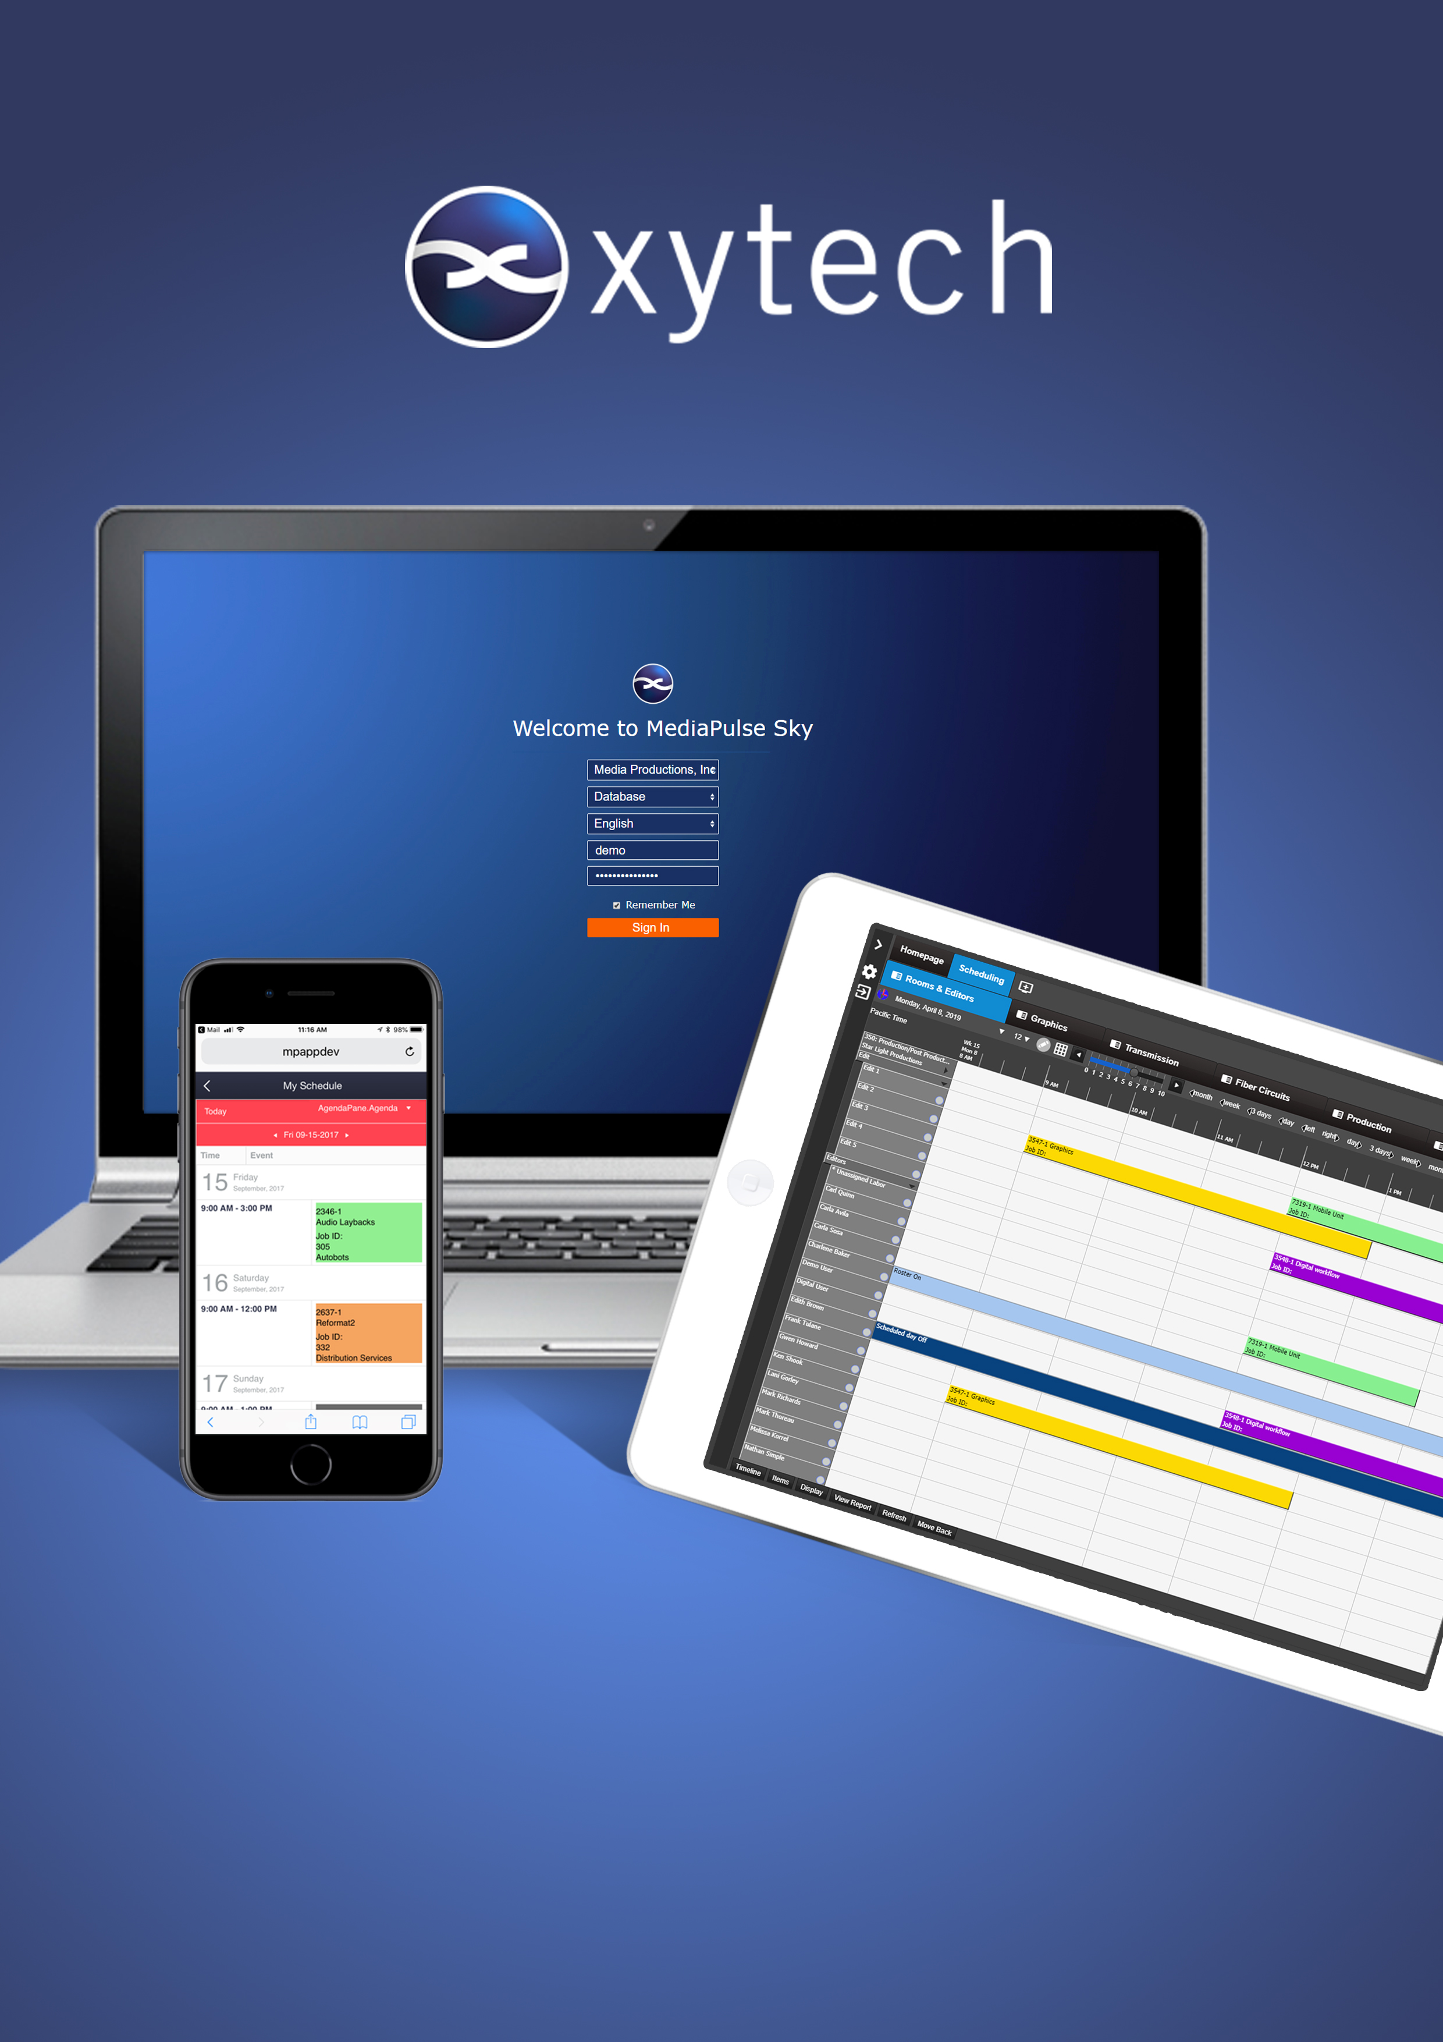
Las Vegas, March 25, 2019 — Xytech, the leader in facility management software for the broadcast, studio, media services and video transmission industries, will launch the 2019 version of its MediaPulse facility management software system at booth SL4705 during the 2019 NAB Show from April 8–11 in Las Vegas.

The MediaPulse Sky UI has undergone a complete reimaging of the entire user interface for a faster, cleaner and modern look. As a part of this update, the user interface now includes a responsive design appropriate for use in all browsers, on all devices. This responsive design features performance improvements, including Xytech’s new Limitless Scrolling for instant search results regardless of the size of the result set.

“At Xytech, we believe we are only as good as tomorrow’s innovation,” said Greg Dolan of Xytech, “Over the last year, we have included countless advancements in our MediaPulse platform, and the 2019 version is our most ambitious effort yet featuring a responsive design and customizable interface.”
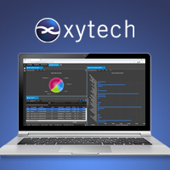
MediaPulse: Accessible for All
A key part of the 2019 version update includes personalizing the MediaPulse experience for each user, from power user to light touch, providing every user exactly the functionality they need, when they need it on the device of their choosing.

“This update addresses a big shift in the marketplace, expanding our technology to foster automation through all users in our clients’ ecosystem,” Dolan said. “With the 2019 version of MediaPulse, every participant in an organization now has a personalized MediaPulse, allowing us to deliver the appropriate experience for each user tailored for their given role.”

In addition to the user experience upgrade, OpenID is supported through Sky and the entire platform has now moved to a 64-bit architecture. Automated IMF distribution functionality, European Working Time Directive support, transmission module updates in addition to hundreds of new features are now available.

The 2019 version of MediaPulse is available in June 2019.

Xytech will be exhibiting at the upcoming 2019 NAB Show from April 8-11, 2019. Located in booth SL4705, Xytech will demonstrate the new features of its leading facilities management software MediaPulse. Those interested in scheduling an appointment may contact Alexandra Kuipers at akuipers@xytechsystems.com, +1(818)698-4958.
About Xytech
For more than 30 years, the world’s premiere media companies have depended on Xytech to run their businesses. MediaPulse is the only end-to-end solution for the complete content lifecycle. MediaPulse provides scheduling, automation, asset management, billing and cost recovery for broadcasters, media services companies and transmission facilities in a scalable platform-independent solution. For more information, visit xytechsystems.com.

Media Contacts:

Katie Kailus
Public Relations
Hummingbird Media
+1 (630) 319-5226
katie@hummingbirdmedia.com

Jeff Touzeau
Public Relations
Hummingbird Media
+1 (914) 602 2913
jeff@hummingbirdmedia.com

