For immediate distribution

Powersoft OEM Amplification Delivers for BASSBOSS AT212-3K Powered Tops
Refresh of Popular Powered Loudspeakers Gets a Boost from Powersoft Digimod 3004PFC2 Module

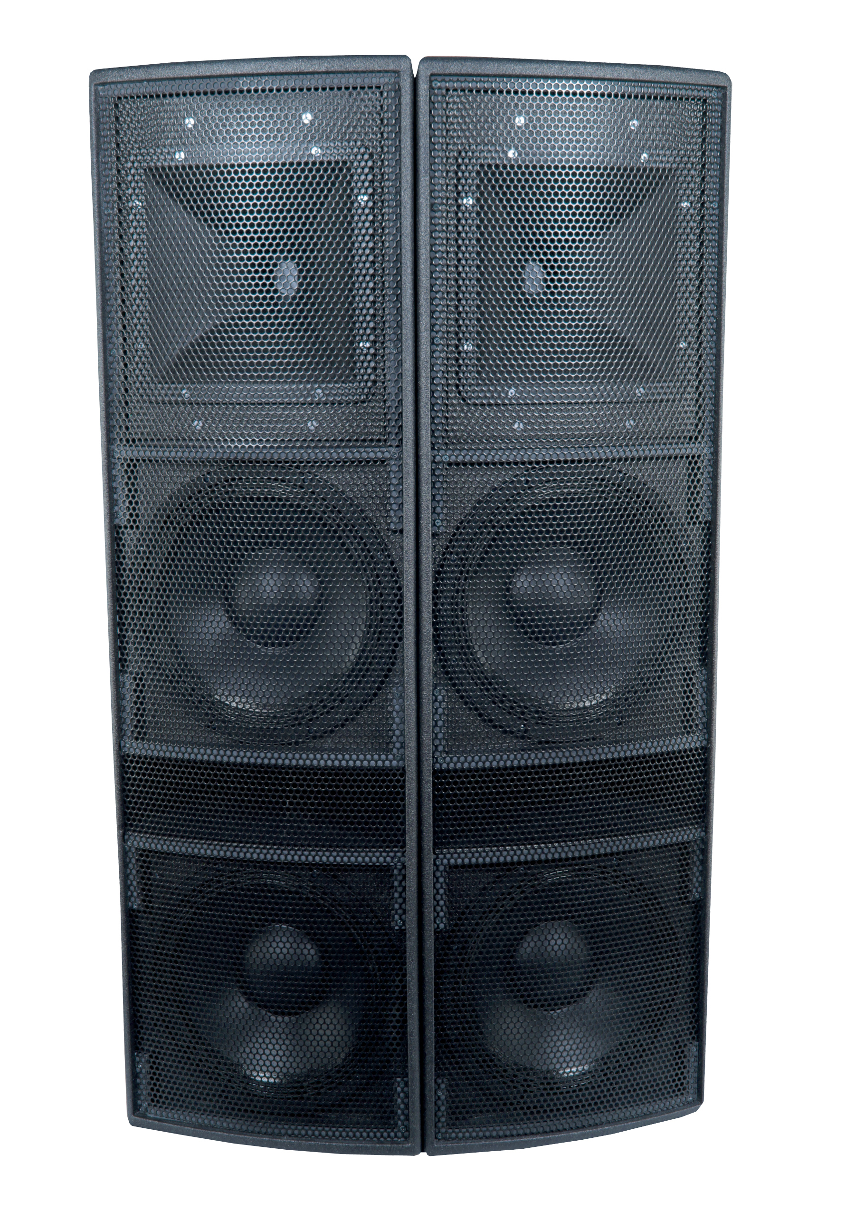
Austin, TX, October 30, 2017 – Austin-based premium powered loudspeaker manufacturer BASSBOSS has announced a refresh of its popular 2-way, self-powered, bi-amplified AT212 Powered Top. The new AT212-3K improves upon the impressive performance of the original with the help of a Powersoft Digimod 3004PFC2 amplifier module, which doubles the available wattage from 1500W to 3000W and delivers improved sound quality and higher dynamic power while maintaining light weight and portability.

“The big difference with the Digimod 3004PFC2 is that it isn’t just more, it’s more AND better. The sound quality of this module is a huge part of its appeal. Its combination of resolution and detail with massive dynamic power allowed us to take the AT212 from competitive to imperative,” says BASSBOSS president David Lee. “The AT212-3K provides an impressive 6 dB of increased output beyond the original without any significant change to weight or size. That’s remarkable on its own, but the “I must have those” responses we hear when demonstrating these boxes are reactions to the sound quality more than the sound pressure level.”

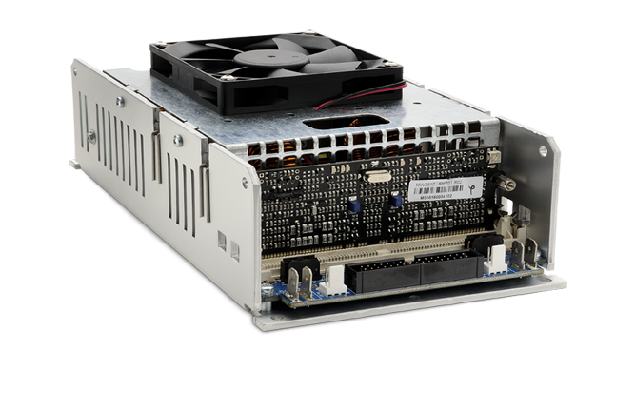
DigiMod 3004PFC2 is the first of a new generation of DigiMod models. Utilizing a cutting-edge power supply design that features both Powersoft’s patented single stage Power Factor Correction (PFC) and Smart Rails Management (SRM), the DigiMod 3004PFC2 delivers optimal performance under any operating conditions with maximal efficiency and minimal power consumption. Pulse Width Modulation (PWM) allows predictability and eliminates intermodulation artifacts, while built-in protection mechanisms including limiting work to ensure longevity.
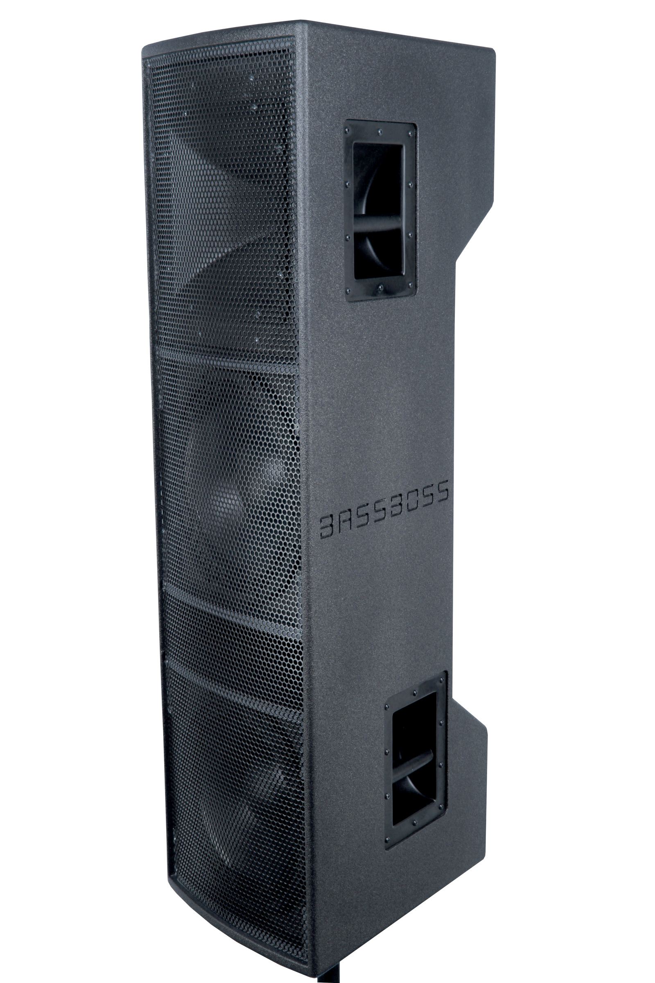
The AT212-3K includes additional upgrades to capitalize on the advanced amplification of the DigiMod 3004PFC2, including new, more sensitive 12” woofers, now with 4” voice coils for increased power handling, longer excursion, and deeper bass response, all while improving midrange articulation. The DM3004’s peak output voltage of 150V allows the AT212-3K to produce remarkable 142 dB peaks and sustained output of 136 dB from a cabinet that weighs only 89 lbs. The AT212-3K maintains the same slim-profile, tight-pack arrayable form factor and rugged Birch construction of its predecessor, so it remains highly portable and easily installable.

The AT212-3K will launch with $4,795 MSRP and $3,895 MAP.

For more information about Powersoft, please visit: www.powersoft-audio.com
For more information about BASSBOSS, please visit: http://ww.bassboss.com

For further information, contact:
Jeff Touzeau (media contact)  Hummingbird Media  Tel : +1 (914) 602 2913  Email: jeff@hummingbirdmedia.com | Francesco Fanicchi  Powersoft (Florence, Italy)  Tel: +39 346 9719798  Email: francesco.fanicchi@powersoft.it

About Powersoft:
Powersoft is the world leader in lightweight, high power, single rack space, energy efficient amplifiers for the professional audio market. Founded in Italy in 1995, headquartered in Florence, Italy, with offices in Camarillo, CA, Powersoft couples the experience and precision of its production department with exceptional components to deliver products with perfect audio response and high performance reliability. Its state-of-the-art amplifiers can be found in an array of markets, ranging from stadiums, sporting arenas, theme parks, performance venues and airports to convention centres, churches and clubs, and are used by the world's leading tour sound companies. For more information, visit the Powersoft website @ www.powersoft-audio.com

