EMBARGOED UNTIL THURSDAY, OCTOBER 20TH, 2022 AT 11:59AM EDT

Moogerfoogers Are Back: All 7 Pedals Now Available as Powerful Audio Effects Plug-ins
Moog makes its debut in the universal software space with recreations of its beloved analog effects pedals. Moogerfooger Effects Plug-ins are now available to purchase for a limited-time introductory price of $149 USD (regularly $249) at moogmusic.com.

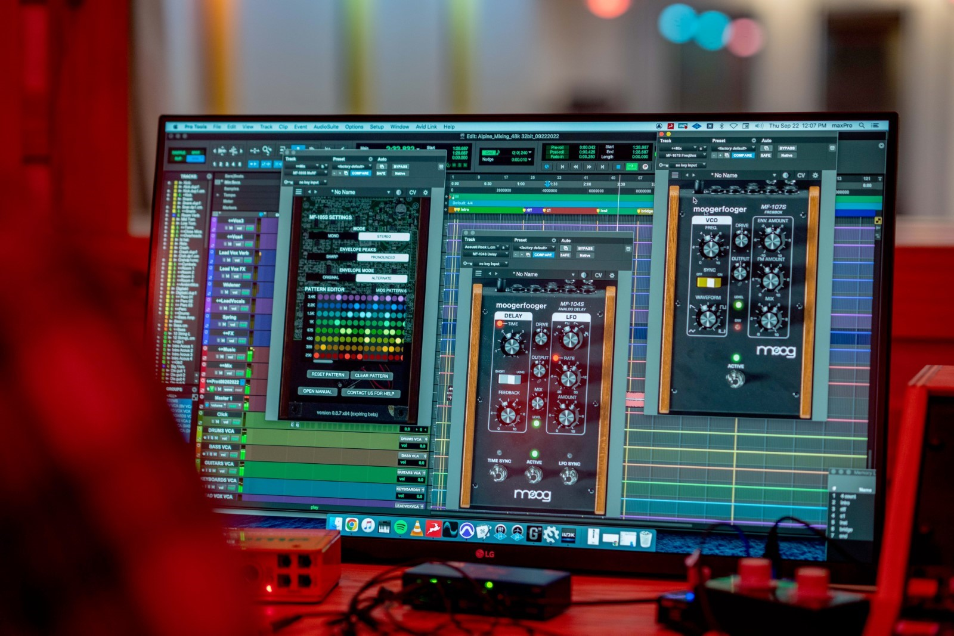

Download hi-res images here

Beginning with Bob Moog’s first instrument designs in the early 1950s, Moog Music’s storied legacy centers on the company’s ability to develop and manufacture some of the world’s best-sounding electronic musical instruments.

Over the last seven decades, Moog’s product catalog has spanned everything from DIY theremin kits and custom large-format modular systems to dynamic polysynths and compact Eurorack-able sound design machines. More recently, the company has brought back some of its most legendary instruments, such as the Model 10 modular system, and introduced professional music apps that have surpassed a million downloads.

This brings us to Moog’s latest venture in reimagining some of its most influential analog instruments of the past for today’s audio production workflow. Enter Moogerfooger Effects Plug-ins. Compatible with all major DAWs across Windows and macOS in AUv2, VST3, or AAX formats, this new software version of Moog’s retired effects pedal collection—used by guitarists and experimental artists ranging from Lou Reed to Thom Yorke, Kim Gordon, Daft Punk, and Thundercat—makes the Moog sound now more accessible than ever.

Keep reading to find all the details about the new Moogerfooger Effects Plug-ins, or visit Moog’s website here.

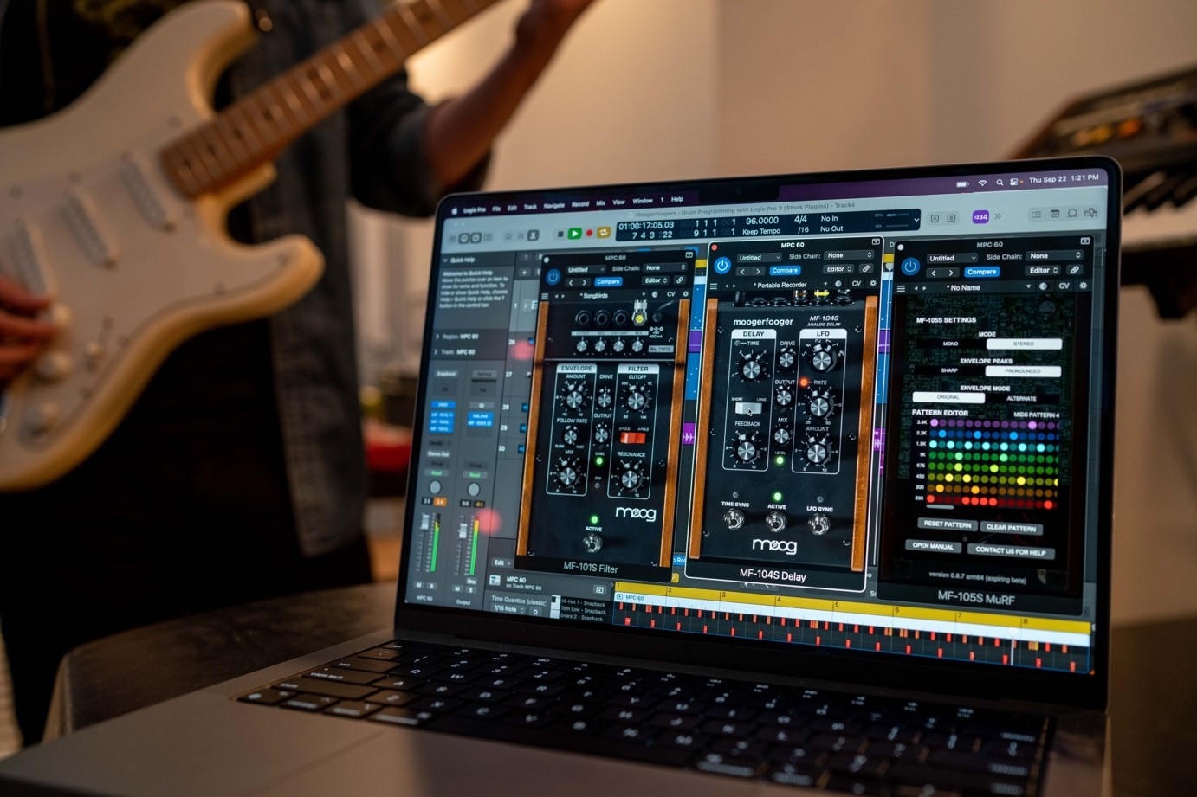

Classic Moog Sound for the Next Generation of Producers
Moogerfooger Effects Plug-ins are a re-invention of Moog’s coveted analog effects pedals, bringing the legendary tone, musicality, and interconnectivity of the original hardware effects to your digital music production environment.

Designed by Bob Moog and his engineering team in the late '90s and '00s, Moogerfooger effects pedals were direct descendants of the original Moog modular synthesizers, adapted to process, modulate, and play with inputs ranging from guitar, voice, and synthesizer to any imaginable audio source. From the MF-104's lush, warm analog delay circuit to the swirling phaser effects of the MF-103 and legendary resonant ladder lowpass filter in the MF-101, Moogerfoogers have become renowned for their sound and adopted by studios and performers around the world.

Each of the seven effects have been meticulously renewed with reverence for the lush, distinctive tones of the original analog circuits—retaining the exceptional sound quality the pedals are known for, while expanding on what's possible in the hardware realm. With stereo functionality and an extended feature set, these plug-ins further tailor the classic Moogerfooger functionality to the modern digital creator. With all parameters ready to be automated as well as the ability to save and manage presets, Moogerfooger Effects Plug-ins mutate and re-shape themselves around your audio tracks.

This feature-packed suite of Moogerfooger Effects Plug-ins is now available to purchase at moogmusic.com. Click here to get started!

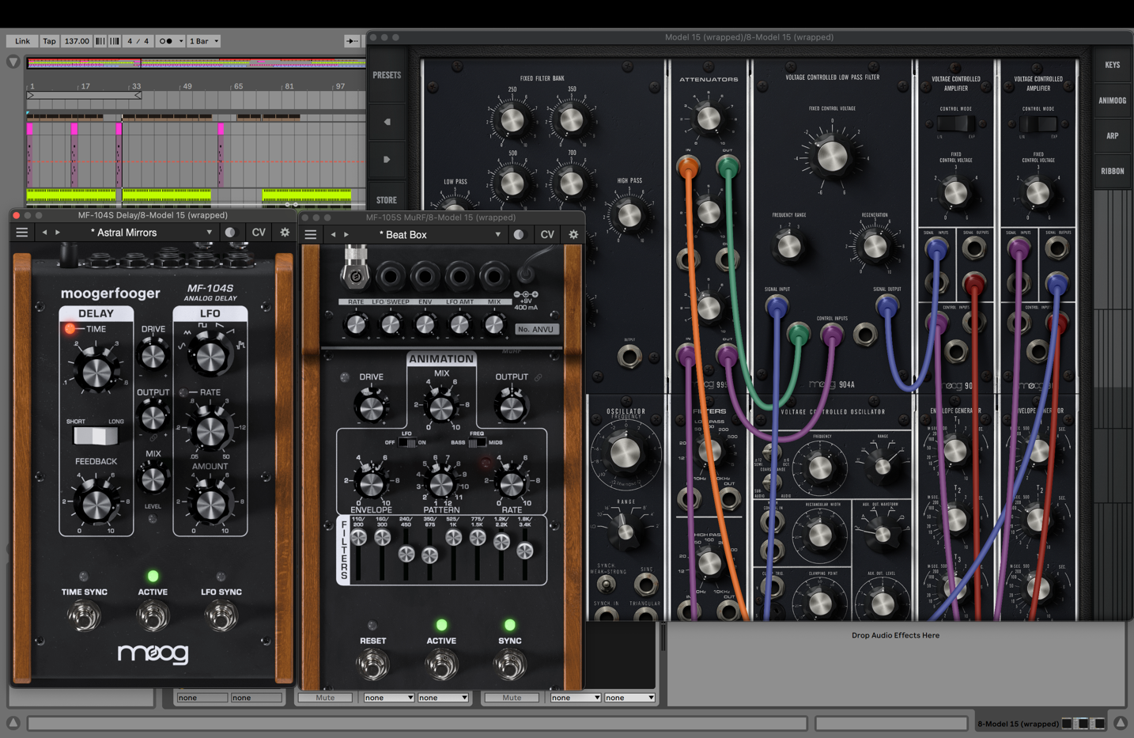

Creative Tools Designed with Interconnectivity in Mind
The original collection of Moogerfoogers were more than the sum of their parts due to their powerful and flexible control voltage inputs and outputs—able to play amongst themselves and combine into dynamic inter-related effects.

Moogerfooger Effects Plug-ins recreate that CV interconnectivity, allowing each instance of a Moogerfooger to modulate the parameters of any other across your project in any major DAW. With digital attenuverters added to every CV input, side-chain capabilities, and DC offset capabilities, Moogerfooger Effects Plug-ins allow for deep control over every aspect of your sound.

The effects family range from clean filtering to wildly experimental modulation designed to manipulate, enhance, and fully transform any sound. Each with its own distinct identity, these effects are designed to work perfectly alongside one another in your audio chain.

The complete collection of Moogerfooger Effects Plug-ins includes all seven reimagined Moogerfooger pedals in software form:

- MF-101S Lowpass Filter - the classic Moog ladder filter with an envelope follower for dynamic control
- MF-102S Ring Modulator - a wide-range carrier oscillator paired with an LFO for effects from soft tremolo through far-out clangorous ring modulation tones
- MF-103S 12-Stage Phaser - a descendant of the vibrant 1970s rack-mounted Moog phaser with an on-board LFO
- MF-104S Analog Delay - a rich, full-bodied delay and modulation circuit that has remained highly sought after to this day
- MF-105S MuRF - a groundbreaking effect combining a resonant filter bank with a pattern generator and skewing envelope for vibrant animation of an incoming sound
- MF-107S FreqBox - a box of gnarly synced VCO sounds with envelope and FM modulation
- MF-108S Cluster Flux - a flexible processor that can modulate between chorus, flanging, and vibrato

Hear how the Moogerfooger Effects Pedals sound in this collection of samples created by synthesist and Moog instrument expert Lisa Bella Donna.

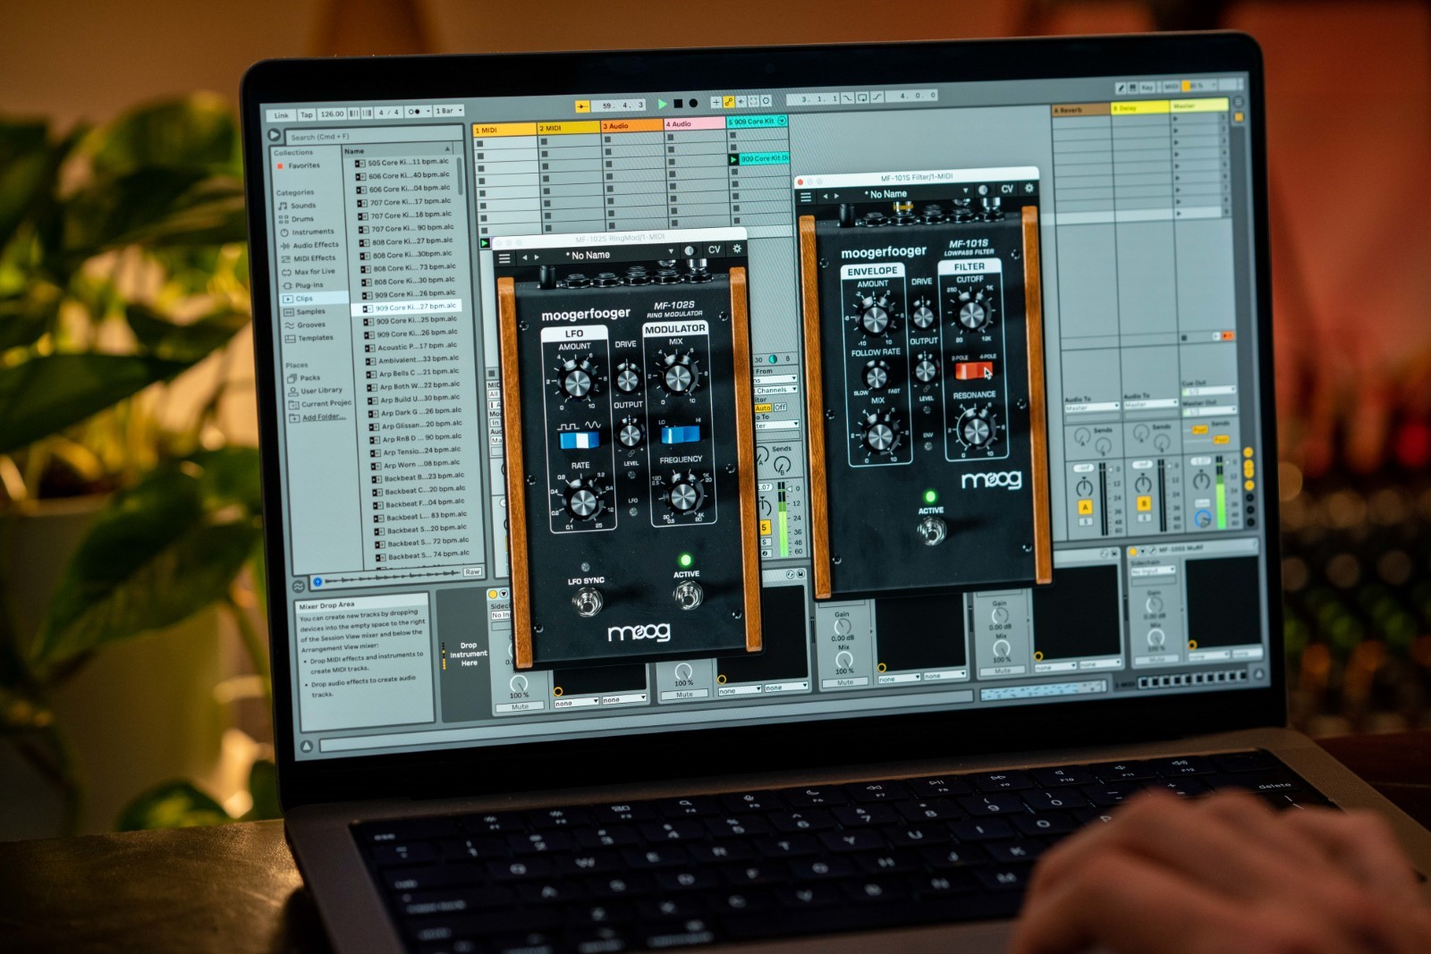

Moog’s Focus on Making Its Instruments More Accessible
The company’s foray into the software space began just over a decade ago with the release of Moog’s first iOS app. Its growing collection of budget-friendly applications for iOS and macOS users has made it possible for more creatives around the world to experiment with sound design and synthesis concepts.

With today’s announcement of the new Moogerfooger Effects Plug-ins, available for both Apple and Windows, the team at Moog takes a giant leap forward in its mission to make professional-level audio production tools more accessible for the artist community. Steve Dunnington, the company’s current VP of Engineering and former apprentice of Bob Moog, shares more on this evolution and the importance of paying tribute to Moog's heritage.

“Bob liked to describe himself as a toolmaker for musicians,” Steve recalls. “He felt that technology should not drive the needs of musicians, but that engineers and toolmakers should use the needs of musicians to harness the power of technologies that serve those needs. He was never dogmatic about whether analog or digital was better; he saw both technologies as different means to serve the musicians that he respected and admired.”

The Moog veteran of 28 years and counting has worked on the development of dozens of hardware and software instruments, including both the classic analog Moogerfoogers and new plug-in emulations.

“As we began the development of the Moogerfooger Effects Plug-ins, it was of paramount importance not just to clone the devices,” Steve continues, “but to look for opportunities where digital technology could improve some of their characteristics. This is in alignment with Bob Moog’s philosophies—he was reluctant to copy his old designs but preferred to continue to refine and improve them based on the needs of musicians. Thus, the envelope follower controls on the new MF-101S become more flexible for a wider variety of program material than the original MF-101, thanks to the possibilities provided by digital technology. Other examples abound in the Moogerfooger Effects Plug-ins, where inspiration was taken from the original with the addition of useful improvements. They sound great, like the classic Moog circuits we know and love.”

New Video Release: Ty Segall Creates Original Song with Moogerfooger Effects Plug-ins, Vintage Minimoog Model D & More
In a new video from Moog Music, Ty Segall invites you inside Harmonizer Studio, home to his wonderland of custom and vintage instruments. Witness the musician and producer’s creative process as he builds an original composition piece by piece using guitar, bass, electric piano, synthesizer, a mix of percussion, and Moog’s new software effects plug-ins.

In the making of “Frog Meets Fly,” Ty demonstrates the sonic range and transformative potential of these effects. Using the MF-107S FreqBox to morph metallic percussion into synth voices and imitate 60s-style fuzz tones on the track’s bass line, adding depth to his Rhodes with multiple instances of the MF-108S Cluster Flux, transforming clean electric guitar into alien lead lines via the MF-102S Ring Modulator, and adding vintage-toned delay to his Minimoog Model D with the MF-104S Delay, Ty puts the processing power of these effects on full display over the 15 separate tracks in this arrangement.

Watch the debut of “Frog Meets Fly” by Ty Segall here.

Now Available for $100 off Regular Pricing
Moogerfooger Effects Plug-ins are available for a limited-time introductory price of $149 USD (regularly $249). This offer includes all seven Moogerfooger effects in one powerful and convenient collection that is compatible with all major DAWs.

These professional audio effects are now available through Moog’s website and select partners around the world. To get started, visit moogmusic.com!

Learn More about Moog Music
Moog Music is the world’s leading producer of theremins and analog synthesizers. The employee-owned company and its customers carry on the legacy of its founder, electronic musical instrument pioneer Dr. Bob Moog. All of Moog’s instruments are assembled by hand in its factory in downtown Asheville, North Carolina. Learn more here.

