DEE SNIDER SINGS FOR HIS SUPPER IN FIRST CAMPAIGN FOR SENNHEISER
Lead singer of metal band Twisted Sister touts Sennheiser’s innovative speech-enhanced Conversation Clear Plus technology
Marlow UK, January 24, 2023 – A significant number of people find it difficult to carry on a clear conversation in a noisy environment, such as in a crowded restaurant or bustling street. At this January’s Consumer Electronics Show, the Sennheiser brand, a global leader in audio technology and innovation, debuted its solution to this problem: Conversation Clear Plus earbuds, a new standard in speech-enhancing consumer wearables.

To help bring awareness to the global masses, the Sennheiser brand enlisted legendary vocalist and musician Daniel “Dee” Snider, most famous as lead singer and songwriter of the 70’s/80’s heavy metal band Twisted Sister, to take centre stage in its first brand campaign for the product. The work, created by independent advertising agency Terri & Sandy, consists of a series of online spots that will launch globally in two-minute, :60, :30 and :15 versions across Facebook, Instagram and YouTube with an initial focus on the U.S., France, Germany, China and Japan. Media is being handled by Amsterdam-based Ogilvy Social.Lab.

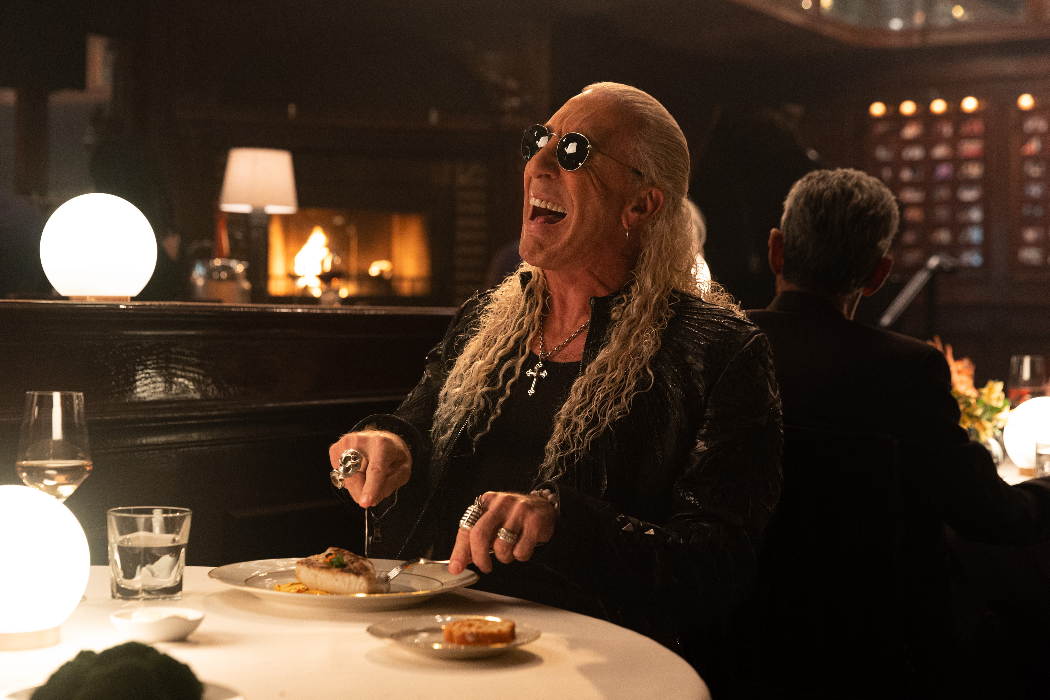
Directed by renowned film and commercial talent Nalle Sjöblad, known for his award-winning work for Burger King, Supercell, Mowi and Gold Bond, the humorously relatable campaign features Dee Snider and a fellow rocker pal out to dinner in a noisy restaurant attempting to carry on a conversation. Noticing Dee’s “struggle,” ripe with a chain of comical miscommunications, the friend quickly switches to heavy metal rocker mode (no doubt what got Dee in this situation in the first place), wailing out his words in a way Dee cannot only relate to, but finally hear. The two carry on their high decibel “song-versation”, clearly disrupting nearby diners, until his assistant comes on the scene and brings Dee the ultra low-profile Sennheiser Conversion Clear Plus earbuds, providing much needed relief to all.

View the 1:00 spot here

“While rock stars might still have the pipes to cut through all the clamour of a noisy restaurant, they’re just like us and will struggle to follow conversations in challenging environments,” says Jeff Marois, Associate Creative Director/Writer, Terri & Sandy. “Dee and his counterpart were the perfect choices to highlight the frustration that can come from trying to carry on a normal conversation when speech intelligibility is compromised – and how Conversation Clear Plus can remedy that – all in a lighthearted, approachable dialogue that mirrors the ethos of the product.”

Let your conversation take centre stage
While the campaign uses humour to tactfully draw awareness to this common issue, Sennheiser’s Conversation Clear Plus is serious about sound. The earbuds, co-developed with Sonova—a worldwide leader in hearing technology— utilise sophisticated digital signal processing technology to enhance conversations and calls in real time. When combined with Sennheiser’s Automatic Scene Detection feature, Conversation Clear Plus analyses the noise levels of a user’s environment and matches the speech enhancement levels to their surroundings. The combination of beam-forming microphones, voice processing, versatile Bluetooth connectivity and true wireless form factor make the earbuds the ideal solution for consumers that relate to Dee’s dinnertime situation all too well: the art of conversation is lost in misunderstandings.

"Sennheiser Conversation Clear Plus reflects our customers’ dynamic lives, allowing users to follow every conversation with ease, wherever they are,” says Daniel Holenstein, Sennheiser Senior Product Manager. “An independent study showed 95% of users experienced significant speech enhancement in noisy situations when using the product.”

In concert with its Active Noise Cancellation mode, Conversation Clear Plus works dynamically to block distracting noises and improve the clarity of conversations for every level of background commotion, even allowing the user to choose how much of their environment they want to hear. When used with the Conversation Clear Plus companion app, the wearer can custom tailor their listening preferences for an intuitive, hassle-free user experience that finally lets their conversation take the spotlight.

www.sennheiser-hearing.com

About the Sennheiser brand
We live and breathe audio. We are driven by the passion to create audio solutions that make a difference. Building the future of audio and bringing remarkable sound experiences to our customers – this is what the Sennheiser brand has represented for more than 75 years. While professional audio solutions such as microphones, meeting solutions, streaming technologies and monitoring systems are part of the business of Sennheiser electronic GmbH & Co. KG, the business with consumer devices such as headphones, soundbars and speech-enhanced hearables is operated by Sonova Holding AG under the license of Sennheiser.
www.sennheiser.com
www.sennheiser-hearing.com
Press contact
Sonova Consumer Hearing GmbH
Paul Hughes
Head of PR and Influencers
Sennheiser Headphones & Soundbars
T +49 (0) 162 2921 861
paul.hughes@sonova.com

Sennheiser UK&I PR agency
sennheiser@harvard.co.uk

