Experience the future of audio: Sennheiser opens new flagship store in sydney

Sydney, 14 December 2018 – Audio specialist Sennheiser has opened the doors to its newest flagship store in the heart of Sydney at 5 Martin Place. Commonly known as the “Money Box”, this heritage-listed building will provide a dramatic venue for music and sound lovers seeking to immerse themselves in the world of Sennheiser and experience the future of audio. The new flagship store will offer a unique experience where consumers can discover Sennheiser’s wide portfolio of audio products – including the new Sennheiser AMBEO Soundbar and the unique Sennheiser HE1.
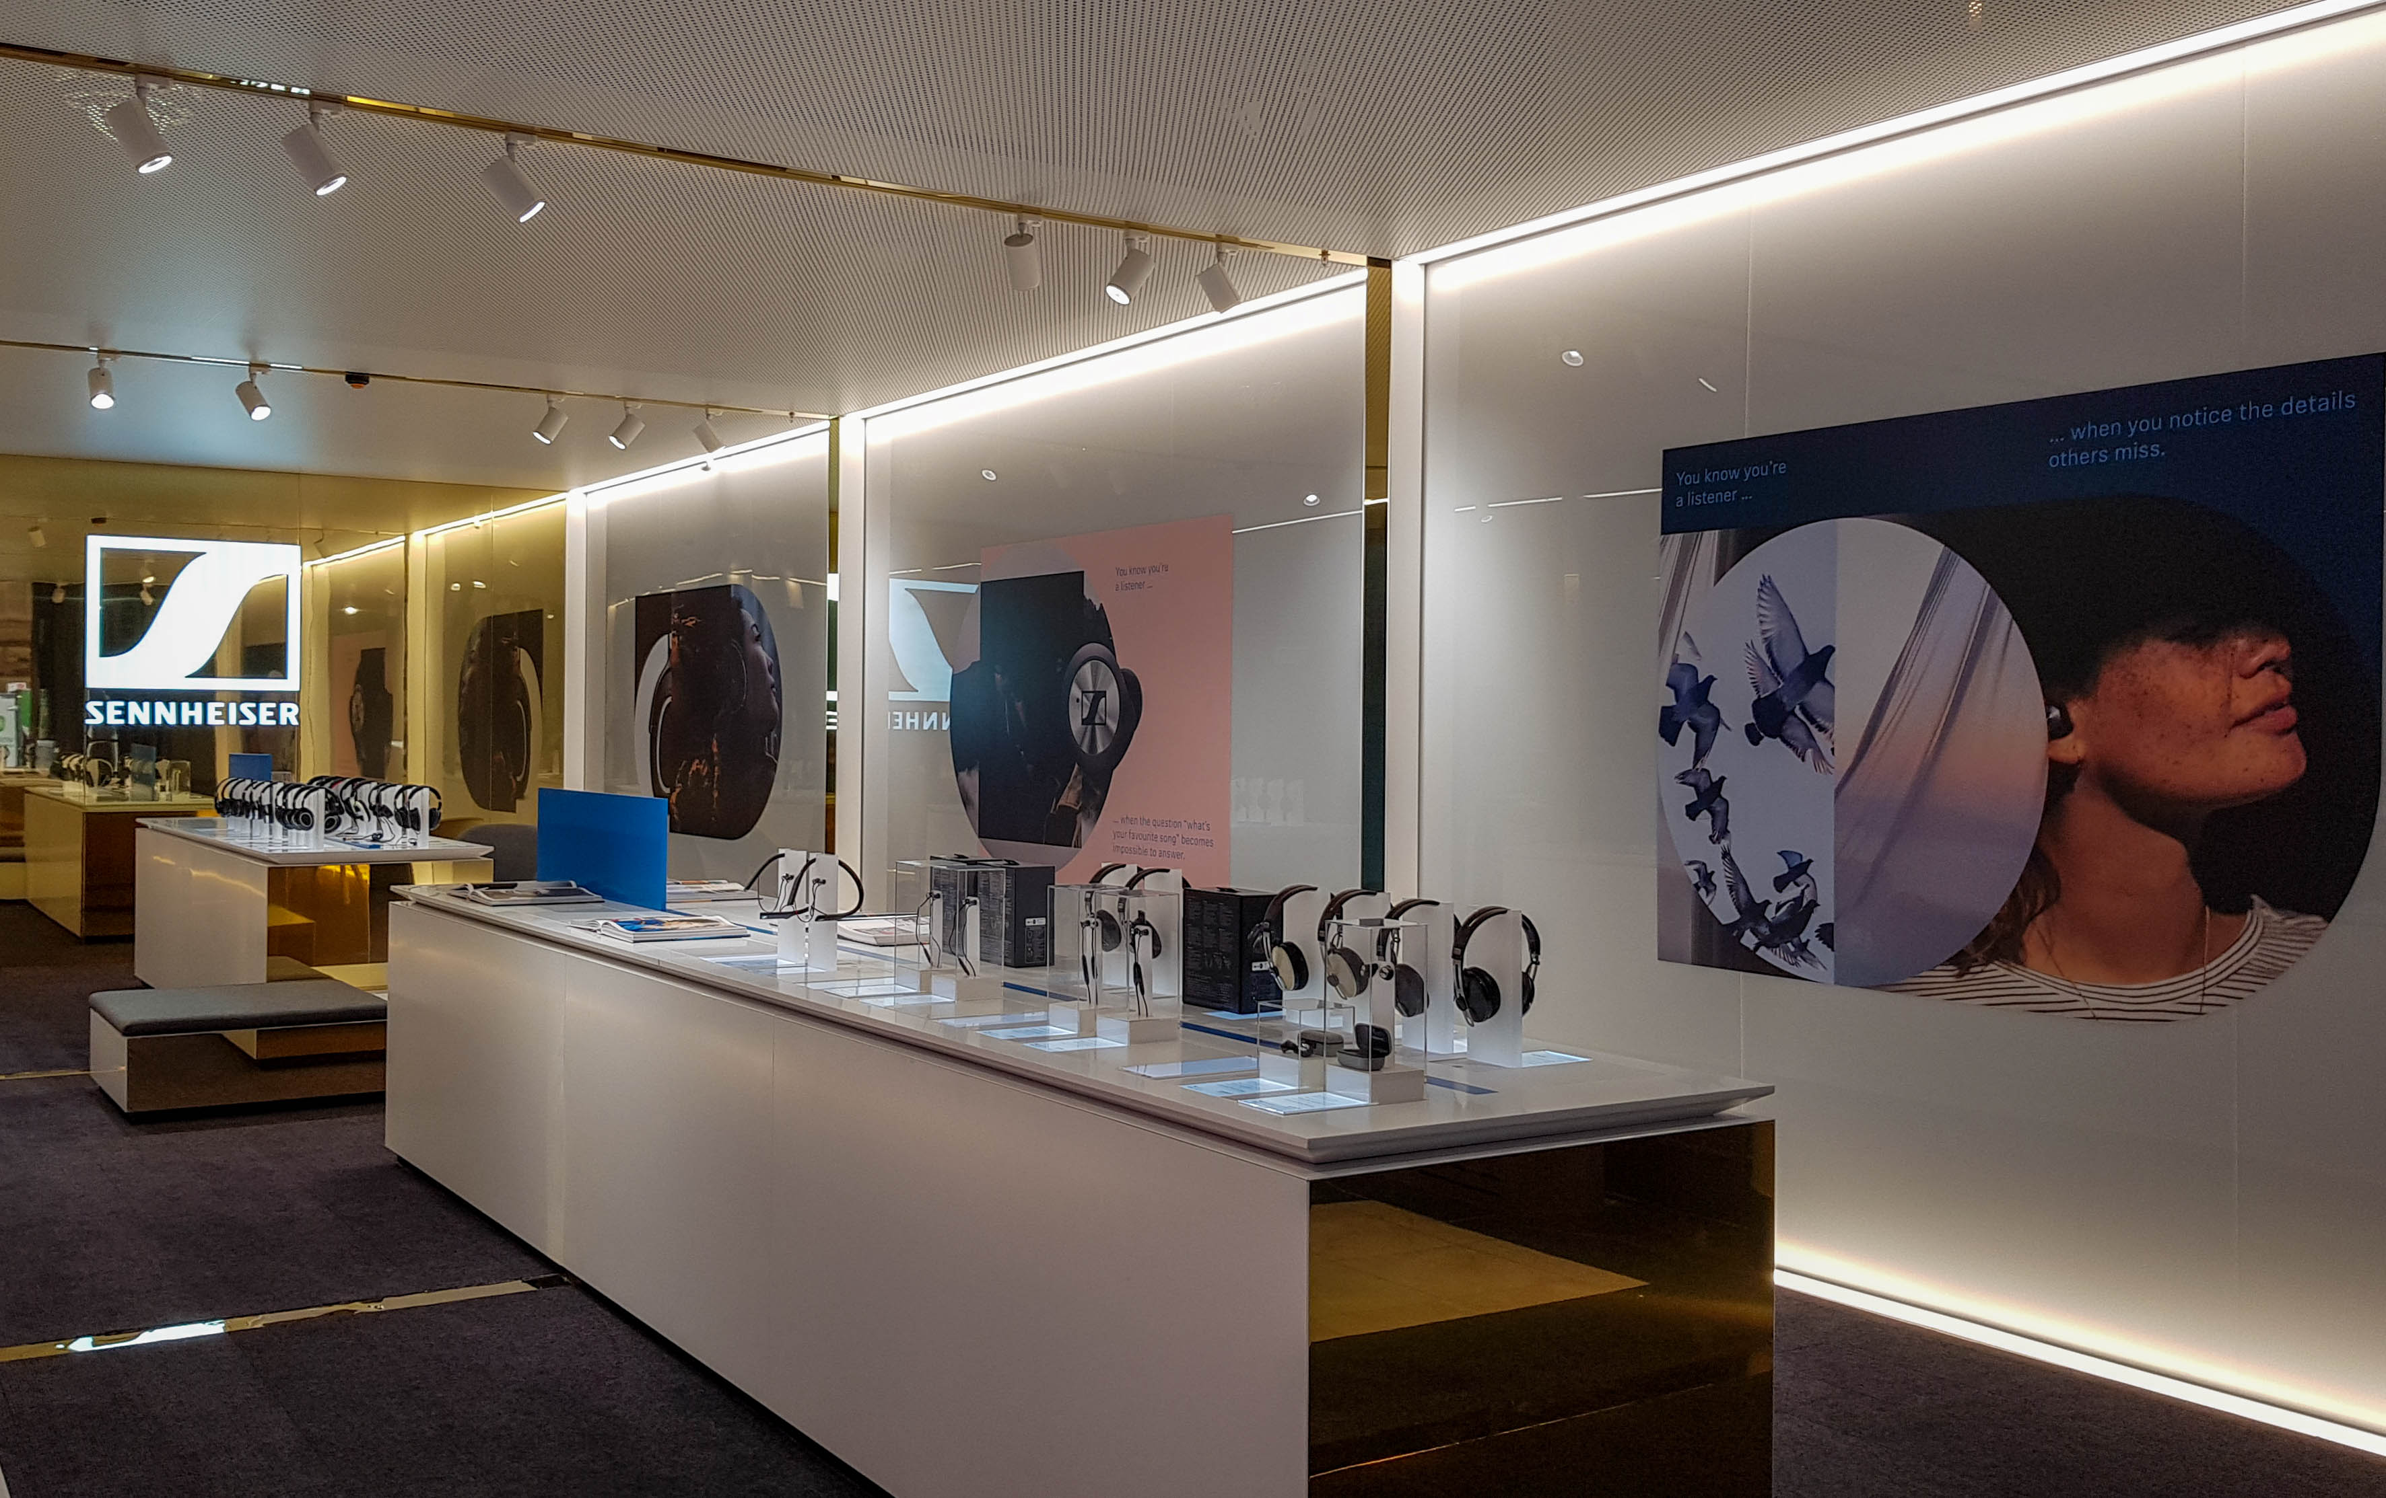

Sennheiser has opened a new flagship store in Sydney’s Martin Place.

The new Sennheiser store will provide the opportunity to test and purchase a wide range of consumer, gaming, business and professional audio products, including exceptional, ground-breaking new products such as the new MOMENTUM True Wireless earphones, which set new standards in audio fidelity for true wireless ear buds. In addition, a premium Experience Room offering personalised listening sessions, will give visitors the chance to be among the first in Australia to listen to the new Sennheiser AMBEO Soundbar, which will be available in 2019. Thanks to unique AMBEO 3D technology, Sennheiser’s entry into the world of sound bars sets new benchmarks in an unparalleled immersive experience. Last but by no means least, the Experience Room will also be home to the exquisite Sennheiser HE1, the world’s best high-end headphones valued at AU$80,000.

The premium experience room will be available for private listening sessions with our AMBEO 3D Soundbar and the exquisite HE1. | 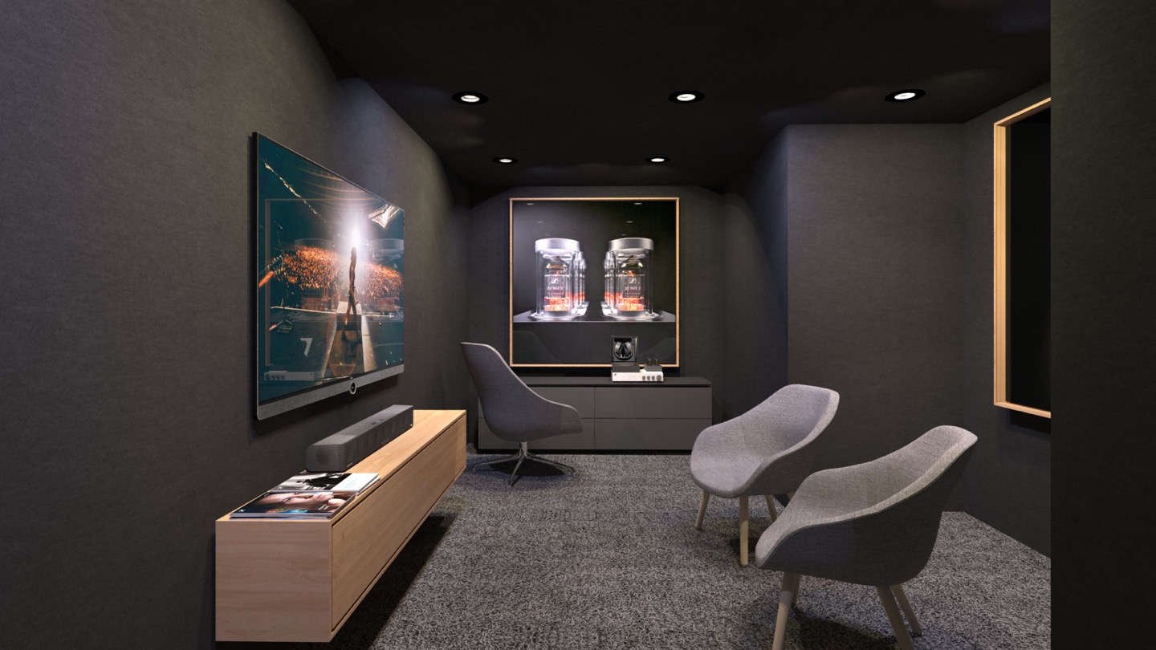

“It was our goal to create an inviting and truly inspiring environment for our customers here in Australia. As a company, we believe in building relationships with our customers. This space will hopefully become a destination for unique listening experiences, special events and a chance to explore our range of innovative audio products.” said Pete Ogley, COO Consumer products, who was a special guest at a grand opening event held last night.

Marek Jaworski, Director of Sales - Retail, for Sennheiser Australia and New Zealand, added “Sennheiser is a brand that Australians have come to love in the audio world, so we are very proud to finally expand into our own retail space in Sydney. It’s brilliant to offer our customers a way to explore our range and to interact with and listen to products in store so they can take their sound experience to a whole new level.”

Opening just in time for Christmas, an expert team of Sennheiser staff are on hand to help customers find their perfect audio companion – for example, helping them match the ideal set of headphones to suit personal listening preferences, style or budget.

The Sennheiser Sydney store is located at 5 Martin Place, Sydney and is open Monday to Sunday. For more information, please visit: https://en-au.sennheiser.com/sennheiser-brand-store-flagship-store or visit the Sydney Store social pages:
Facebook: https://www.facebook.com/SennheiserSYD/
Instagram: @sennheisersyd

about Sennheiser
Shaping the future of audio and creating unique sound experiences for customers – this aim unites Sennheiser employees and partners worldwide. Founded in 1945, Sennheiser is one of the world’s leading manufacturers of headphones, microphones and wireless transmission systems. With 21 sales subsidiaries and long-established trading partners, the company is active in more than 50 countries and operates its own production facilities in Germany, Ireland, Romania and the USA. Since 2013, Sennheiser has been managed by Daniel Sennheiser and Dr. Andreas Sennheiser, the third generation of the family to run the company. In 2017, the Sennheiser Group generated turnover totaling €667.7 million. www.sennheiser.com

Press Contact
Sennheiser Australia & New Zealand Hausmann Communications
Heather Reid Sienna Coleman
Public Relations Manager Consultant
T: +61 448 119 609 T: +61 (0)468 567 468
heather.reid@sennheiser.com sienna.coleman@hausmann.com.au

