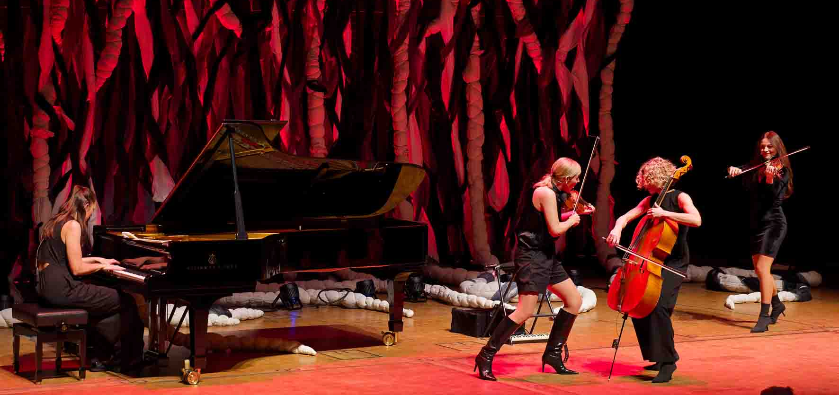

“Salut Salon” on tour with Sennheiser Spectera
The German chamber music quartet combines classical music with folk, jazz, and pop

Wedemark, December 2025 – For more than two decades, chamber music quartet Salut Salon has been challenging the sometimes rigid conventions of classical concert formats with their unique blend of creativity, charm and wit. Their soundscapes are a fusion of classical music, folk, jazz, pop, tango nuevo, film soundtracks and their own compositions, creating an unmistakable cosmos full of sophistication, vitality and humour while making it all seem incredibly effortless. On Salut Salon’s current tour, excellent sound is ensured by Sennheiser’s Spectera wideband wireless ecosystem.

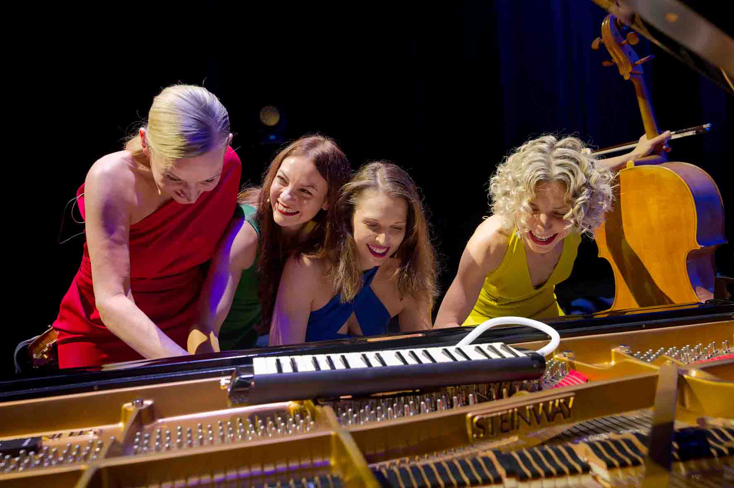 | Salut Salon at the Konzerthaus Dortmund concert hall  From left to right: Angelika Bachmann, Alvina Lahyani, Kristiina Rokashevich and Maria Well  (Photo courtesy of Salut Salon and the Konzerthaus Dortmund)

Stage without cables
The Sennheiser Spectera wideband ecosystem has been used by Salut Salon since early summer 2025. The components are owned by Florian Hinz from Hinz Audio, who alternates with Thorsten Seeliger as the sound engineer for Salut Salon and was able to take delivery of the components via Sennheiser’s sales partner NORDLITE very soon after the system’s launch.

During the performance at the Konzerthaus Dortmund concert hall on 8 November 2025, Seeliger set up the Spectera Base Station in the concealed side area of the stage together with an L 6000 charging station. Two PoE-powered Spectera DAD antennas were installed close by on stands and were directed towards the performance area.

Angelika Bachmann, Salut Salon’s founder and first violinist, Alvina Lahyani (violin), Maria Well (cello) and Kristiina Rokashevich (piano) used bidirectional Spectera SEK bodypacks for their personal in-ear monitoring and vocals. Four other SEK bodypacks were used for the cello, accordion and grand piano.

Sound engineer Thorsten Seeliger is delighted that there are no cables on the stage  (Photo courtesy of Salut Salon and the Konzerthaus Dortmund) | 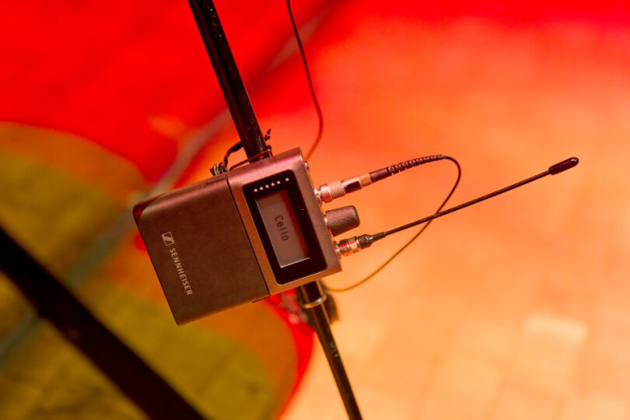

“I always used to set up wired microphones at the grand piano, but the transmission quality of the Sennheiser Spectera is excellent and I’m really pleased that I don’t have to lay – and see – any cables on the stage anymore,” says Seeliger, who has been Salut Salon’s sound engineer for almost two decades and is a Spectera expert at NORDLITE Event Solutions GmbH.

Compliments for uncompromising sound
In Dortmund, Seeliger used an 8 MHz wide UHF frequency band with a centre frequency of 554 MHz for the wireless audio transmission of Salut Salon. He selected the “Live” audio link mode for both microphone and IEM channels. The “Live” mode makes use of Sennheiser’s proprietary SeDAC audio codec with a latency of a mere 1.6 milliseconds.

“Other digital IEM systems have a latency of at least 2.7 milliseconds and they don’t offer any bidirectional functionality either,” Seeliger points out. “In my opinion, the audio quality in ‘Live’ mode is already so fantastically good that I don’t even need to use the PCM mode, which is completely lossless in operation but quite resource-intensive. In addition, if I used PCM, I would have to employ the second available 8 MHz band of the Spectera system, and I prefer to keep this free as part of my backup plan if something goes wrong.” Depending on the configuration, the Sennheiser Spectera Base Station controls up to 64 audio links (32 inputs and 32 outputs) and uses up to two independent RF wideband channels instead of a large number of narrowband RF carriers.

Thorsten Seeliger has been the sound engineer for Salut Salon for almost 20 years  (Photo courtesy of Salut Salon and the Konzerthaus Dortmund) | 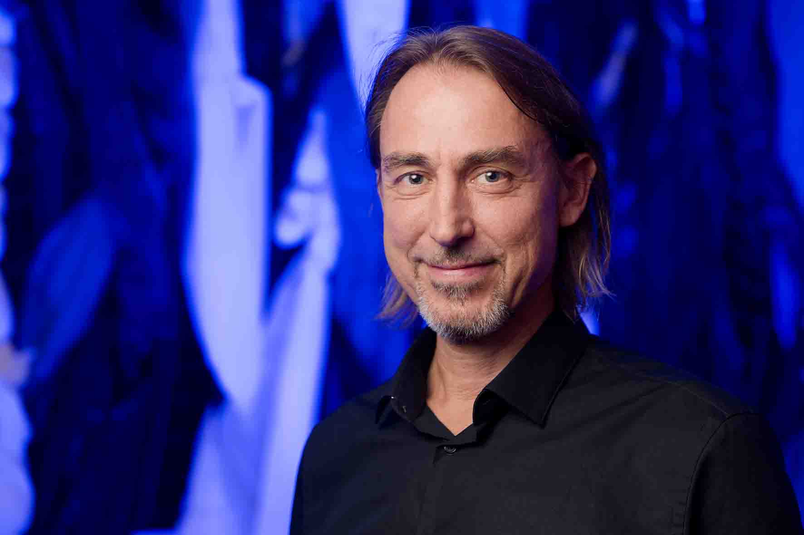

The Spectera Base Station was connected to the digital audio console via MADI to keep the latency as low as possible. “Excessive latency in their in-ear monitors would definitely be a problem for the classically trained musicians of Salut Salon, particularly because Angelika Bachmann, for example, uses a single monitoring earpiece in her right ear and hears her violin directly in her left ear without an earpiece,” Seeliger explains. “In this case, an audible time delay would be unacceptable.”

Salut Salon’s transition to the new wideband wireless system was seamless. Seeliger reports that, initially, cellist Maria Well was taken aback by the sound of the digital in-ear channel, as she had never experienced sound quality like that before, but soon was highly impressed. “She quickly noticed that everything now sounded like an unamplified instrument – only a little louder. There can hardly be a greater compliment for the sound of an in-ear channel,” says Seeliger, adding: “I clearly remember what it was like the first time I directly compared Spectera with other state-of-the-art in-ear wireless solutions I had frequently worked with. At first, I could hardly believe the sound could be so much clearer, more dynamic and better overall compared to analogue systems.”

According to Seelinger, the Salut Salon musicians have no problems at all using the infinitely rotatable volume buttons on their SEK bodypacks. The sound engineer only uses the remote control function for the listening volume if the musicians ask him to. “The fact that only one bodypack is required for both the microphone and in-ear monitoring channels instead of two devices is a huge step forward for Salut Salon, especially because of their various costume changes,” he adds. “I’ve always wanted something like that.”

Seeliger has always wanted to have a system like Spectera that combines a microphone and IEM in a single beltpack  (Photo courtesy of Salut Salon and the Konzerthaus Dortmund) | 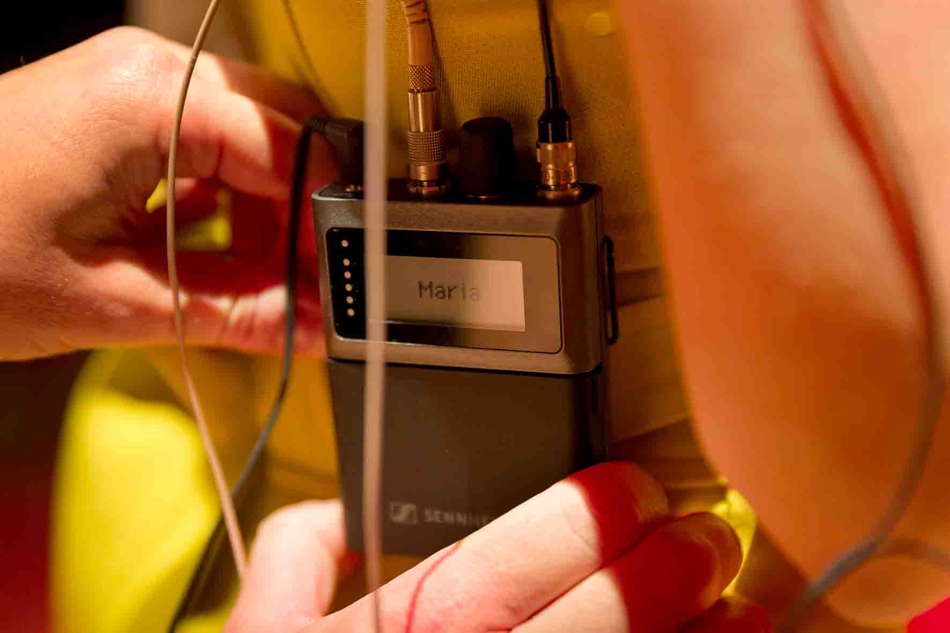

Seeliger is completely satisfied with the capacity of the SEK bodypack’s BA 70 lithium-ion batteries: “I always use the batteries from the previous day’s performance for soundcheck, and then use fully charged BA 70s for the show itself. Depending on the in-ear monitoring volume and other parameters, I can achieve five to six hours of operating time. That’s more than enough.”

“Once you’ve used Spectera, there’s no going back!”
Frequency management, which used to be a complex procedure, can now be done in next to no time using Spectera, much to Seeliger’s delight: “It’s really become very easy. I carry out a scan at the venue, select a free space, enter the data and after a workflow that takes about 15 seconds, everything is ‘set and done’. Even the bodypacks are automatically set at the correct frequency without any input from me. That means, with this system, I’m ready to start much faster than before, and I also don’t have to bother with the tedious task of sticking tape on the bodypacks to mark the user’s name. The performers also appreciate seeing their own name appear on the continuously visible e-ink displays. It’s a nice feature. And if there’s a new performer, I simply use the software to change the name on the display.” Seeliger uses Spectera WebUI on a laptop at the FOH console.

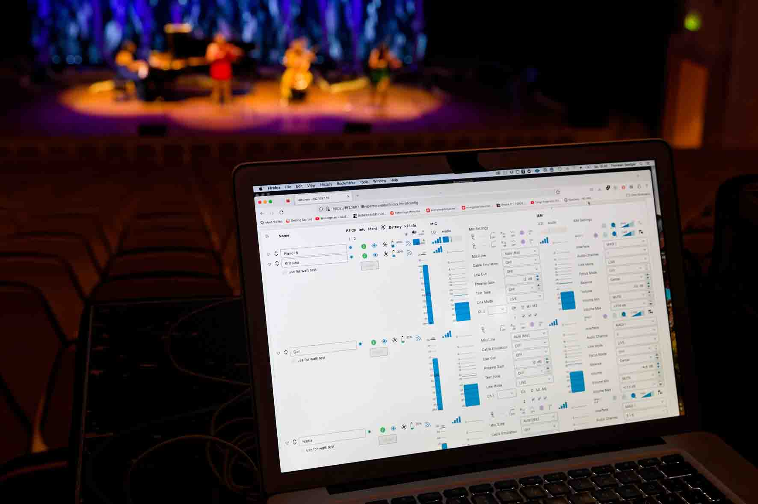 | Spectera WebUI at the FOH console  (Photo courtesy of Salut Salon and the Konzerthaus Dortmund)

A further benefit of Spectera that helps ensure a fast set-up is its small space requirements: “Our old wireless system used to occupy a large 19-inch cabinet that was actually pretty heavy,” Seeliger recalls. “The current solution is much more convenient, particularly because we, as the production team, travel to the venue in a small van rather than a full-size truck.”

The fact that the two Spectera DAD antennas for Salut Salon only need to be placed on one side of the stage and not on both left and right also helps to simplify the set-up procedure. According to the Seeliger, this does not have any negative impact on coverage of the performance area: “I’ve had a lot of very good experience with this arrangement – it’s absolutely reliable! At the end of the concert, the four musicians move through the auditorium and leave at the back while still playing their instruments. Even here, there have never been any problems with range. I’ve never once seen the ‘Link Quality Indicator’ drop during a show, even in pretty challenging RF environments.”

Seeliger is highly impressed by the sound quality of the Sennheiser Spectera ecosystem: “In-ear monitoring no longer has any noise whatsoever and I haven’t noticed an artifact or experienced a dropout on tour. As far as the sound is concerned, there really is nothing that you could criticise when using Spectera. Particularly with a sampling rate of 96 kHz, the sound is absolutely fantastic! Salut Salon will definitely be using Sennheiser’s wideband system for their concerts in the future – there’s no going back!”

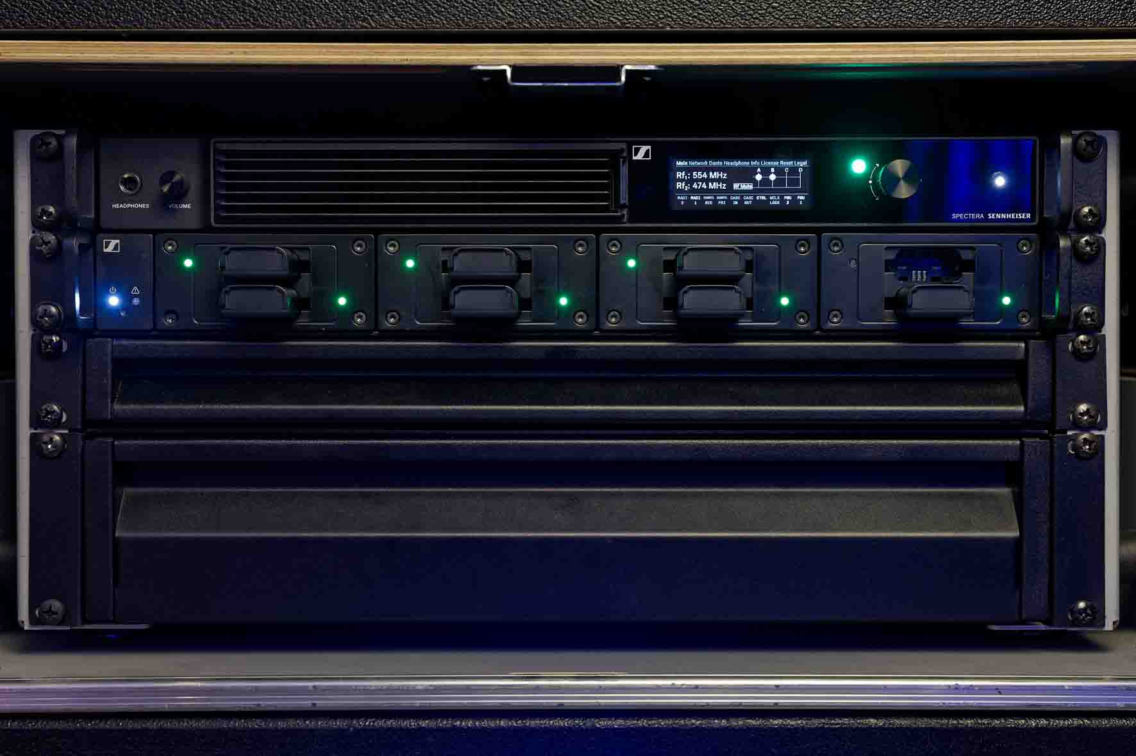 | The Spectera Base Station, an L 6000 charging station and two drawers for the SEKs and accessories – the Spectera wideband system takes up hardly any space  (Photo courtesy of Salut Salon and the Konzerthaus Dortmund)

Seeliger’s contact at Sennheiser is Jörg Langel, Business Development Manager, Touring & Rental. Langel says: “The new Sennheiser Spectera ecosystem is successfully proving itself in everyday life on tour. All the feedback I’ve received so far has been positive, particularly with regard to the sound quality, reliability and user-friendliness. Spectera uses the possibilities provided by WMAS in a unique manner. With its faultless performance, the system offers impressive results even in critical RF environments. The trust that early adopters such as Florian Hinz and Thorsten Seeliger have placed in the system has definitely not been misplaced. Spectera represents a quantum leap forward for professional wireless applications and is a genuine game changer!”

“A world of difference!”
Angelika Bachmann, the founder of Salut Salon, is a highly talented musician who gave her first concerts when she was only four years old. At the age of five, she began to compose her own music, and performed as a soloist with renowned orchestras from the age of seven. After leaving high school, she studied philosophy, education and German language and literature at the University of Hamburg, as well as music and speech training at Hamburg University of Music and Drama. She completed a Masters degree in psychology at the University of Wuppertal. In 2011, she was awarded the German Federal Cross of Merit for her volunteering work. Together with Salut Salon, she performs concerts on all continents.

“The members of Salut Salon are always those who are not currently having a baby, taking their kids to nursery or taking a break to help their husbands at home…” says Bachmann with her usual cheeky sense of humour. She describes Salut Salon as “a quartet of ten musicians” who “do rock’n’roll as a part-time job” to enable them to combine work and family life. “Salut Salon is made up of three cellists, three pianists and four violinists,” she explains. “We are close friends and before each section of the tour we always discuss how the performance dates work best for each one of us and therefore for all of us.”

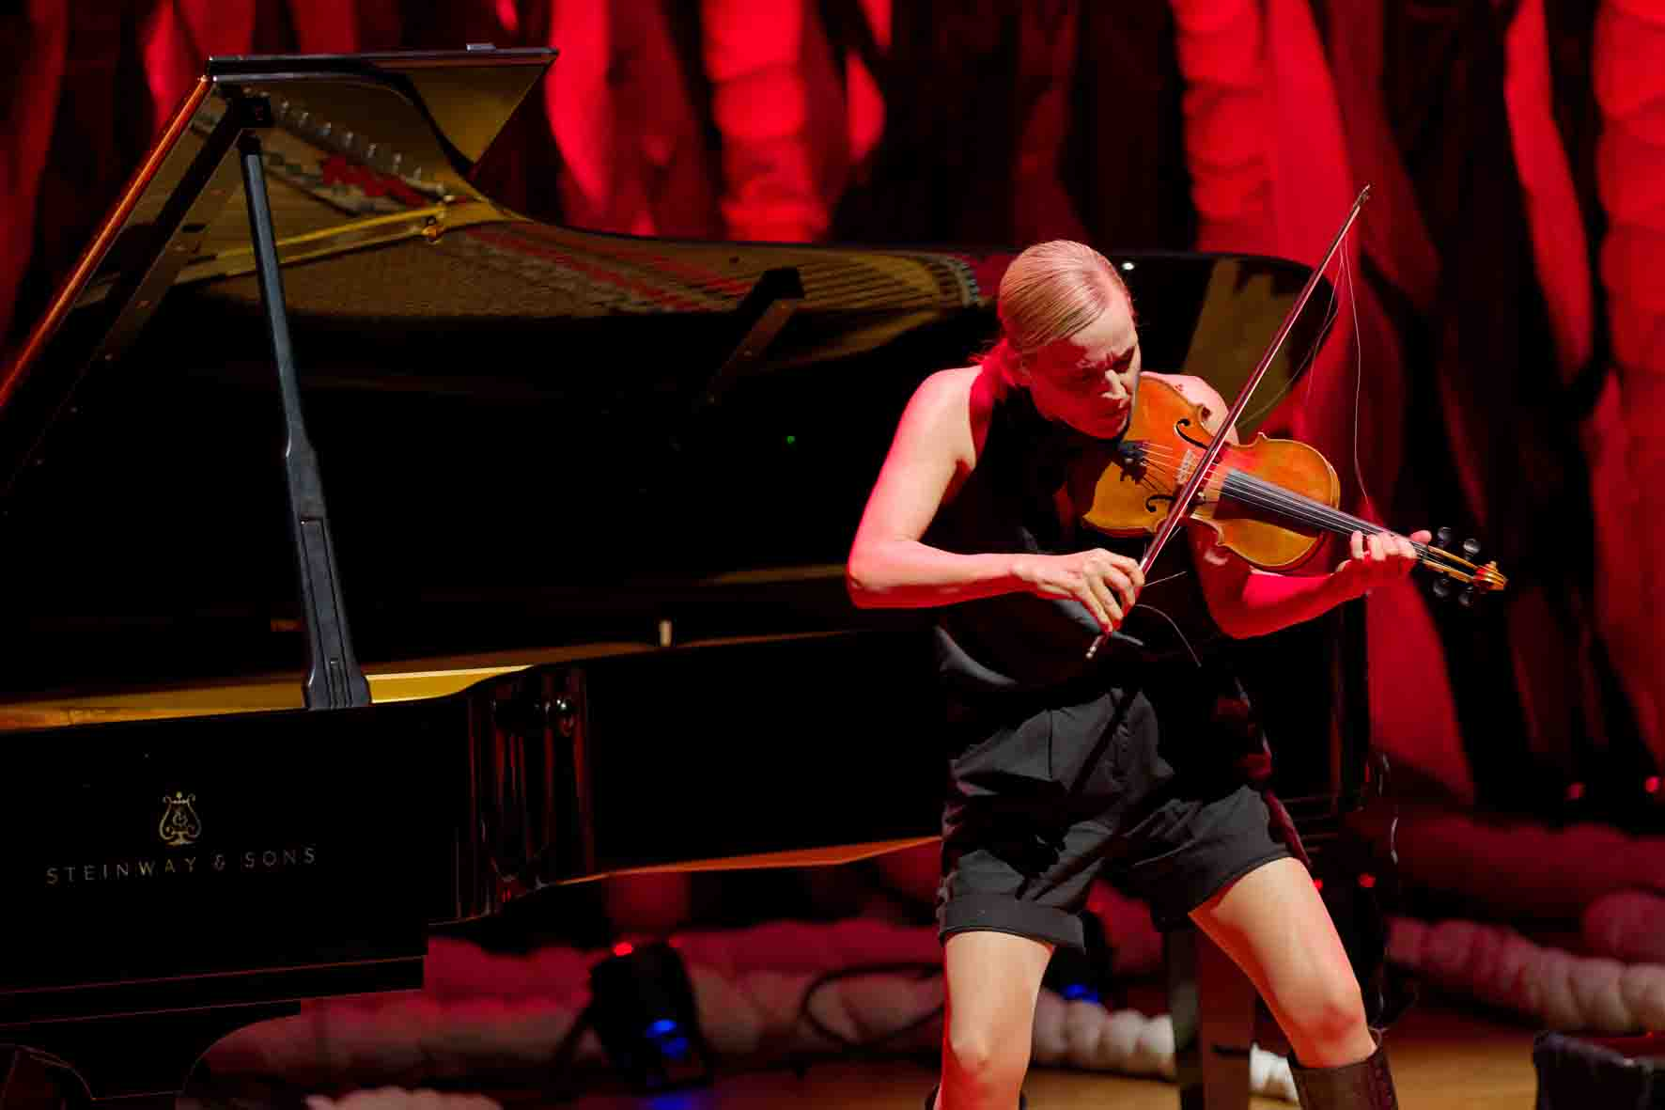 | Angelika Bachmann, founder and first violinist of Salut Salon  (Photo courtesy of Salut Salon and the Konzerthaus Dortmund)

On stage, the musicians of Salut Salon are continuously in motion, and even the pianist often leaves her usual place at the piano, for example to start singing while playing the accordion. For that reason, a wireless sound system is absolutely essential for the concerts. “A conventional set-up with fixed microphones just wouldn’t work for me and the others,” says Bachmann. “I can't imagine not being able to move around on stage – that's simply unthinkable for me.”

As far as in-ear monitoring is concerned, Bachmann attaches great importance to having a sound that is as unadulterated as possible. During the performances, she wears a standard open earpiece in her right ear and no earpiece in her left ear, allowing her to hear her instrument directly as well as the other musicians and the surroundings. “I don’t need two earpieces. I can’t split myself in two,” she says with a grin.

When asked about Spectera, Bachmann explains: “The fact that we are using Spectera on our current tour is down to Thorsten Seeliger, who has been working with us as our sound engineering expert for almost 20 years now. What I immediately noticed as a positive aspect of Spectera is the incredible brilliance and clarity of the sound. Everything that used to sound a bit unclear sometimes and somehow not quite natural is now much better. With Spectera, my in-ear sound is better that ever before, and I’m really happy with it. I have the advantage of having perfect pitch, and for me it is important to have a clean reproduction of overtones, which are no longer cut off at the top with Spectera, unlike in analogue IEM wireless systems. The sound is now much closer to that of a real instrument. It makes a world of difference!”

Virtuoso with verve
Whether they are presenting Vivaldi or vocal acrobatics, Gershwin or Gulda, rap or Ravel – the musicians from Salut Salon transcend national and cultural boundaries with their concerts, inspiring audiences with their sensationally virtuoso and highly entertaining musical skills. With apparent ease, they cross the borders between classical and popular music and win hearts throughout the world with their playfulness and exceptional talents.

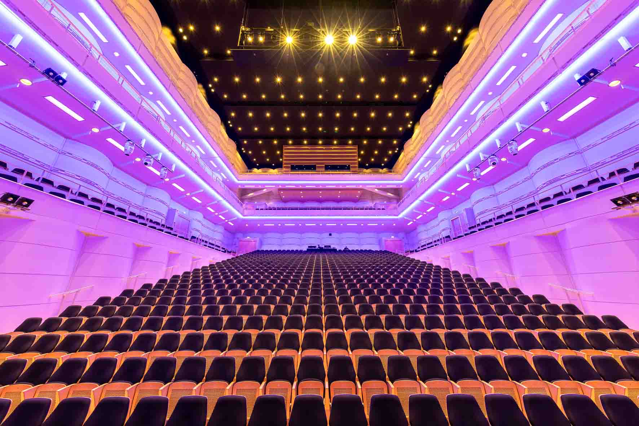 | The Konzerthaus Dortmund provides excellent acoustics  (Photo courtesy of the Konzerthaus Dortmund)

Their current programme called “heimat” (homeland), which the musicians are taking on tour from 2025 to 2027, comes across as a commitment to curiosity, an openness to the cultures of the world and a desire to leave the beaten track. But what is most surprising is that they make it all seem so effortless – something that is rarely found in established classical music performances. Music by Dvořák, Fauré, Piazzolla and Prokofiev is played in arrangements by Angelika Bachmann that condense the pieces to their essentials, embellished by elements of folk music from Estonia, Bulgaria and Argentina. In addition, there are their own compositions such as their piece called “Flucht” (flight).

Thanks to Sennheiser Spectera, the sound at these highly acclaimed concerts is in a class of its own, allowing magical moments to be experienced in the best possible audio quality, for example at the Konzerthaus Dortmund with its excellent acoustics designed by GRANER+PARTNER. The Hamburger Abendblatt newspaper hit the nail on the head when it called the multi-award-winning ensemble “Hamburg’s most charming cultural export”. There could hardly be a more fitting way to describe Salut Salon.

https://salutsalon.de/
https://www.nordlite.de/
http://wp.hinz-audio.de/

(Ends)

The high-resolution images accompanying this media release, plus additional images, can be downloaded here. All photos by courtesy of Salut Salon and the Konzerthaus Dortmund.

About the Sennheiser Brand – 80 Years of Building the Future of Audio
We live and breathe audio. We are driven by the passion to create audio solutions that make a difference. This passion has taken us from the world’s greatest stages to the quietest listening rooms – and made Sennheiser the name behind audio that doesn’t just sound good: It feels true. In 2025, the Sennheiser brand celebrates its 80th anniversary. Since 1945, we have stood for building the future of audio and bringing remarkable sound experiences to our customers. While professional audio solutions such as microphones, meeting solutions, streaming technologies and monitoring systems are part of the business of Sennheiser electronic SE & Co. KG, the business with consumer devices such as headphones, soundbars and speech-enhanced hearables is operated by Sonova Holding AG under the license of Sennheiser.
www.sennheiser.com
www.sennheiser-hearing.com

Global Pro Audio Press Contact
Stephanie Schmidt
stephanie.schmidt@sennheiser.com
+49 (5130) 600 – 1275

