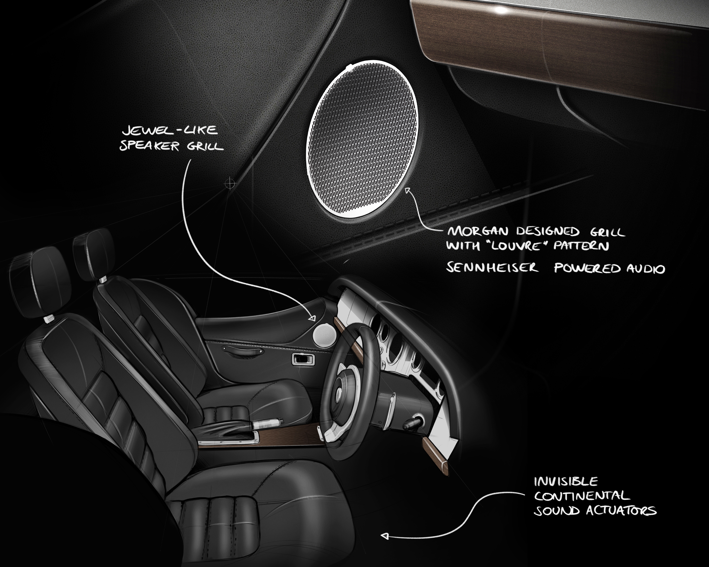

Morgan, Sennheiser and Continental celebrate quality of sound with technology partnership
Morgan and Sennheiser to enter into technology partnership, supported by Continental

Wedemark, 18 May 2022 – The next generation of Morgan sports cars will utilize Sennheiser’s software technology to deliver a quality sound experience to Morgan drivers. The partnership is supported by technology company Continental and its speakerless Ac2ated Sound System.

Morgan Motor Company is excited to announce it has entered into a technology partnership with audio specialist, Sennheiser. Working jointly with the support of Continental Engineering Service’s Ac2ated Sound System, the long-term project will transform the sound experience of future generations of Morgan sports cars.

Both companies have extensive experience in their field as well a legacy of craftsmanship, heritage and attention to detail, their expertise, jointly with Continental’s, will help to establish an innovative level of audio quality for lightweight Morgan sports cars.

The partnership with Sennheiser continues Morgan’s philosophy of combining traditional craftsmanship with innovation, and the latest technology. This approach to 21st Century coachbuilding is celebrated throughout Morgan’s current model range which comprises Plus Four, Plus Six and the recently launched Super 3.

In the past, Morgan cars have presented challenges for audio systems due to limited space, low weight requirements and the nature of an open top sports car when optimising sound quality. With the combination of Continental’s hardware and Sennheiser’s software, these challenges will be overcome, presenting an all-new proposition to new and existing Morgan customers.

Sennheiser – the iconic audio expert – is entering the automotive industry with its award-winning software technology and sound tuning know-how, aiming to revolutionize the way driver and passengers experience sound. Thanks to Sennheiser’s end-to-end expertise of sound capture and reproduction, Morgan will be the first automotive OEM to unlock the development of a new generation of sound experiences in its cars for enhanced music enjoyment. The two companies share a long-term development vision sealed by this partnership.

Continental’s innovative system abandons conventional speaker technology triggering selected surfaces in the vehicle interior to produce sound. The result is an extremely natural and enveloping sound experience for the occupants, who feel as if they are sitting in a concert hall surrounded by sound. In comparison to conventional audio systems, Ac2ated Sound not only produces high audio quality but also enables a reduction of the weight and space taken up by up to 90 percent.

Graham Chapman, Chief Operations Officer, Morgan Motor Company, said: “We are delighted to be entering into a technical partnership with Sennheiser, supported by Continental. Sennheiser is a pioneer in its field, with a long tradition of developing ground-breaking new technology. As a small, lightweight sports car, a Morgan traditionally presents a packaging and weight saving challenge when identifying audio solutions. During our early discussions with Sennheiser and Continental it was clear that their technology provides a solution to these challenges, we are excited to announce more and introduce this new technology to our customers soon.“

Veronique Larcher, Head of Mobility at Sennheiser, said: “It is a privilege to bring our audio software expertise to one of the world’s longest established automotive manufacturers, one with a commitment to quality, craftsmanship and performance – values very close to our heart at Sennheiser. Morgan Motor sports cars are born from industry leading technologies implemented into the vehicles themselves as well as the production and design processes, and we are proud to be a part of this completely unique and fresh vision of 21st-century coachbuilding.“

“With the cooperation of Morgan, Sennheiser and Continental experts, we have brought together the highest level of expertise in the areas of vehicle design, acoustics and user experience. By overcoming the challenges of weight and space, we can soon offer Morgan´s customers a premium sound experience“, says Christoph Falk-Gierlinger, Managing Director Continental Engineering Services.

(Ends)

The images accompanying this press release plus additional photos can be downloaded here.

About the Sennheiser brand
We live and breathe audio. We are driven by the passion to create audio solutions that make a difference. Building the future of audio and bringing remarkable sound experiences to our customers – this is what the Sennheiser brand has represented for more than 75 years. While professional audio solutions such as microphones, meeting solutions, streaming technologies and monitoring systems are part of the business of Sennheiser electronic GmbH & Co. KG, the business with consumer devices such as headphones, soundbars and speech-enhanced hearables is operated by Sonova Holding AG under the license of Sennheiser.

www.sennheiser.com
www.sennheiser-hearing.com

Global Pro Audio Press Contact

Stephanie Schmidt
Stephanie.schmidt@sennheiser.com
+49 (5130) 600 – 1275

About Morgan Motor Company
Morgan Motor Company is a British manufacturer of handcrafted sports cars located in Malvern Link, UK. The world-famous Morgan vehicles offer a unique blend of charisma, quality materials, craftsmanship and performance. Morgan has been handcrafting coach built traditional British sports cars that are thrilling to drive and unique within the marketplace since 1909. In March 2019, Investindustrial purchased a majority share of the company and by doing so invested in the long-term future of the Morgan Motor Company building cars in Britain. The Morgan family, along with the senior management team and the wider workforce, retain a shareholding of the company and work alongside Investindustrial. Morgan produces around 850 cars per year, of which more than 70% are exported. Its model range – comprising Super 3, Plus Four and Plus Six – is sold through 70 official dealerships in 32 countries.
About Continental Engineering Services
Continental Engineering Services (CES), a wholly owned Continental company, was founded in 2006, and as an agile and flexible engineering and production partner develops tailor-made, technologically sophisticated solutions for a wide range of applications, including automotive, railway engineering, aviation, shipping, mining and smart cities. More than 2,000 employees worldwide contribute their expertise and experience in the key technologies for automated driving, information management & connectivity, electrification and services in the field of multimodal mobility. This makes possible a new level of individual, safe and sustainable mobility.

