**CONQUEST (30 mm)**

REFERENCE NUMBERS

L3.320.4.72.6

L3.320.4.07.6

L3.320.4.97.6

L3.320.4.87.6

L3.320.0.87.6

CALIBRE

Self-winding mechanical movement

Exclusive Longines calibre L592.5

8¾ lines, 22 jewels, 28.800 vibrations per hour

Magnetism-resistant (ISO 764), with silicon balance-spring

Power reserve: up to 45 hours

FUNCTIONS

Hours, minutes, seconds

Date at 6 o'clock

CASE

∅ 30 mm; thickness 9.70 mm

Round, stainless steel

Sapphire glass with multi-layer anti-reflective coating   
on both sides

Bezel set with 48 Top Wesselton IF-VVS diamonds,

Ø 1.15-1.20; total 0.326 ct for ref. L3.320.0.87.6

Transparent screw-on case back

Distance between lugs: 15 mm

DIALS

Silver sunray, with applied indexes and Super-LumiNova®

treatment at 3-6-9-12 o'clock and on the rectangles

of the other hours

Green or blue sun ray, white mother-of-pearl, with 15 Top

Wesselton VS-S diamonds, Ø 0.80-0.85; total of 0.037 ct

HANDS

Rose-gold plated

Polished rhodium-plated,

with Super-LumiNova® treatment (hours and minutes)

WATER-RESISTANCE

Water-resistant up to 10 bar (100 metres)

BRACELET

Stainless steel with triple safety folding clasp;

pusher-operated opening mechanism

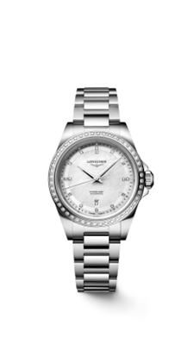

L3.320.4.97.6

L3.320.4.72.6

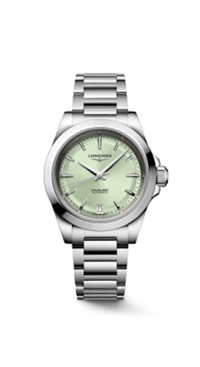**CONQUEST (34 mm)**

L3.320.0.87.6

REFERENCE NUMBERS

L3.430.4.92.6 / L3.430.4.92.9

L3.430.4.99.6 / L3.430.4.99.9

L3.430.4.02.6 / L3.430.4.02.9

L3.430.0.87.9

L3.430.5.72.6 / L3.430.5.72.9

L3.430.5.02.6 / L3.430.5.02.9

L3.430.5.92.6 / L3.430.5.92.9

L3.430.5.98.6 / L3.430.5.98.9

CALIBRE

Self-winding mechanical movement

Exclusive Longines calibre L888.5

11½ lines, 21 jewels, 25,200 vibrations per hour

Magnetism-resistant (ISO 764), with silicon balance-spring

Power reserve: up to 72 hours

FUNCTIONS

Hours, minutes, seconds

Date at 6 o'clock

CASE

∅ 34 mm; thickness 10.90 mm

Round, stainless steel for refs. L3.430.4.92.6/9;

L3.430.4.99.6/9; L3.430.4.02.6/9; L3.430.0.87.9

Bezel set with 48 Top Wesselton IF-VVS diamonds, Ø 1.25-1.30;  
total of 0.403 ct for ref. L3.430.0.87.9

Round, steel with rose gold cap for other refs.

Sapphire glass with multi-layer anti-reflective coating

on both sides

5N rose gold screw-in crown for ref. with rose gold cap

Transparent screw-on case back

Distance between lugs: 17 mm

DIALS

Blue, pink, green, silver or purple sunray

Applied indexes with Super-LumiNova® treatment

at 3, 9 and 12 o'clock and on the rectangles of the other hours

White mother-of-pearl, with 14 Top Wesselton VS-SI diamonds,

Ø 0.80-0.85; total of 0.035 ct for ref. L3.430.0.87.9

HANDS

Polished rhodium-plated, with Super-LumiNova® treatment

(hours and minutes)

Rose-gold plated, with Super-LumiNova® treatment (hours and minutes)

WATER-RESISTANCE

Water-resistant up to 10 bar (100 metres)

BRACELET AND STRAPS

Stainless steel with triple safety folding clasp with

pusher-operated opening mechanism

Blue, pink, green, white, red or purple rubber, with double safety

folding clasp; pusher-operated opening mechanism;

micro-adjustment

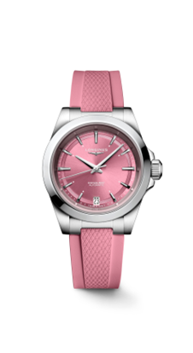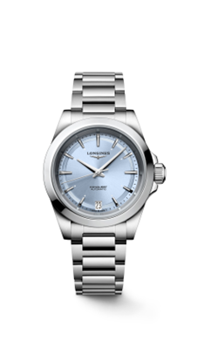

L3.430.4.02.6

L3.430.4.92.6

L3.430.4.99.9

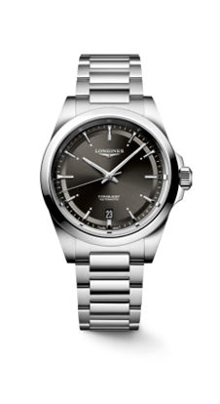**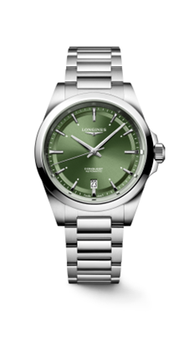CONQUEST (38 mm)**

L3.720.4.02.6

L3.720.4.52.6

REFERENCE NUMBERS

L3.720.4.72.6

L3.720.4.02.6

L3.720.4.92.6

L3.720.4.52.6

L3.720.4.62.6

CALIBRE

Self-winding mechanical movement

Exclusive Longines calibre L888.5

11½ lines, 21 jewels, 25,200 vibrations per hour

Magnetism-resistant (ISO 764), with silicon balance-spring

Power reserve: up to 72 hours

FUNCTIONS

Hours, minutes, seconds

Date at 6 o'clock

CASE

∅ 38 mm; thickness 10.90 mm

Round, stainless steel

Sapphire glass with multi-layer anti-reflective coating   
on both sides

Screw-in crown

Transparent screw-on case back

Distance between lugs: 19 mm

DIALS

Silver, green, blue, black or champagne sunray, with applied indexes

and Super-LumiNova® treatment at 3-6-9-12 o’clock and

on the rectangles of the other hours

HANDS

Polished rhodium-plated,

with Super-LumiNova® treatment (hours and minutes)

WATER-RESISTANCE

Water-resistant up to 10 bar (100 metres)

BRACELET

Stainless steel with triple safety folding clasp;

pusher-operated opening mechanism

**CONQUEST (42 mm)**

L3.720.4.62.6

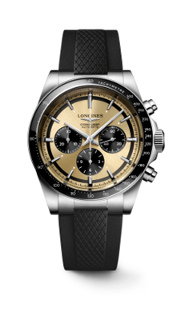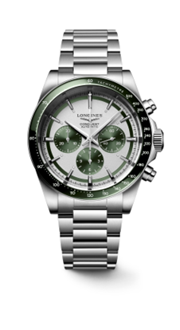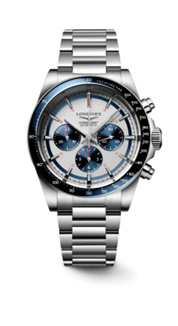

L3.835.4.32.9

L3.835.4.98.6

REFERENCE NUMBERS

L3.835.4.98.6 / L3.835.4.98.9

L3.835.4.02.6 / L3.835.4.02.9

L3.835.4.32.9

CALIBRE

Self-winding mechanical movement

Exclusive Longines calibre L898.5

12½ lines, 37 jewels, 28,800 vibrations per hour

Magnetism-resistant (ISO 764), with silicon balance-spring Power reserve: up to 59 hours

FUNCTIONS

Hours, minutes and small seconds at 3 o'clock

Chronograph

12-hour counter at 6 o'clock

30-minute counter at 9 o'clock

CASE

∅ 42 mm, thickness 14.30 mm

Round, stainless steel

Sapphire glass with multi-layer anti-reflective coating   
on both sides

Blue, green or black ceramic bezel with tachometric scale  
Screw-in crown

Transparent screw-on case back

Distance between lugs: 22 mm

DIALS

Matt silver or sunray champagne

Counters and small seconds in blue, green or black

Applied indexes with Super-LumiNova® treatment

at 3-6-9-12 o'clock and on the rectangles of the other hours

HANDS

Polished rhodium-plated,

with Super-LumiNova® treatment (hours and minutes)

For models L3.835.4.98.6 and L3.835.4.98.9

red for the counters at 6 and 9 o’clock; with a red pointer for the central chronograph seconds hand

WATER-RESISTANCE

Water-resistant up to 10 bar (100 metres)

BRACELET AND STRAPS

Stainless steel with triple safety folding clasp;

pusher-operated opening mechanism

Blue, green or black rubber, with double safety folding clasp;

pusher-operated opening mechanism; micro-adjustment

L3.835.4.02.6