

Biuro prasowe better. gaming agency
bettergamingagency.prowly.com

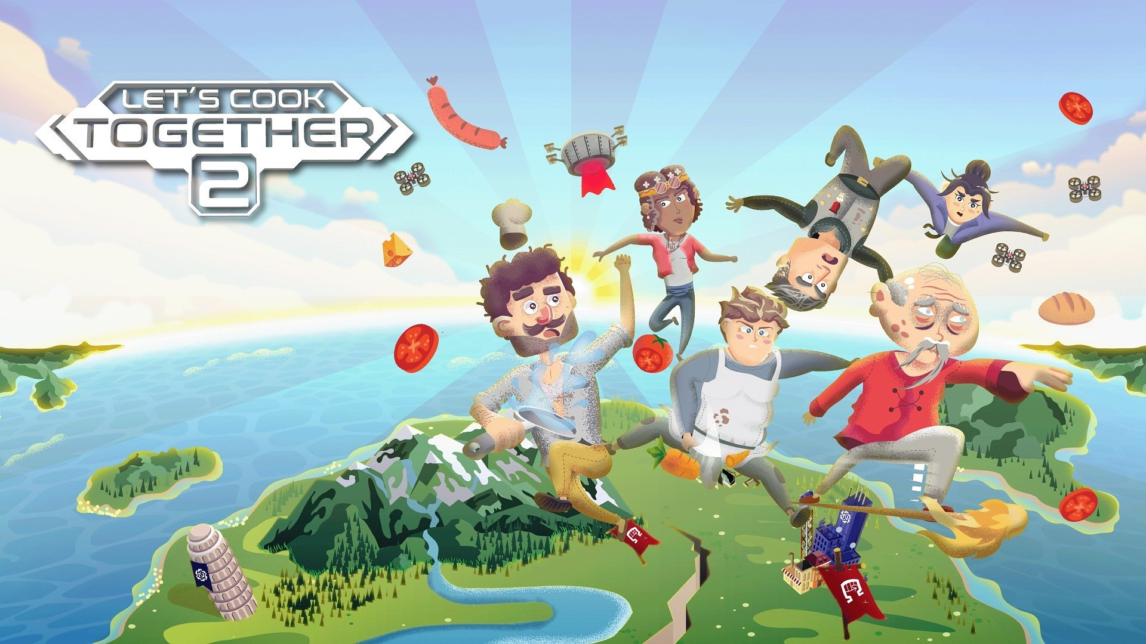

Let's Cook Together 2 is out now! – Yes, Chef! On PC and consoles – Yes, Chef!

Looking for an idea for tonight's dinner? Forget it! Order a pizza, relax, and enjoy preparing virtual dishes from all around the world. That’s right, with this kind of cooking, you don’t need to clean up after turning your kitchen into a disaster zone! Let's Cook Together 2 is now available on PC, Xbox One, Xbox Series S/X, and Nintendo Switch.

Let's Cook Together 2 is the sequel to the crazy cooperative game where players work together to master the art of cooking while overcoming culinary challenges from all corners of the world. Who knows, maybe through these gameplay sessions, you’ll learn how to cook a perfect portion of pasta! The game, developed by Yellow Dot, focuses on cooperation, which allows up to four players to join forces. But the developers didn’t forget about the lone wolves of the kitchen – you can complete the campaign and other challenges alone. Level layouts adapt to the number of players, ensuring a smooth and engaging experience whether you're cooking solo or as part of a chaotic kitchen crew The stakes are high, as players will face off against the mega-corporation Nutri, using nothing but pots and pans.

Let's Cook Together 2 - watch the launch trailer

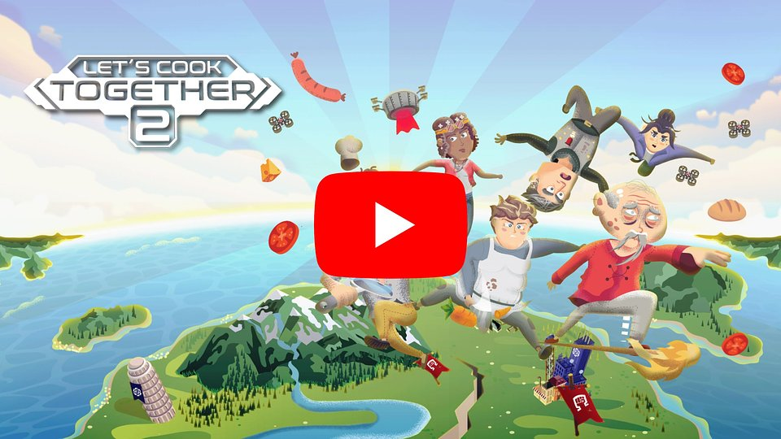
https://www.youtube.com/watch?v=CAxq52GfJQY

Join the Resistance and fight to restore flavor to a world where growing and preparing food is forbidden. A life without delicious meals has left people confused, apathetic, and lacking ambition. In this challenging fight, a remarkable invention could tip the scales in your favor – a device that allows you to rediscover recipes from the old world.

During their journey to culinary freedom, players will travel through 4 countries, where they will complete 250 levels and master 65 recipes – including a wide range of dishes, from Italian classics such as pizza, bruschetta, and lasagna, to Japanese specialties like sushi, gyoza dumplings, and udon noodles, finishing with Polish masterpieces (cuisine that is really close to the developers' hearts) like bigos and pierogi.

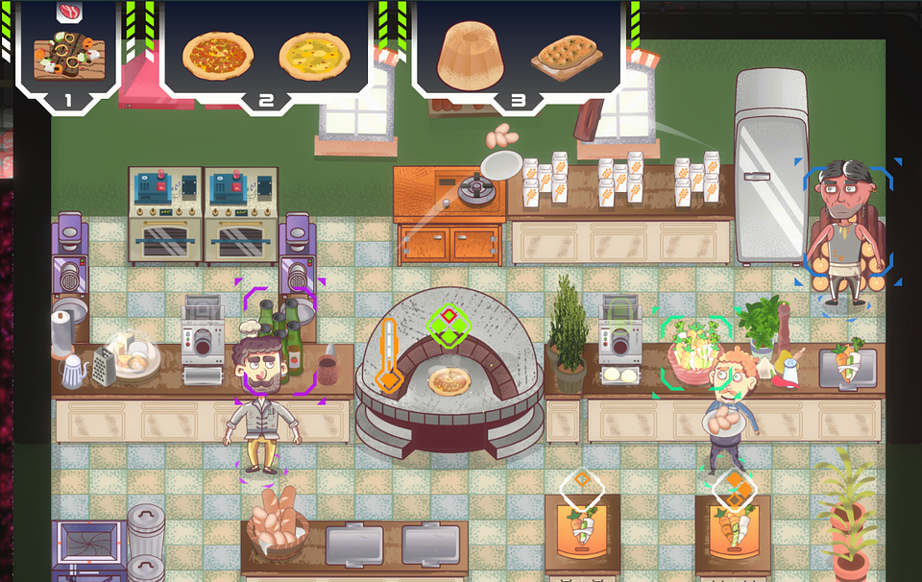

But the challenges don’t end there. The developers have created a detailed and intuitive level editor, in which everyone can create their own culinary battleground and share it with the community. Thanks to this, no one will run out of challenges in Let's Cook Together 2, and no one will have to give away their apron.

Let's Cook Together 2 tastes delicious thanks to key features like:

🥞 More, better, nicer – Let's Cook Together 2 is a sequel that significantly expands on the ideas introduced in the first installment. Players can look forward to even more exciting challenges and gameplay mechanics, as well as a completely new, stylized visuals.

🥟 Level editor – create your own levels to impress others and share them with the gaming community. With intuitive tools, anyone can design new challenges, ensuring the fun never ends.

🍕 Seasoned for all skill levels – adjustable difficulty level, suited for players of varying skill levels, makes the game a great choice for family sessions. The co-op mode, where up to four players can have fun together, has been designed so that every participant remains equally engaged.

🥐 Kitchen nightmares – crazy challenges make the gameplay full of dynamism: rushing with hot pots, battling kitchen fires, tossing ingredients across the room – in Let's Cook Together 2, all of this is as normal as a walk in the park, but you definitely shouldn’t try it at home.

🌮 Culinary Class War – for those who prefer competition over cooperation, there’s the PvP mode – Kitchen Battles, where every second counts in the race for the culinary master title.

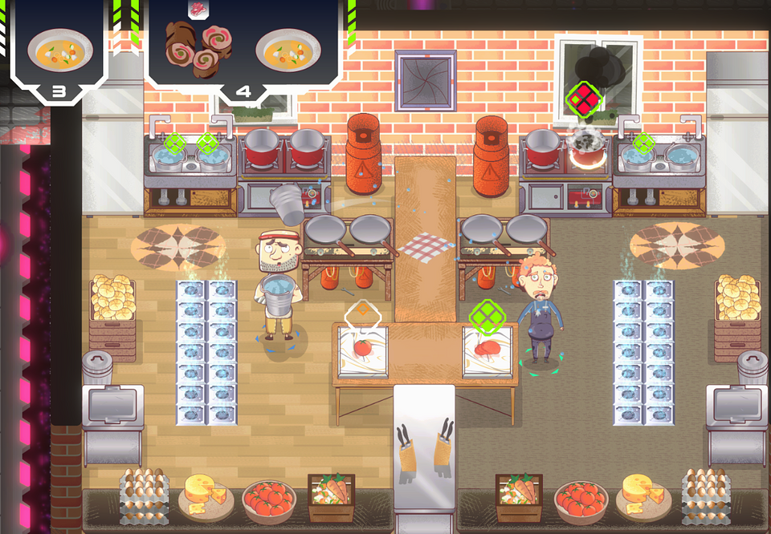

Developed by Yellow Dot, Let's Cook Together 2 is now available on PC and consoles: Xbox One, Xbox Series S/X, and Nintendo Switch. Anyone interested in testing their skills in cooperative cooking can try the demo. Let's Cook Together 2 is priced at $23.99 / €23.50, and during the launch period, the game is available with discounts of up to 15%.

We also encourage you to keep up with the latest news about the game and Yellow Dot's activities on the official website and social media.

● Official website
● X (Twitter)
● Facebook
● TikTok
● Discord

The full press kit is available here.

About Yellow Dot:

Yellow Dot is a small, independent game development studio based in Gdańsk, Poland. We specialize in creating cooperative games, with a focus on providing enjoyment for everyone – from experienced gamers to those just starting their journey in the world of virtual entertainment. The central theme of our games is communication. We aim for the gameplay dynamics to shift depending on who you're playing with – a partner, friends, or the whole family. Currently, we are working on Let's Cook Together 2, the sequel to our warmly received title, where players collaborate to tackle culinary challenges.

