For immediate distribution

Powersoft’s M-Force 301P01 Receives Outstanding Technical Achievement Nomination for NAMM 2019 TEC Awards
M-Force 301P01 is the company’s latest innovation in the realm of infra bass

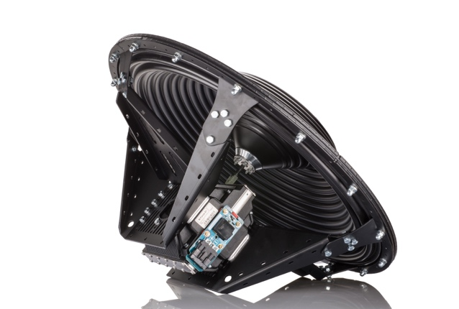
Anaheim, California, July 5, 2018 – Powersoft, a world-leading manufacturer of professional power amplifiers, announced that its M-Force 301P01 — an all-in-one solution for low-frequency applications — has received a nomination for Outstanding Technical Achievement in Sound Reinforcement Loudspeakers for the 34th annual NAMM Technical Excellence & Creativity Awards.

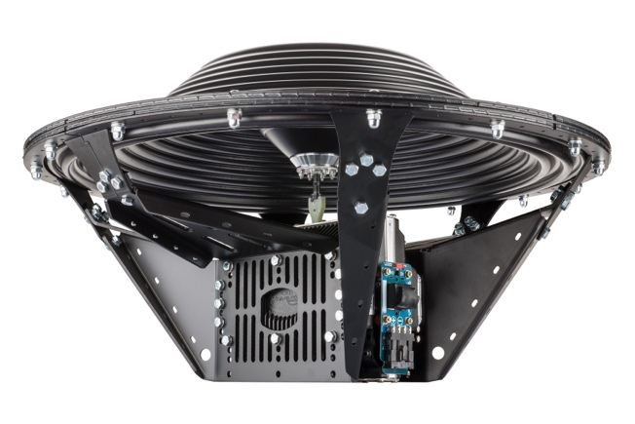
Introduced at this year’s Prolight & Sound, the new M-Force 301P01 is Powersoft’s latest category-leading solution in the realm of infra bass. The product has been updated with a series of additional features to simplify the workload for Powersoft’s growing community of OEM partners. The M-Force 301P01 is engineered in a robust, factory-assembled package which greatly simplifies implementation. The motor is matched to a purpose-built diaphragm through a newly designed coupling and a lightweight chassis, which improves thermal dissipation.

"We are extremely honored to receive a nomination once again by the TEC Foundation," said Francesco Fanicchi, Head of Brand and Communications for Powersoft. "Our M-Force platform is a category-defining solution, and further demonstrates our thought leadership in the installed sound and OEM markets.”

The Ultimate Application: M-Force at Coachella
Earlier this year at Coachella’s Sahara Tent, perhaps the largest stage for EDM music, Powersoft’s
M-Force was the driving force behind Rat Sound’s SuperSub cabinets — which delivered the ultimate sub-bass response. The SuperSub cabinets, which featured M-Force’s patented moving magnet linear motor structure, effectively set a new standard in low-end performance at the massive outdoor festival, helping Rat Sound address the challenge of massive coverage areas, while minimizing offsite sound and the need for premium quality and consistency.

Presented by the NAMM Foundation, the TEC Awards are the pro-audio and musical instrument industries' most prestigious awards, celebrating the spirit of innovation and honoring best-in-class products in the pro-audio community. Following a two-month call for entries, a panel comprised of leaders in audio and production carefully evaluated each entry before selecting the M-Force 301P01.

Winners will be announced during the annual awards ceremony during The NAMM Show on January 26, 2019, at the Anaheim Hilton Pacific Ballroom.
###

For further information, contact:

Jeff Touzeau (media contact)  Hummingbird Media  Tel : +1 (914) 602 2913  Email: jeff@hummingbirdmedia.com | Francesco Fanicchi  Powersoft (Florence, Italy)  Tel: +39 339 6381206  Email: francesco.fanicchi@powersoft.it

Or visit www.powersoft-audio.com
About The NAMM Foundation:
The NAMM Foundation is a nonprofit organization funded in part by the National Association of Music Merchants and its 9,900 members. The Foundation’s mission is to advance active participation in music making across the lifespan by supporting scientific research, philanthropic giving and public service programs. For more information about the NAMM Foundation, please visit www.nammfoundation.org.
About Powersoft:
Powersoft is the world leader in lightweight, high power, single rack space, energy efficient amplifiers for the professional audio market. Founded in Italy in 1995, headquartered in Florence, Italy, with offices in New Jersey, , Powersoft couples the experience and precision of its production department with exceptional components to deliver products with perfect audio response and high-performance reliability. Its state-of-the-art amplifiers can be found in an array of markets, ranging from stadiums, sporting arenas, theme parks, performance venues and airports to convention centers, churches, and clubs, and are used by the world's leading tour sound companies. For more information, visit the Powersoft website at www.powersoft-audio.com.

