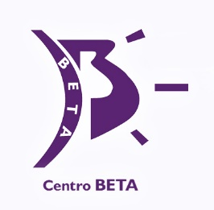
GONZALO ZARAUZA

Centro Beta

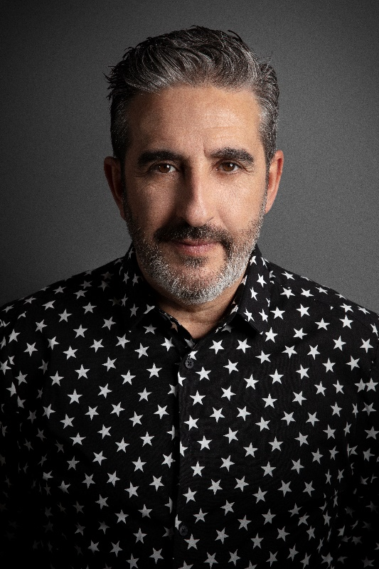
Gonzalo Zarauza Norato (Guipúzcoa, San Sebastián), is the co-founder and director of Centro BETA. Growing up as part of a family of hairdressers gave him the confidence to leave formal education and dive into the world of hairdressing. After initially training as a hairdresser technician, he then progressed to senior technician advising on personal image and following on from that, he became a qualified expert in personal image and marketing. In his eagerness to acquire new knowledge, he trained as a Pivot Point Monitor and as a Habia Professor (an Authority in the Industry of Hairdressing and Beauty). Educator by vocation, he has trained at all levels, from basic education, training for employment and providing continuous training for active professionals, having developed various programs and content for courses in the field of hairdressing and styling.

In 1990 together with Alejandro Azurmendi, he founded the BETA Hairdressing Education Centre, where he performs tasks in management and coordination, as well as developing and monitoring training programs in hairdressing and aesthetics. Gonzalo Zarauza has also published several books covering topics such as haircut, various techniques, finishes and upsweeps. Gonzalo Zarauza is an Official Ambassador for Montibello, and Elegance Hair Extensions.

The stylist from Guipúzcoa has received several awards, including:

- the Gold Star for Professional Excellence (I.E.P. Madrid 2014)
- the Award for Business Innovation and Creativity (Crea Imagen Bilbao)
- Honorary Consultant Patron (Omat Foundation)
- Best Continental Academy award presented by Intercoiffure Mondial
- Fígaro award in 2015 in the category "Fashion Catwalk" with the collection Fresh

GONZALO ZARAUZA

Centro Beta

- Finalist at the AIPP Awards 2016/2017 in the avant-Garde category (created together with Manuel Mon)
- Spanish Hairdresser of the Year 2016-2017, awarded by Club Figaro
- Best Avant-Garde Collection Award at the Chicago ABS
- Figaro award for the best Avant-Garde collection in 2018 (created together with Manuel Mon)
- Finalist at the AIPP Awards 2019/2020 in the Best Commercial category (Out of Sight collection)
- Finalist at the AIPP Awards 2020/2021 in the avant-Garde category (created together with Manuel Mon)

He regularly writes articles in magazines from the professional sector of hairdressing and has to his credit several books on hairdressing and image consulting. His latest publication "Wedding Dreams", which gives advice on weddings and ceremonies, was launched in Spain in February 2019 to great acclaim.

