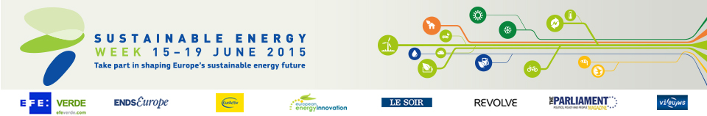

Energy Days in Austria (2)
- Excursion to PET to PET Recycling
Date: 16/06/2015 - 18/06/2015
Time: From 10:00 to 16:00
Location: Müllendorf
- Vienna Energy Forum
Date: 18/06/2015 - 20/06/2015
Time: From 10:00 to 18:00
Location: Vienna

