The Chrystalle Edit
From daytime demure to evening elegance, Wacoal’s best-selling collection Chrystalle is back for SS17 in a selection of exquisite shades and styles which are designed to make you look and feel divine

Chrystalle is back for SS17 offering luxurious and delicate styles of lingerie and loungewear in a choice of three stunning new colours. A complete lifestyle collection, the Chrystalle wardrobe offers you a series of sophisticated and relaxed looks which will take you from day wear to night wear.
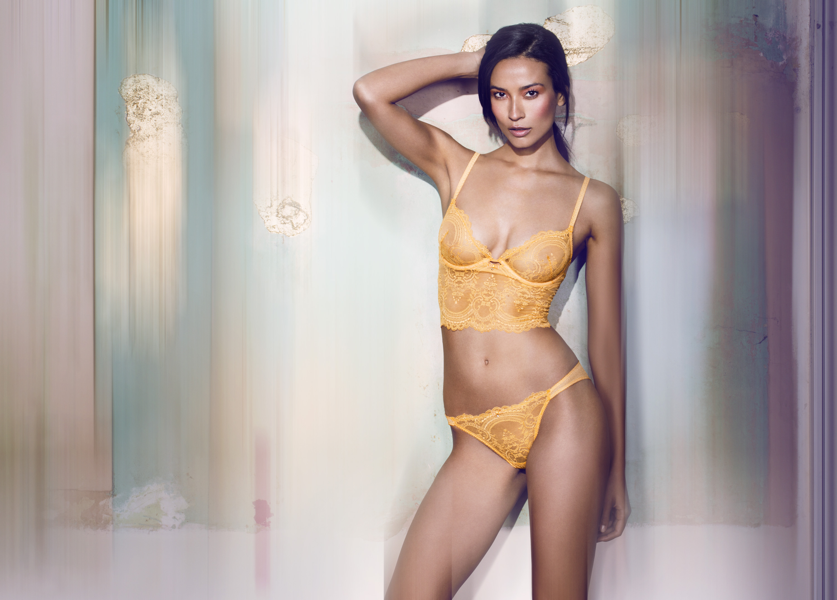
Launching in a new and eye catching clementine shade or crisp white colour is the Chrystalle Bralette available from S-XL, this stretch Leaver’s Lace style features a flattering hemline to the waist and a sexy low plunge look. Alternatively choose the UW fuller figure bra available from 32D-38FF for great support and full coverage, the balcony bra available from a 34B-36F which features a decorative scallop at the neckline, or finally the UW Spacer bra available from 30B-36FF for a light and seamless shape. A choice of Leaver’s Lace brief or short co-ordinates then compliment the range beautifully.

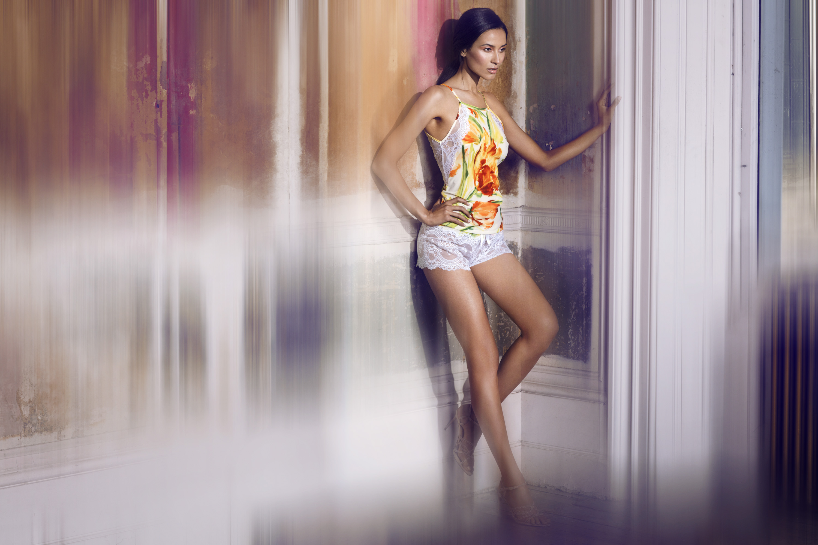
Additionally, Wacoal introduces Chrystalle in a couture inspired botanical tulip print that was designed and printed exclusively for Wacoal in Italy. Wear the Padded Push Up bra from a 32A-38D cup which gives a beautiful round and natural shape and features removable cookies for a great cleavage - with matching brief (S-XL). Layer over the stunning trapeze-shaped Camisole, the ultimate luxury loungewear piece, with a large-scale botanical print in a two-way stretch crepe de chine this is available in sizes: S-L, and comes with a matching Sleep Short S-XL.

“When women wear Chrystalle we want them to feel absolutely beautiful. Chrystalle is very much a fashion collection made up of ready to wear styles. Not only does it offer rich decorative Leaver’s lace which looks and feels fabulous it

also features stunning sparkling touches. Most popular is the bralette, a style to be seen with a sexy low plunge, this is perfect for the outerwear trend. The Chrystalle loungewear is also a must have, offering light yet luxurious pieces perfect for looking good whilst relaxing.”

