3 – Mojo Tools
By Ivo Burum

Once you have decided whether your phone is mojo-friendly — enough speed, power and memory — you might consider the following mojo tools.

Microphones for mojo work
For this article we looked at a number of Sennheiser microphones, some that I’ve been using for mojo work for almost a decade, and a couple of relatively recent additions. A comparative list of microphone options from a number of manufacturers can be found in The Mojo Handbook: Theory To Praxis (Routledge), my latest book.

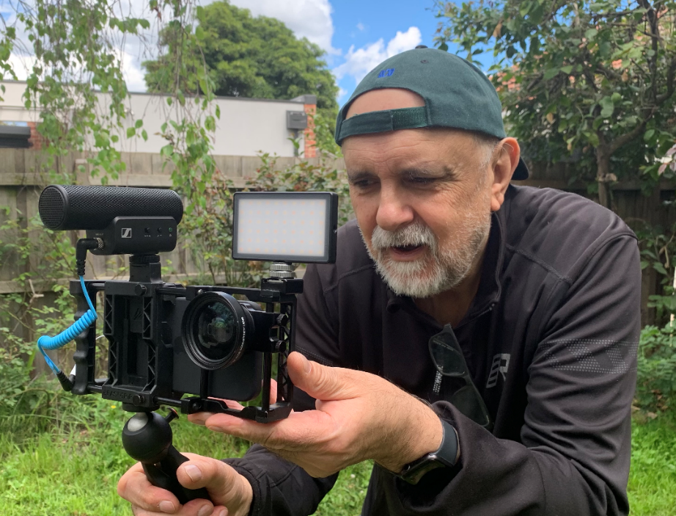 | Figure 1  Ivo Burum using kit with Sennheiser MKE 400, Panel Mini light, Beastgrip Pro (with Kenko lens) and Manfrotto PIXI tripod (Photo credit: Ivo Burum)

If you are close enough to your subject, with little or no background noise, the microphone on your smartphone, or the one on your headset should get you out of trouble. However, using third-party microphones can dramatically enhance audio quality:

(1) SHOTGUN or directional microphones with super-cardioid patterns that predominantly record sound in front of the microphone capsule are essential for all handheld close-quarter, run and gun mojo filming. I’ve been using an industry standard, the Sennheiser 416, for about 25 years. However, it’s a bit big for mojo work and a better option for on camera run-n-gun work might be the Sennheiser MKE 400 shotgun microphone ($199.95USD). A metal-bodied mic with a super-cardioid pattern, it records in front and behind the capsule. Optimised for speech, it has attenuation and runs for an incredible 100 hrs on two AAA battery. I have been using the earlier version for about 6 years.

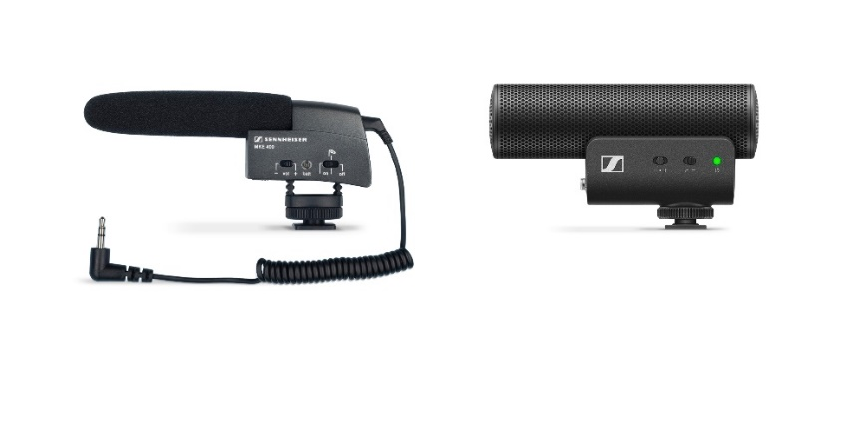 | Figure 2  Previous Sennheiser MKE 400 and the new version
The new Sennheiser MKE 200 ($99.95USD) is a cheaper, smaller version of the 400 — no battery required, in-built mesh wind protector, internal shock mount, it ships with TRS to TRS and TRS to TRRS cables and a windsock. A stubby metal-bodied microphone, its small size makes it ideal to use with smartphones and small-bodied DSLR cameras. Its sturdy design and the fact that it doesn’t use a battery, makes it fail-safe and ideal for schools and student kits.

(2) LAVALIER microphones with an omni-directional pattern are excellent for sit-down interviews. They are clipped to an interviewee’s lapel 6-8 inches from their mouth and can be placed on a desk between two interviewees.

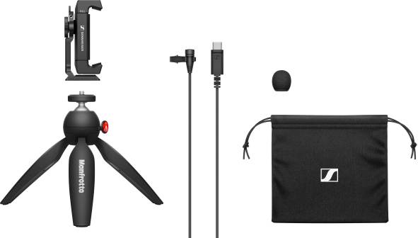 | Figure 3  Sennheiser XS Lav USB-C Mobile Kit

Sennheiser’s new XS Lav Mobile ($49.95USD) is a lapel microphone that you can wear on your shirt. Intended for mojo work it comes with a mini jack that fits most smartphones, or in a USB-C configuration ($59.95USD) for devices using that connection. It also comes in a combo kit that includes a phone clamp with multiple fixing screws and a Manfrotto PIXI tripod, all for under $100USD. Less than a good dinner. I like the XS Lav because its cable is longer than most lapel mics and can more easily be hidden.

Ivo’s tip: Choose a lapel mic with a longish cable, or buy a short extension, so that the cable can be hidden out of shot.

(3) WIRELESS MICROPHONES are used to record audio where the source is some distance from the smartphone, like on talent moving in a demonstration, on a boat or a walk-and-talk interview.

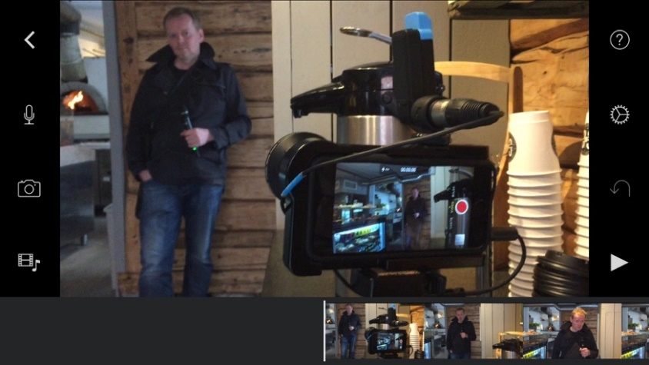 | Figure 4  Norwegian journalist recording a stand-up using an iPhone and Sennheiser AVX Combo Set wireless system  (Photo credit: Ivo Burum)

My advice is to buy the best wireless or radio microphones you can because you’ll keep them for some time. Here are a couple that Sennheiser produce that I use:

Sennheiser AVX Combo Set ($1049USD) is a favourite because of its functionality and its compact size. This combo kit includes a handheld microphone as well as bodypack and lapel microphone. The reduced size makes the AVX wireless system ideal for mojo work, range is over 100 metres. I use this set a lot and recommend it highly for mojo work. Here’s an article and video on the AVX: http://smartmojo.com/2015/09/17/sennheiser-avx-combo-first-look/
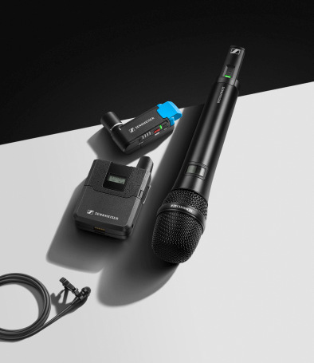 | Figure 5  Sennheiser AVX Combo Set

The Sennheiser XSW-D ENG Set ($470USD) is a small digital kit in the 2.4GHz band, that includes plug-on transmitters for any dynamic mic and the included ME2-II omni-directional lapel condenser mic. Rechargeable batteries with 5 hours run time. Link up to five systems. I have tested it effectively to beyond the 75m range that Sennheiser recommends.

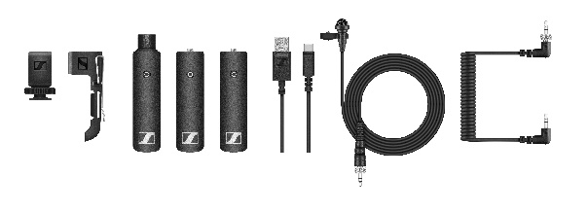 | Figure 6  Sennheiser XSW-D ENG Set

Recently, Sennheiser has added the XSW-D Portable Lav Mobile Kit ($329.95USD) to its portfolio, which includes a mobile-optimised connection cable.

Figure 7  Sennheiser XSW-D Portable Lav Mobile Kit with optimised 3.5mm TRRS cable | 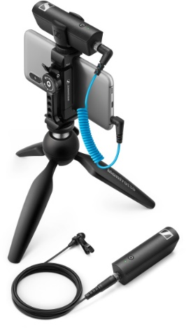

Ivo’s tip: Sit your subject back to the wind to shield the lapel microphone that’s attached about 8 inches below the subject’s mouth. Or, if using a shotgun-type microphone, put the mobile journalist’s back to the wind when recording an interview. They shield the microphone and any wind that gets past will hit the back of the microphone.

Camera Cradles and Lenses
Cradles enable a steadier shot when working handheld and provide attachment points for lenses, microphones, lights, and tripods. Attaching a wide-angle lens to the cradle adds stability and enables mojos to get closer to their subject while maintaining a medium close-up (MCU) interview frame. Being close to the sound source improves audio quality. New smartphones ship with effective stability optics and electronics and a variety of onboard lenses, so cradles are not always needed. In fact, sometimes their bulk can paint a mojo who’s working in conflict zones, as a target. If you require attachment points and don’t need additional lenses, then a cheaper clamp, like those in the Sennheiser Mobile Kits, might be for you.

There are many cradles, or rigs on the market. I use the Beastgrip Pro bundle ($248USD), which includes their Kenko Pro series 0.75 wide-angle lens. I like the additional weight that I’m used to that gives my smartphone a heavier feel, making it easier to control when shooting handheld. If you are teaching mobile storytelling at a school or university and need to supply equipment to students, who use a range of phones, Beastgrip Pro is a strong contender because it takes a variety of phones. Another cheaper effective option is the smaller, cheaper mobile kits and clamps.

Ivo’s tip: When cradles are loaded with smartphone, light and microphone, they make the mojo look more professional. In conflict regions all that gear can cry out ‘target’.

Tripods
I use a short Beastgrip BT 50 tripod ($60USD) that can be attached to a cradle and used as a handle to help stabilize shots. I also use a Manfrotto PIXI tripod ($35USD) and love it because of the red articulation button that makes it quicker to adjust than the BT 50. If you need extra height for a stand-up, stick it on a car roof, a wall, or on a filing cabinet. I also use a Pro Master Professional XC525C Carbon tripod ($390USD) because it’s light, folds relatively small and has a removable monopod leg.

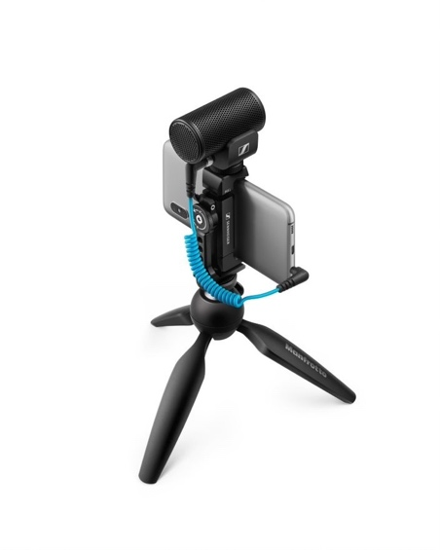 | Figure 8  Less obtrusive Sennheiser MKE 200 Mobile Kit using Manfrotto PIXI Tripod

Lights
On-camera lights come at various price points from $30USD to $250USD. I look for the ability to choose intensity settings because interviewees can find bright light distracting. I use a Manfrotto Lumimuse 8 ($140USD). I also use a Lume Cube Panel Mini ($59.95USD). It’s the thickness of a bunch of 10 credit cards, has adjustable colour temperature ranging from 3200K to 5600K and adjustable brightness from 1% to 100%, so you can avoid blinding your interviewee.

Gimbals
There are a number of gimbals on the market that enable the operator to walk or run smoothly with the smartphone. I use the DJI Osmo Mobile 3 ($99USD), because it’s cheap (most are a similar price), folds up, is easy to use for occasional operators. Find one you like and buy that.

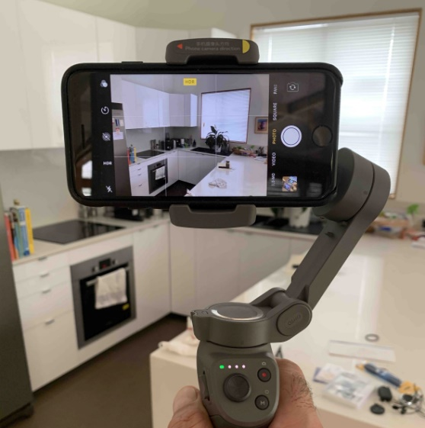 | Figure 9  Osmo Mobile 3 gimbal  (Photo credit: Ivo Burum)

Mojo Kit
You can make up your mojo kits depending on your need and the amount of money you wish to spend. Here are examples of a basic, intermediate and advanced mojo kit. You can of course mix and match the level of equipment and brands, depending on your requirements and price points.

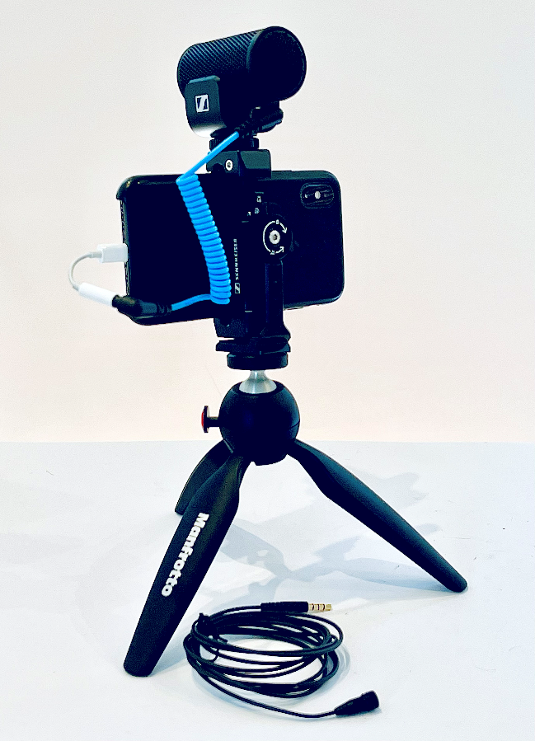 | Figure 10  Basic Kit  With iPhone XS, MKE 200 Mobile Kit (includes Manfrotto PIXI and Smartphone Clamp), XS Lav Mobile clip-on mic, and TRRS to Lightning adaptor  (Photo credit: Ivo Burum)

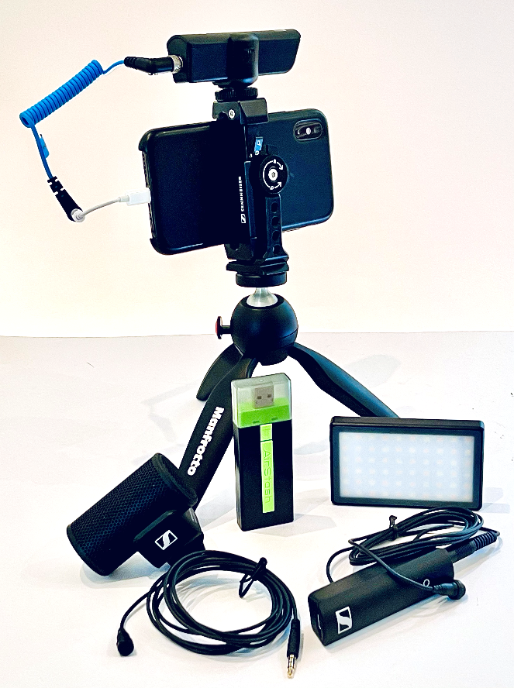 | Figure 11  Intermediate Kit  With iPhone XS, XS Wireless Digital Portable Lav Mobile Kit (includes Manfrotto PIXI and Smartphone Clamp), MKE 200 vlogging microphone, XS Lav Mobile clip-on mic, Airstash, Lume Cube Panel Mini, and TRRS to Lightning adaptor  (Photo credit: Ivo Burum)

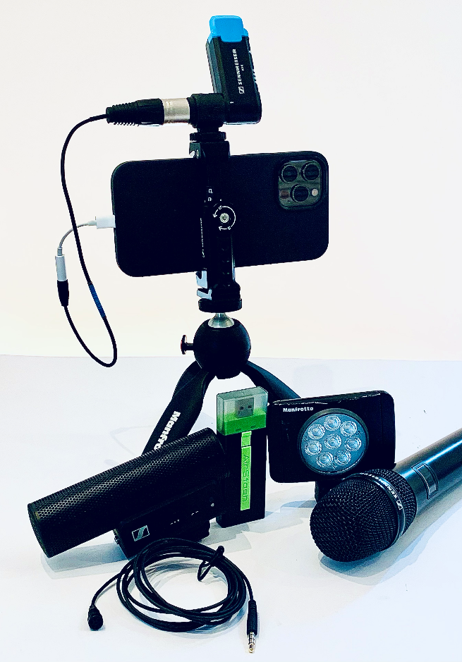 | Figure 12  Advanced Kit  With iPhone 12 Pro Max, MKE 400 Mobile Kit (includes Manfrotto PIXI and Smartphone Clamp), AVX wireless microphone system, XS Lav Mobile clip-on mic, Manfrotto Lumimuse Light, Airstash, TRS and TRRS to Lightning adaptors  (Photo credit: Ivo Burum)

Apps
The app industry began in 2008 after the launch of the iPhone. Today, there are more than six million apps for Android, iOS, and other platforms.

Camera Apps
I use the native camera app that ships with the iPhone, except when I need a higher level of control, in which case I use the following:

- Filmic Pro ($19.99USD) for iOS and Android is the most used advanced video camera app, with separate white balancing, light metering and focus points, variable frame rates, bit rates and real-time audio monitoring.

Figure 13
Filmic Pro app

- Camera+: is arguably the best stills camera app on the market, with high-level image control, stabilizer, separate exposure and focus settings, white balance, and control over brightness, colour and sharpening ($2.99USD)

Ivo’s tip: Learn to shoot with the camera app that ships with your phone and concentrate on exposure, framing, and recording shots that tell a story. When you run out of functionality, look for a more powerful app.

Sound Apps
I record audio using my camera app. If you need 96kbps audio, Lossless (ALAC/CAF) or Wave formats, you might try one of these two excellent audio apps:

- Ferrite (iOS) is probably the best audio app I have used because it is very user-friendly and the free version gives you so many features that you may never need the paid one.
- Rec Forge ii is an excellent full-featured Android audio recording app that I find a little complicated and so do my students.

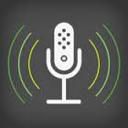 | Figure 14  Ferrite app

Edit Apps
The following are the most functional edit apps on the market for advanced mojo work:

Figure 15
Edit apps iMovie, Kinemaster and Luma Fusion

- iMovie ships with the iPhone and was one of the first apps to offer multiple video tracks. It provides all the features you need to edit professional stories quickly but lacks a powerful titling tool and keyframe audio ducking. It includes Green screen (chroma). Great app to learn on (free).
- LumaFusion is the relatively new kid on the iOS block and probably the most powerful of the edit apps. It has six video and six audio tracks (plus six embedded), slip-trim and anchored edit features, colour correction, layered titles, keyframe audio and is optioned like a professional edit suite. It’s a fully featured edit app that trumps many desktop editors ($29.99USD).
- Kinemaster was the first professional smartphone edit app loaded with features that works across iOS and Android platforms. It includes Chroma key, an easy-to-use titling tool, blur, audio manipulation and lots more. Kinemaster is free and adds features and removes the watermark for a subscription cost of $39.99USD.
- VN is another multi-track cross-platform edit app that enables good control over vision and audio, has four video and multiple tracks of audio, easy-to-use titles tool, keyframes, animation and much more, all for free, without a watermark. VN also has a PC version.
- Power Director is another fully featured cross-platform edit app that enables multiple video and audio tracks, powerful effects, on-board grading facilities and playout at 4k. Free to install, then $56.99USD per year subscription. Has a desktop version.

Key features to look for in edit apps:
Multitrack Video: an app with at least two video tracks.
Multitrack Audio: Look for at least three audio tracks, plus the in-video audio.
Audio Mixing: All five apps include an audio mixing tool. The least effective is iMovie.
Audio Ducking: Involves selecting audio keyframes to lift or lower specific audio levels at key points.
Transitions: An ability to make a variety of transitions between video clips and audio tracks.

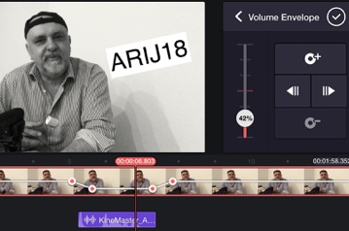 | Figure 16  Audio Ducking  (Photo credit: Ivo Burum)

Chroma Key: A number of the apps described above offer Chroma Key facilities. Below is an example of Chroma Key (Green Screen) on Kinemaster. The composite was made by shooting the journalist against a green screen then shooting a Wide Shot (WS) of the city before keying the city into the green screen. Having worked in TV for years, these facilities available on a smartphone are game changing.

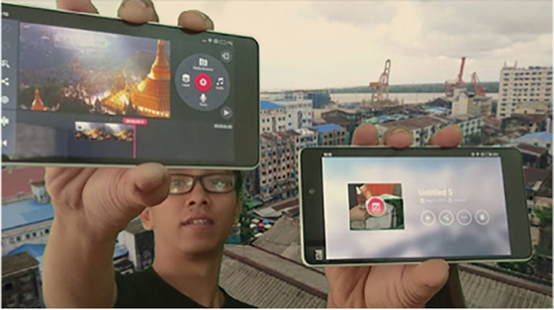 | Figure 17  Kinemaster Green Screen  (Photo credit: Ivo Burum)

Titles: Kinemaster and Luma Fusion include powerful title tools with a variety of fonts. iMovie Titles are rudimentary and when using iMovie, I generally import the finished video into Kinemaster, Luma Fusion or VONT to do a titles pass.
Subtitles: I often use the Kinemaster and Luma Fusion titles tool to create subtitles. However, I also use two discreet subtitling apps:
- DIY Subtitles is a manual app that creates titles relatively easily.
- Mixcaptions creates subtitles automatically and it works well enough to save time. It offers several font styles and three sizes. Once the app has created the subtitles, you can alter those that are incorrect.
Video Grading: I use Video Grade ($6USD) which has 14 functions for fixing underexposed or incorrectly balanced media. Many edit apps have on-board grading functionality.

Transfer Devices
Smartphones get clogged with media and we often delete valuable content to free up space. Don’t delete your media — you might need it to update your story, or to sell. I use transfer devices to shift and store media and clean out my smartphone. A Lightning version for iOS devices is iXpand by Sandisk; Airstash by Maxell is a WiFi version that works across platforms.

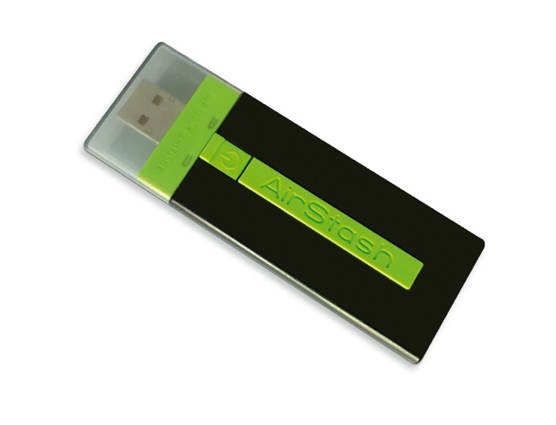 | Figure 18  Airstash  (Photo credit: Ivo Burum)

Ivo’s tip: Do not delete media from your smart device until you have rendered your edit project, your timeline, into a video!

Battery Pack
- I use the Powerstation AC at 22000mAH ($199USD) that gives me between 24 and 100 extra hours of power.

Go mojo…

