10 May 2021 – Press Release

D'Ieteren pledges to reduce CO₂ emissions by 50% by 2025 and implements ambitious action plan

Meanwhile, D'Ieteren offsets emissions and aims to go carbon-neutral

The goal of reducing the company’s carbon footprint is one of the two flagship commitments in D'Ieteren's sustainability strategy, which is working towards developing sustainable and fluid mobility for all.

The D’Ieteren group's mobility branch aims to halve the carbon footprint of its business activities by 2025, taking concrete action involving its vehicle fleets, logistics and energy consumption. In addition to these campaigns, the company has begun offsetting its CO₂ emissions and is now carbon neutral.

Denis Gorteman, CEO: "Our commitment to reduce our CO₂ emissions via our stringent action plan is very ambitious, even exceeding the Paris Agreement objective of limiting the temperature rise to 1.5 °C. Despite an uncertain economic environment, we do not want to sidestep the challenges of social sustainability and are investing for the future. As the leader in our industry, we wish to extend our leadership position to the field of social responsibility."

D'Ieteren is also firmly committed to promoting equal opportunities and inclusion. Diversity is a factor in innovation, performance and quality of life within the company, which serves more than 1.2 million customers.

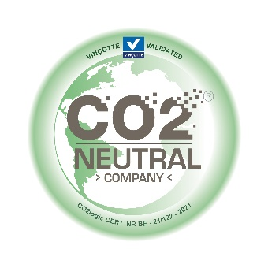

Where are we now?
D’Ieteren has been measuring its CO₂ emissions and working to reduce them for more than 10 years now. However, in view of the climate emergency, the company decided to step up its ambitions.
In 2020, D'Ieteren reduced its CO₂ emissions by 20% compared to 2019, the year used as the baseline for the 2025 carbon target.
This reduction is due, in part, to the lower volumes of new vehicles and spare parts delivered to dealerships and the increase in teleworking due to the health crisis.
The challenge facing D'Ieteren is to contain the growth of its emissions as the situation gradually returns to 'normal', while rapidly implementing high-impact and sustainable CO₂ reduction actions to achieve the 2025 target.

D’Ieteren's carbon footprint
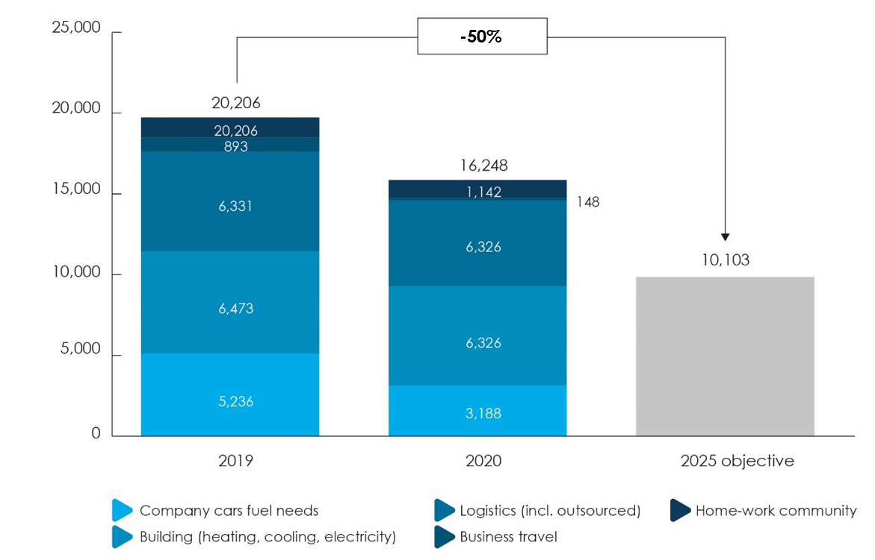

The carbon footprint covers scopes 1 and 2 as well as the most relevant aspects of scope 3, the activities of D'Ieteren Automotive SA and D'Ieteren Centers SA. The carbon footprint has been calculated by CO2Logic since 2010 and was audited by PriceWaterhouseCoopers for 2020.

Practical actions
The Group has been implementing practical initiatives since early 2021, while others are being analysed and/or developed.

Initiatives launched in the first half of 2021
- Exclusive use of green electricity, which will reduce emissions by around 1,000 tonnes of CO₂.
- Accelerated implementation of the green mobility policy for staff. Moving beyond initiatives already launched to facilitate multimodality, promote carpooling and even contribute to the financing of electric bicycles, D'Ieteren is shifting into high gear to electrify its vehicle fleets and encourage staff to purchase electric or hybrid vehicles.
  - In addition to equipping its sites with more charging points, D'Ieteren is installing standard charging points in the homes of those employees that have a company car.
  - The charging points are being installed by its subsidiary EDI (Electric by D'Ieteren) which, in addition to supplying the charging point, enables users to use their recharging card to access the largest public recharging network in 25 European countries, while providing split billing services (i.e. re-invoicing the company for electricity consumed at home for recharging vehicles).
- Encouraging structural teleworking, allowing those employees whose job so allows to work three days a week at home (instead of two, as was the case before the health crisis). To encourage teleworking, D'Ieteren provides flat-rate allowances to cover Internet service, electricity and/or heating costs and equips its staff with appropriate office and IT equipment. These measures come on top of training and advice on remote team management, work-life balance and ergonomics, as well as a growing number of communication campaigns.
- Overhauling the emergency spare parts delivery system for dealers based on more efficient order planning, making it possible to reduce the number of trips made without compromising customer service.

Other projects to reduce CO2 emissions are under way.
Since the aim of reducing emissions by 2025 is ambitious, a great many projects will be implemented in the coming months and years.
These include reducing surface area occupied, especially for retail activities, and redeveloping sites, such as the D'Ieteren distribution centre in Erps-Kwerps, with two objectives in mind:
- maximising the energy efficiency of buildings;
- introducing new ways of working that promote both teleworking and on-site meetings for collaborative work.
To develop an increasingly green staff mobility policy, D'Ieteren has also decided to join forces with Mob Box – the Group subsidiary specialising in supporting companies by providing mobility consultancy – to conduct detailed research into its employees' mobility habits and then take appropriate measures to reduce CO₂ emissions while optimising employee satisfaction.
Using green electricity to recharge employees’ vehicles at home and while teleworking is another project currently under study.

These initiatives supplement a range of pro-environment actions that have been pursued for several years now.
Since 2006, D'Ieteren Group – via its estate subsidiary D'Ieteren Immo – has been pursuing a broad programme of actions to reduce the carbon footprint of its real estate assets by reducing energy consumption (monitoring facilities and optimising their performance), generating green power on its sites and storing the energy it produces itself.

Offsetting emissions that are currently unavoidable
In addition to actions taken to reduce the carbon emissions of its business activities, D'Ieteren takes responsibility for that part of its climate impact that cannot be reduced and is investing in offsetting emissions produced in 2020 via VCS-certified carbon credit projects. In partnership with CO2Logic, D'Ieteren supports two types of projects, one allowing the absorption of CO₂ emissions by supporting a conservation project, the other aiming to prevent CO₂ emissions by generating renewable energy.

Guatemala rainforest conservation project
The Sierra del Lacandón national park in Guatemala is home to stunning biodiversity, but every year the park loses its forest cover due to poor agricultural practices, fires caused by burning techniques and illegal deforestation. Thanks to D'Ieteren's support for the project, it is possible to implement effective measures to tackle each of these challenges. As a result, it is helping to protect nearly 2,600 hectares of primary forest, i.e. nearly 2.3 million trees which will continue to play the vital role of absorbing and sequestering CO₂, while also protecting many endangered species.

Renewable energy development project in India
India's power grid is heavily dependent on power plants that burn fossil fuels, such as coal, and therefore emit huge amounts of CO₂. As a result, the Indian energy sector contributes a great deal to climate change and air quality issues. The project D'Ieteren is supporting aims to develop a network of wind turbines that will supply the power grid with clean, renewable energy while encouraging the transition to a low-carbon economy. Thanks to this contribution it is already possible to guarantee the production of nearly 780 GWh of renewable energy and provide sustainable electricity for more than 720,000 Indian families.

Antoine Geerinckx, Founder CO2Logic: "We award CO₂-Neutral Certification to organisations that calculate, reduce and offset their impact on the climate. Since 2015, this label has been validated by Vinçotte – an independent third-party certifying body – with a view to avoiding meaningless environmental declarations. The CO₂-Neutral label is not only beneficial for our planet, but also ensures that labelled companies receive recognition for the real efforts they are making on behalf of the environment. Well done, D’Ieteren!"

Denis Gorteman, CEO D'Ieteren: "A company's social responsibility is only consistent and effective if, firstly, it is part of the company's strategy, and secondly, it involves its staff in its proactive approach. At D'Ieteren, we are all working towards the mobility of the future by deploying our skills and know-how to serve our customers and rolling out services that promote a sustainable lifestyle."

Thanks to the initiatives we are taking to reduce and offset our CO₂ emissions, D'Ieteren is helping to achieve the United Nations' three sustainable development goals.
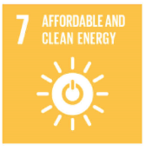
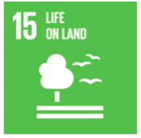
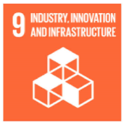

Our sustainability strategy
Mobility is not only our business, but also a social issue. That means we are particularly well placed to deploy our expertise and know-how to benefit our customers, partners, employees and society in general. We aim to be the benchmark and a source of inspiration when it comes to sustainable mobility. Being responsible also means promoting sustainable growth for all and minimising our environmental impact. Our two priority commitments dovetail perfectly with this global approach.

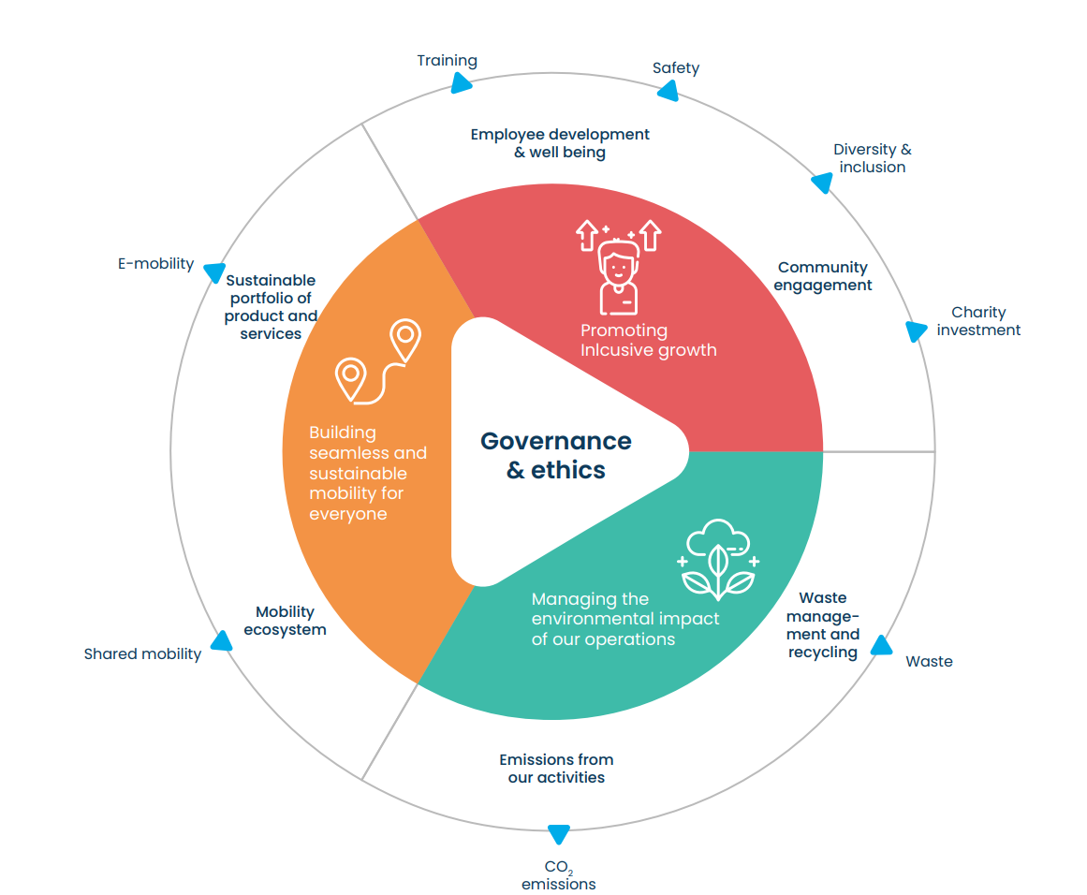
Our approach

Insérer les SG

Our priority commitments:
- Maximally reduce our CO₂ emissions
- Promote equal opportunities and inclusion

