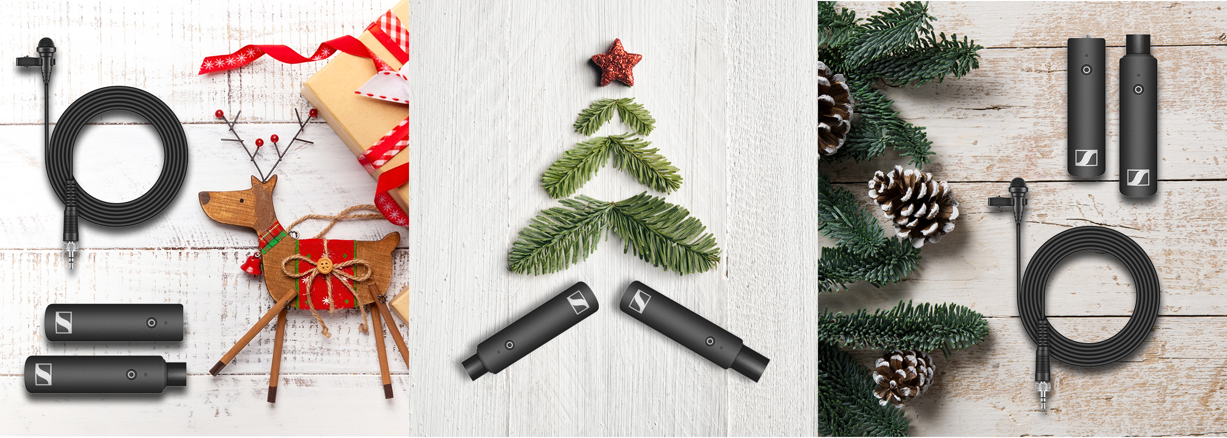

PERFECT SOUND FOR THE MOST BEAUTIFUL MOMENTS

Wedemark, November 2019 – If your passion is capturing beautiful moments, the holiday season presents a wealth of opportunities. As well as recording stunning visuals, to truly capture the magic, great sound is crucial. Why not surprise family and friends this Christmas with equipment that lets videos of these special times truly sparkle with excellent sound? From hobbyist to experienced professionals, Sennheiser’s microphone range provides the perfect gift for every filmmaker.

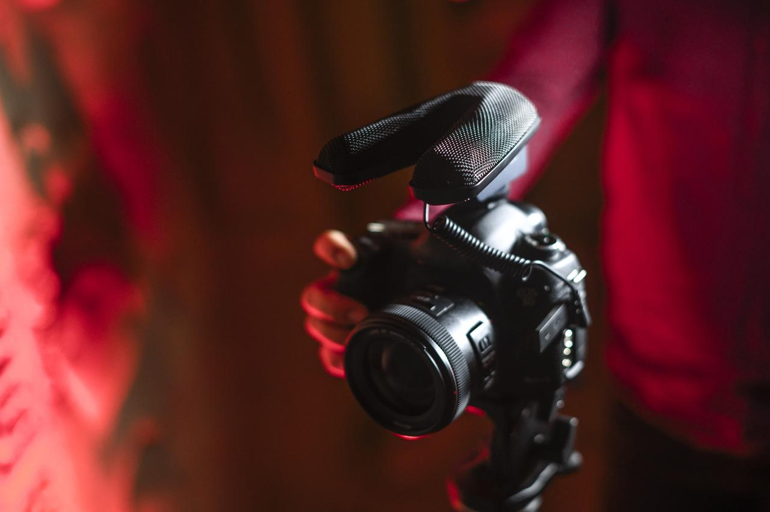 | What you see is what you hear  MKE 440 Stereo On-Camera Microphone  + Two matched mini shotgun mics capture the audio you want, while rejecting sound outside the camera angle  + Robust and compact all-metal construction  + 3-level sensitivity adjustment and low-cut for perfectly levelled festive sound  MSRP: EUR 349 / GBP 289 / USD 349.95  + Get the MZH 440 fur windshield for winter field recordings at EUR 49 / GBP 41 / USD 49.95 (MSRP)

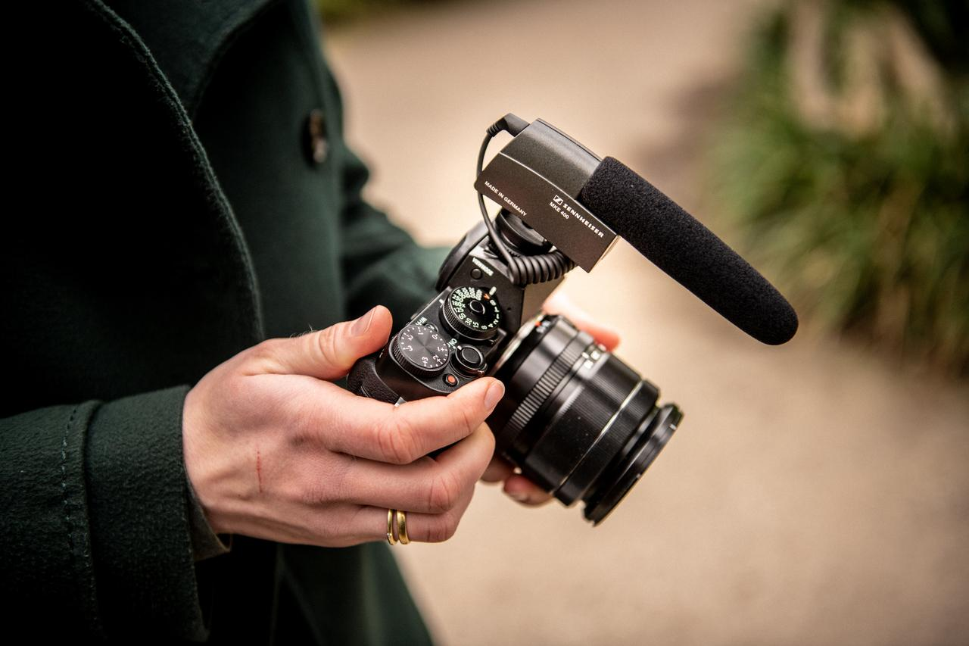 | Heavenly sound without side effects  MKE 400 Mini-Shotgun On-Camera Microphone  + Thanks to its compact size and good side noise rejection, this mini-shotgun microphone is ideal for recording those festive moments  + Perfectly levelled sound due to switchable sensitivity for long and short distances  + Integral shock-mount for rejection of handling noise  + Extremely robust with an all-metal housing  MSRP: EUR 199 / GBP 169 / USD 199.95  + Get your MKE 400 the MZW 400 professional accessory kit for Christmas: With the included hairy windshield, it’s more than a match for wintery snow flurries!  MSRP: EUR 39 / GBP 33 / USD 39.95

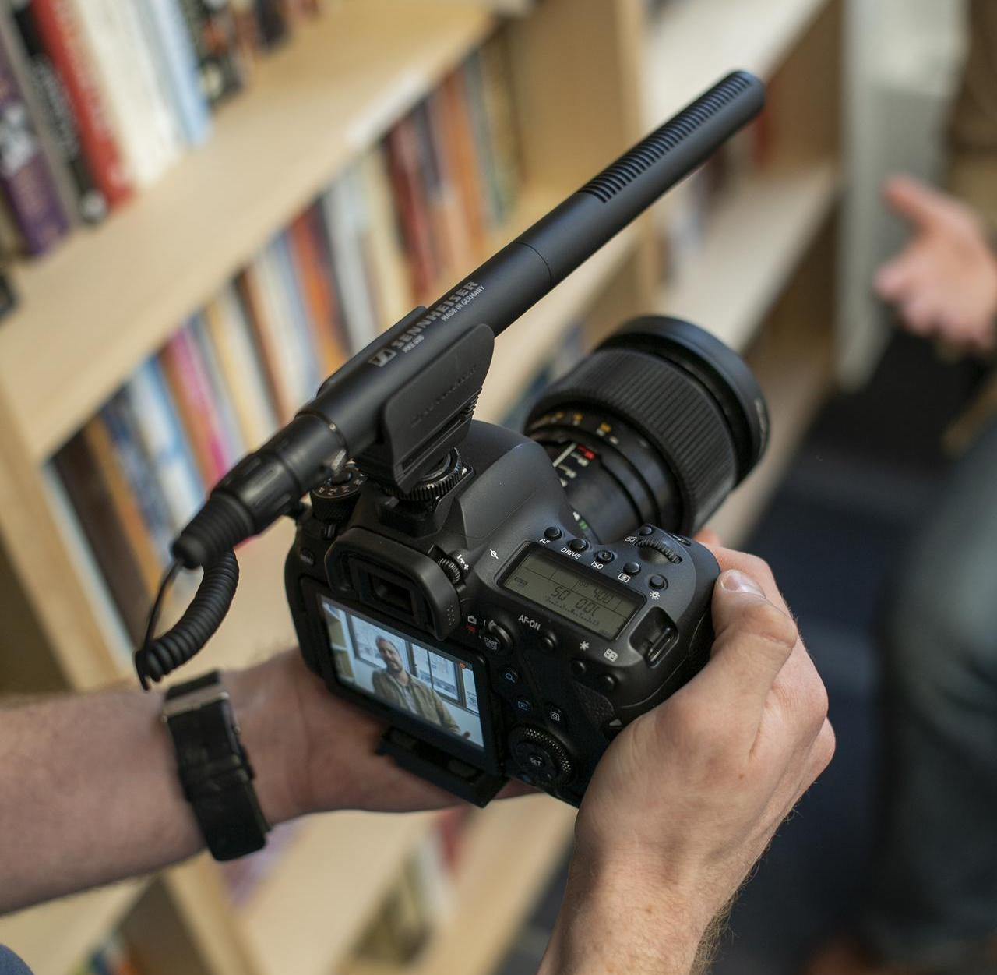 | For demanding filmic challenges  MKE 600 Shotgun mic  + Picks up sound from the direction the camera is pointing, thanks to its high directivity  + Strong suppression of structure-borne noise; switchable low-cut filter to reduce wind noise  + To enable you to tailor the shotgun mic to your camera, order the cable separately: get the KA 600 cable for DSLRs/DSLMs with mini-jack audio input, the KA 600i for smartphones with a mini-jack or a standard XLR cable for professional cameras  + Your choice for outside recording in winter wonderland: the MZH 600, a combined foam windshield and hairy cover  MSRPs: MKE 600: EUR 299 / GBP 249 / USD 329.95  KA 600 and KA 600i connecting cables: EUR 13 / GBP 11 / USD 19.95  MZH 600: EUR 49 / GBP 41 / USD 69.95

Creating lasting memories

Memory Mic
+ High-quality audio for your smartphone recordings
+ Memory Mic works with a dedicated app, downloadable from the App Store or Google Play
+ Simply clip the mic to the clothing, records audio at any distance from the smartphone
+ Automatically synchronizes the audio with your smartphone video
MRSP: EUR 199 / GBP 169.99 / USD 199.95

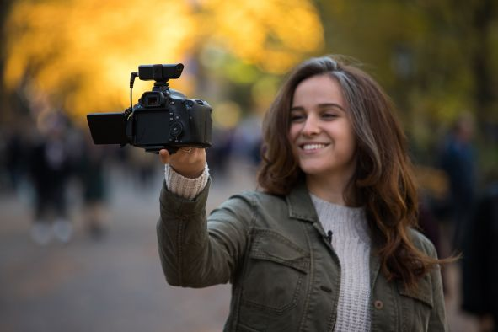 | An instant connection  XS Wireless Digital Mic System  + The ideal wireless audio partner for your DSLR or DSLM lets you capture speech with clarity  + 2.4 GHz transmission for worldwide, license-free operation  + Instantly ready for recording with one-touch ease of use – you won’t miss a single moment of your party with family and friends  + Prefer to use this mic with your smartphone? A TRS to TRRS adapter will do the trick  + Various sets provide the perfect equipment for the most common applications, for example the pictured XSW-D Portable Lavalier Set: EUR 349 / GBP 289 / USD 349.95 (MRSP)

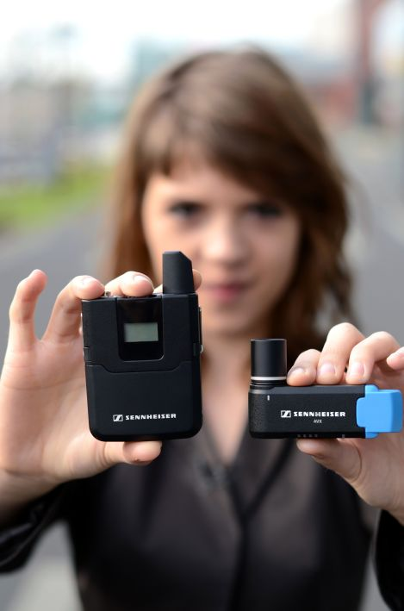 | Full focus on festive pictures  AVX Digital Wireless Mic System  + Match to your camera once and enjoy perfectly levelled sound for all recordings, whether during silent nights or at loud parties  + Ideal for DSLRs/DSLMs or professional cameras, operates license-free in the 1.9 GHz range  + Never worry about interference again: AVX selects the best operating frequency automatically and inaudibly  + Various sets let you choose between lavalier mic, handheld mic or both, from the AVX-ME2 SET at EUR 699 / GBP 589 / USD 699 (MRSP) to the fully-fledged  AVX-Combo SET at EUR 999 / GBP 839.00 / USD 999.00

: https://sennheiser-brandzone.com/c/181/zoyDzE7y.

About Sennheiser
Shaping the future of audio and creating unique sound experiences for customers – this aim unites Sennheiser employees and partners worldwide. Founded in 1945, Sennheiser is one of the world’s leading manufacturers of headphones, loudspeakers, microphones and wireless transmission systems. Since 2013, Sennheiser has been managed by Daniel Sennheiser and Dr. Andreas Sennheiser, the third generation of the family to run the company. In 2018, the Sennheiser Group generated turnover totaling €710.7 million. www.sennheiser.com

Local press contacts
Sarah James Victoria Chernih
sarahj@gasolinemedia.com.com victoria.chernih@sennheiser.com
+44 1483 223333 +44 7881 091687

