# Music Tech Book Publisher Bjooks Donates 50+ Copies of *THE MINIMOOG BOOK* to Synth Education Non-Profit

Each book donated to the Bob Moog Foundation will serve as a valuable resource for electronic music education, honoring the legacy of innovator Dr. Bob Moog.

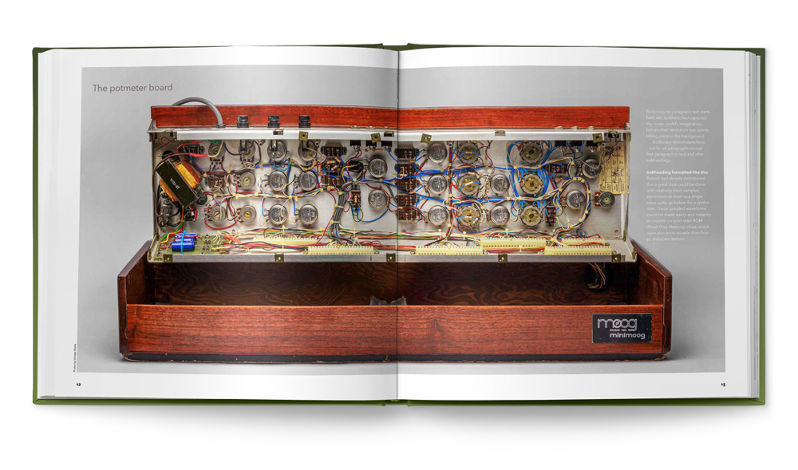

**Asheville, North Carolina, May 22, 2024** — Independent book publisher [Bjooks](https://u14456542.ct.sendgrid.net/ls/click?upn=u001.0i-2FJ-2FedkxMGDABIl5kmwiPPkuL-2Fy9xz6dTa4Hrnyxtw-3DCJdK_-2Fa7tUViJZo-2BwdGxm1M2lA0HjtVgga76-2FU77aHNfri9EP1zXfJcFeSUteaA5elM9BRi278uiRqh-2FCpUAf5hBTmgm5EyU6FoTXbCuCupB0c3vIC2RUvRvcJDO1pKCdCzGoRFRd-2FcaEZhRuTtM70wf3F26CVQcjdcuZXJS2jSOv44jcZEDy-2FQHm4eE1ttl6969-2F3BergUcZFopTDdKou7OdH9X7hML6MvuCcII-2FWzwmuneM3djAXu-2BtF5OfFJWaFBMp68umSxNBjTg2bM-2BX-2BctKsM1cEvYo-2Fd823c5Th5JCZrp-2BQwwgowKHnMuMK8e7nWxujtdPfbTxWO0WY5OLIlrm3Khy3-2FIkp8Tgeq1gcdxdUfcszhLVcc38vtlgTy6K98P7s-2B4z-2BuEYEeomJGYI3d-2BfopByOaFZlPRwyiAdoXiPjhpGHOR61H-2FwamQIleGDDttB3rEICtZ8cuZCBZwhEExTsLZAWJeS2mjFxRf4lIGeUlE-3D) has announced they will donate more than 50 copies of their new title, [*THE MINIMOOG BOOK*](https://bjooks.com/theminimoogbook), to the [Bob Moog Foundation](https://moogfoundation.org/) and its [Moogseum](https://moogseum.org/).

The small Danish publishing company and Asheville, NC, non-profit organization have been longtime supporters of one another — both sharing educational missions at the intersection of music, history, and technology.

Bjooks’ generous book donation is in celebration of [the Moogseum’s five-year anniversary](https://moogfoundation.org/5-years-of-innovation-creativity-and-inspiration-at-the-moogseum) and synthesizer pioneer Bob Moog’s birthday, May 23rd, which is known throughout the electronic music community as International Synthesizer Day.

“On this date each year, many artists choose to reflect and show appreciation for one of the most influential inventors in modern music history: Dr. Bob Moog,” Bjooks founder Kim Bjørn stated. “His and Herb Deutsch’s invention of the Moog modular synthesizer in 1964 changed everything. It paved the way for now-ubiquitous instruments like Minimoog Model D and Voyager, which — in the hands and minds of creatives — have given us all some of our favorite sounds, songs, and live performance moments.”

[*THE MINIMOOG BOOK*](https://bjooks.com/theminimoogbook) has been a labor of love for Bjørn, author JoE Silva, editor Mike Metlay, and all collaborators involved with presenting this comprehensive work in a way that honors the legacy of Bob Moog, who would have turned 90 this year.

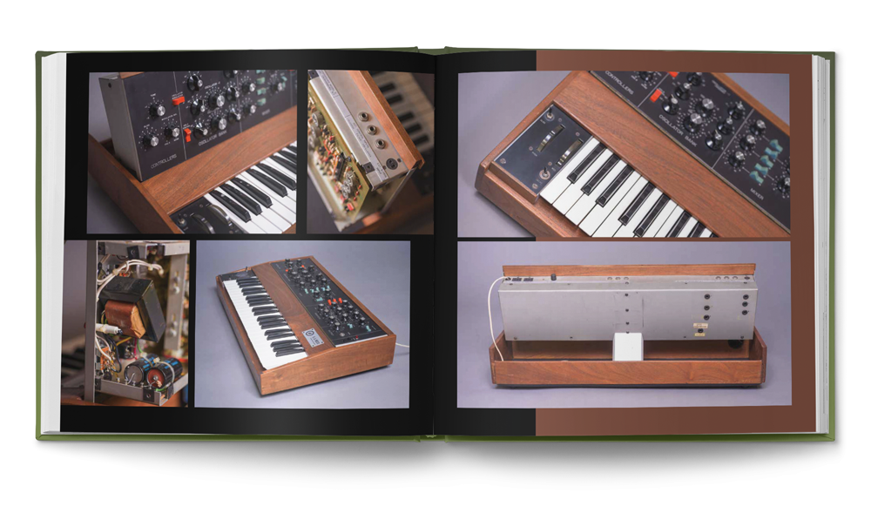

As the book details the journey of Moog’s most beloved instrument, it is a must-have resource “for anyone interested in the Minimoog, synthesizer history, and the evolution of contemporary music,” said Michelle Moog-Koussa, daughter of Bob Moog and Executive Director of the Bob Moog Foundation.

“I believe this book serves as an enduring reference and celebration of one of the most important developments in musical history,” Moog-Koussa continued. “It will certainly be a staple in my personal research library.”

To celebrate more than 50 years of the Minimoog’s influence since its debut in 1970, Bjørn has committed to donating a minimum of 50 books to the Bob Moog Foundation once the 368+ page work goes to print this summer.

*THE MINIMOOG BOOK* is currently [available to pre-order via Kickstarter](https://bjooks.com/theminimoogbook). Backers can purchase an early copy at a special price — and with exclusive materials and perks — now through May 27th, 2024.

For anyone interested in ordering an early copy of the book and supporting its production, [more information can be found here](https://bjooks.com/theminimoogbook).

**About Bjooks**

Bjooks is a boutique music tech publishing company started by author, designer, and musician Kim Bjørn. His first book, *PUSH TURN MOVE*, was published in 2017. This was followed by *PATCH & TWEAK* in 2018, which has since been referred to as the “Bible of Modular Synthesis.” Subsequent titles include *PEDAL CRUSH* (2019), *PATCH & TWEAK with Moog* (2020), *SYNTH GEMS 1* (2021), *PATCH & TWEAK with KORG* (2022), and *INSPIRE THE MUSIC*, released in cooperation with Roland Corp. on its 50th anniversary in 2022. Bjooks’ latest work, *THE MINIMOOG BOOK*, is now available to pre-order. Learn more at[bjooks.com](http://bjooks.com/).