a thrillingly immersive music experience
Sennheiser’s AMBEO Soundbar now supports Sony’s 360 Reality Audio

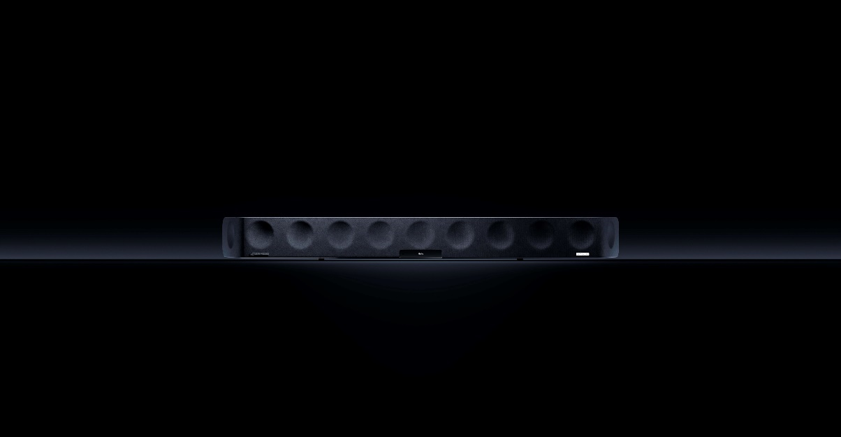

Marlow, UK, April 23, 2021 – Sennheiser’s award-winning AMBEO Soundbar delivers a thrillingly immersive sound experience and deep bass that has to be heard to be believed. In addition to 3D audio formats Dolby Atmos, MPEG-H and DTS:X, the soundbar now supports Sony’s 360 Reality Audio. This new music experience utilises Sony’s object-based 360 Spatial Sound technology to place individual sounds in a spherical sound field. Music created in 360 Reality Audio can be enjoyed through compatible streaming services.

360 Reality Audio is a new music experience that uses Sony's object-based 360 Spatial Sound technology. Individual sounds such as vocals, chorus, piano, guitar, bass and even sounds of a live audience can be placed in a 360 spherical sound field, giving artists and creators a new way to express their creativity. Listeners can be immersed in a field of sound exactly as intended by artists and creators, while music content created in this new format can be conveniently played back through compatible music streaming services.

With the latest firmware update, AMBEO Soundbar customers can access 360 Reality Audio content via Google Chromecast, allowing them to stream music in 3D without any additional devices. Currently, live music streaming provider nugs.net offers 360 Reality Audio via Chromecast, with additional services and content expected to follow.
“We are delighted our AMBEO Soundbar, with its amazing 3D immersive sound, now supports Sony’s 360 Reality Audio,” says Maximilian Voigt, Product Manager at Sennheiser. “Our customers can now stream music and enjoy exceptional spatial audio by simply downloading the latest firmware update without the need to purchase any additional equipment, for even more convenience.”

Award-winning AMBEO Soundbar
Sennheiser’s AMBEO Soundbar brings perfectly tailored 5.1.4 sound and powerful bass to any living room, without the need for additional speakers or an external subwoofer. In addition to 360 Reality Audio, it is compatible with Dolby Atmos, MPEG-H and DTS:X. Thanks to its Upmix Technology, the AMBEO Soundbar can also recreate stereo and 5.1 content in stunning 3D audio. The soundbar features five different pre-sets (movie, music, sports, news and neutral) tailored to a range of scenarios and content types, that precisely adjust not only the frequencies but also the 3D sound characteristics. Meanwhile, Sennheiser’s Smart Control App allows users to adjust acoustic settings via smart devices, including setting pre-sets, personalising the sound with the equaliser and selecting from three different AMBEO modes.

The listed company, product and service names are trademarks or registered trademarks of each company.

ABOUT SENNHEISER
Shaping the future of audio and creating unique sound experiences for customers – this aim unites Sennheiser employees and partners worldwide. Founded in 1945, Sennheiser is one of the world’s leading manufacturers of headphones, loudspeakers, microphones and wireless transmission systems. Since 2013, Sennheiser has been managed by Daniel Sennheiser and Dr. Andreas Sennheiser, the third generation of the family to run the company. In 2019, the Sennheiser Group generated turnover totaling €756.7 million.
www.sennheiser.com

Local Press Contact

Maik Robbe
Communications Manager UK, Ireland & Nordics
maik.robbe@sennheiser.com
T +44 (0) 7393 462484

