For immediate distribution

Ferrofish Announces Next-Generation Successors in the A32 Series with the A32pro & A32pro Dante Multi-Format Converters and Routers
The two new 32x32-channel AD/DA converters offer dynamic high-quality solutions for live sound, broadcasters and recording studios

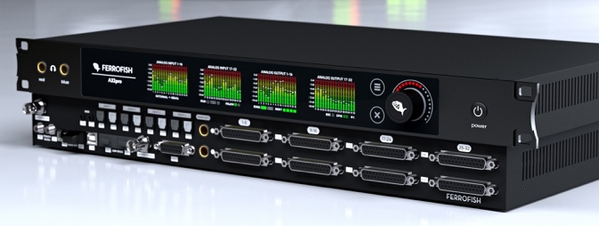
Fort Lauderdale, Florida, February 25, 2021 — Five years ago, Ferrofish launched its A32 Series, a set of flexible AD/DA and format converters, which quickly became one of the most popular converters in their class. Now, the leading German pro-audio manufacturer has announced the next-generation with the release of the A32pro and A32pro Dante continuing Ferrofish’s tradition of reliable, transparent audio devices with high-channel counts. The two new converters also feature a newly-designed black finish, an updated, intuitive front panel with remote control options, plus GPIO options for redundancy and DSP expansion — making them perfect for recording applications using long cable runs in live audio, broadcast or location-based recording.

The Future of Audio Conversion
Representing the culmination of Ferrofish’s extensive R&D developments over the last years, the new A32pro Series embodies the natural evolution of the company’s cost-effective and highly flexible AD/DA converters. By combining high analog channel-counts with extensive digital I/O and powerful signal routing — alongside options for redundancy and future upgrade paths — Ferrofish’s A32pro Series sets a new standard in high-quality with reliable signal conversation and distribution for modern recording studios, live audio playback systems and broadcast audio facilities.

With its wealth of I/O choices, the new A32pro Series can also operate as a highly flexible digital audio format converter and signal router. Audio signals can be freely converted between all analog and digital formats while being simultaneously routed to multiple destinations in blocks of 8 channels, allowing for use in a wide range of professional audio applications. Multiple Ferrofish units can be connected in series to provide an incredible number of audio channels in a comparatively minimal amount of rack-space as redundant power supplies ensure the reliability necessary for ‘mission-critical’ applications.
Dynamic Upgrades with Incredible Connectivity
Based on the new modular hardware platform and featuring the latest generation of AD/DA
converters from ESS Tech, the new A32pro and A32pro Dante pack an incredible amount of connectivity options into a single 1U frame. Both products feature 32 analog inputs and 32 analog outputs on fully balanced DSub25 connectors. On the digital side, both devices have support for up to 64 channels of MADI I/O via dual SFP slots, which can accommodate either optical or coaxial MADI SFPs and can run in tandem for added redundancy. Up to 32 channels of ADAT optical I/O is provided in each direction with full support to double sample rates of 96kHz.

A dual-slot bay is provided for future DSP expansions providing additional processing powered for both the A32pro and A32pro Dante’s on-board SHARC DSP processor. The new series also offers a selection of remote-control options including Ferrofish’s free companion app, REMOTEFISH, available on their website. REMOTEFISH debuted last year and allows for complete control over single or multiple Ferrofish devices, including all inputs, outputs, monitoring, routing and settings. Setting the A32pro Dante apart is that it includes 64x64 Dante I/O channels on dual Ethernet ports with redundant functionality.

Other features include a Stereo TRS Main Out with dedicated DAC monitoring path, 32x32 ADAT I/O channels on TOSLINK jacks with 96kHz support, 64x64 MADI I/O channels on LC Multimode SFP module, user exchangeable (with Optical Singlemode and Coax SFP module option available). The units feature Wordclock I/O on BNC connectors with proprietary jitter reduction circuit and MIDI I/O on 3.5-mm TRS connectors. The GPIO port is included for remote presets for switching and alert monitoring on dSub15. Also included is a dual stereo headphone 1/4” TRS outputs with HQ-amp modules and a dedicated DAC.

Beyond a highly intuitive four-screen multitouch user interface, the converters feature an illuminated touch sensitive high-res encoder.

For more information, visit ferrofish.com.

About Ferrofish
Known for its precision-engineered German technology, Ferrofish manufacturers high-quality, innovative advanced audio applications. From its class-leading A16 MK-II and A32 AD/DA converters to its Verto Series of intuitive Dante converters, Ferrofish is known for its premium conversion solutions that are ideal for a wide range of applications. For additional information, visit the company online at http://www.ferrofish.com.

About Synthax, Incorporated
Synthax Inc. is the exclusive USA distributor for RME digital audio solutions, Digigram broadcast audio systems, Appsys digital audio tools, Ferrofish advanced audio applications, myMix personal monitoring systems and ALVA cableware. We supply a nationwide network of dealers with these products for professional audio, broadcast, music industry, commercial audio, theater, military and government applications. For additional information, visit the company online at http://www.synthax.com.

Media Contacts:
Shelby Coppola
Public Relations
Hummingbird Media
+1 (203) 598-8167
shelby@hummingbirdmedia.com

Jeff Touzeau
Public Relations
Hummingbird Media
+1 (914) 602 2913
jeff@hummingbirdmedia.com

