Sennheiser to launch Control Cockpit release 4.0.0 at InfoComm Connected
Control and monitoring software now integrates the SpeechLine Multi-Channel Receiver and Digital 6000 wireless microphone series

Wedemark, 15 June 2020 – Sennheiser has announced a major update of its Sennheiser Control Cockpit, a software tool that makes daily work routines in controlling and monitoring large microphone set-ups a breeze. Besides design and usability enhancements, the latest version 4.0.0 now adds the ability to monitor the new SpeechLine Multi-Channel Receiver and the EM 6000 receiver from Sennheiser’s Digital 6000 series, in addition to evolution wireless G3 and G4, SpeechLine and the TeamConnect Ceiling 2 microphone. This makes the software a universal tool for corporations and education facilities. Version 4.0.0 can be downloaded here and experienced at the virtual InfoComm Connected from June 16 to 18.

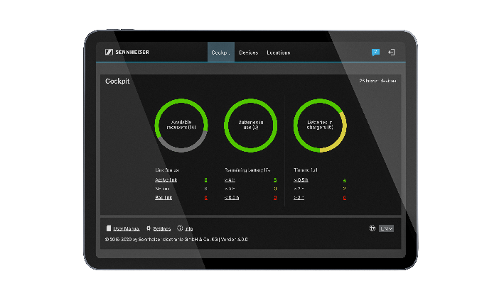 | Sennheiser Control Cockpit 4.0.0 is able to monitor the new SpeechLine Multi-Channel Receiver and the Digital 6000 wireless microphone series

Important software enhancements
Sennheiser Control Cockpit now features a “location-based Mute” functionality: All devices in e.g. a room can be grouped and their mute switches synchronized, so that all devices can be muted and unmuted together, either centrally via the Sennheiser Control Cockpit or locally on one of the devices. Location-based Mute is available for TeamConnect Ceiling 2 and SpeechLine Digital Wireless, including the new Multi-Channel Receiver. Also, the software now employs SSL encryption to make data transmission between the user interface and the host server even more secure.

The user interface of the software has had a refresh, too, and you can easily switch between Details View and Monitoring View. In addition, the software is now available in a Chinese language version.

Saving time, cost and effort
Sennheiser Control Cockpit provides centralized monitoring and control of Sennheiser microphone systems. Enabling remote device management as well as remote troubleshooting and support, Sennheiser Control Cockpit makes workflows and operation as easy as possible. The software provides IT staff with a real-time overview of all networked devices, including their location and status, and is accessible from anywhere in the network on all common platforms.

“The prime benefits of the software are easy battery management and remote troubleshooting,” explains Peter Grünert, Product Manager Software. “Whereas in the old days, IT staff had to walk to every single room and check the microphones on site, they can now take a look at the dashboard and quickly identify where action is really required. The same goes for remote troubleshooting – a look at the dashboard, and you can immediately see if a mute switch has been operated accidentally or the sensitivity changed unintentionally – and remedy this via the software.”

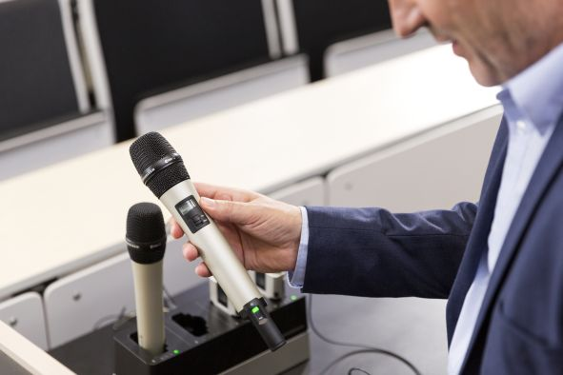 | Less to worry about for users and operators: Sennheiser Control Cockpit helps IT staff to ensure that mics are fully charged and in perfect working condition

InfoComm Connected
The new software version can also be experienced at InfoComm 2020 Connected, which will take place from June 16 to 18. Registration for the virtual show is free, and participants will have the opportunity to browse products, watch exclusive videos and schedule meetings with Sennheiser’s Business Communications team.

Following InfoComm Connected, Sennheiser will host a post-show webinar in cooperation with AVIXA on July 2 from 1:00 – 2:00 PM EDT. To register, please visit https://www.avixa.org/events/event-details/2020/07/02/default-calendar/webinar-modern-solutions-for-corporate-and-education-campus-wide-audio-by-sennheiser.

The images included with this press release can be accessed at https://sennheiser-brandzone.com/c/181/TcJhi1UK.

About Sennheiser
Founded in 1945, Sennheiser is celebrating its 75th anniversary this year. Shaping the future of audio and creating unique sound experiences for customers – this aim unites Sennheiser employees and partners worldwide. The independent family company, which is managed in the third generation by Dr. Andreas Sennheiser and Daniel Sennheiser, is today one of the world’s leading manufacturers of headphones, loudspeakers, microphones and wireless transmission systems. In 2018, the Sennheiser Group generated turnover totaling €710.7 million. www.sennheiser.com

Global Press Contact

Stephanie Schmidt
Stephanie.schmidt@sennheiser.com
+49 (5130) 600 – 1275

