Tune into Zen: Introducing the iFi ZEN DAC 3 for Every Listener
Southport, England— April 15, 2024—iFi Audio, a trailblazer in high-fidelity audio components, proudly introduces its latest innovation: the iFi ZEN DAC 3. Featuring a refreshed design and updated features, this home-based DAC has been designed to electrify gaming, casual listening, and critical audiophile experiences.

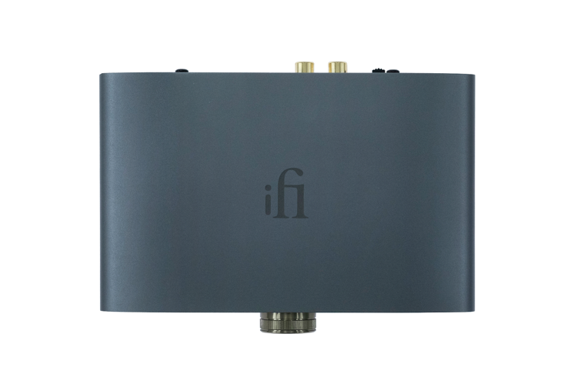

Amidst the hustle and bustle of modern life, the ZEN DAC 3 offers some much-needed zen in a world full of noise with something for everyone. Whether you’re a gamer looking to ignite your immersive gaming sessions, a casual listener or an audiophile with the desire to elevate your experience, the ZEN DAC 3 takes the listening experience to new heights with its unparalleled performance.

With its sleek design and uncompromising performance, the ZEN DAC 3 has been meticulously crafted to help users rediscover the purity of music and immerses listeners in a world of pure harmony.

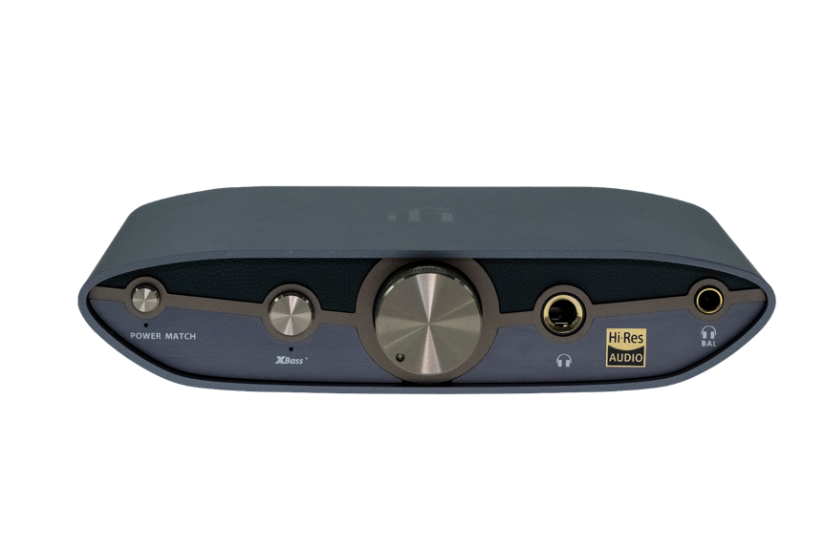

With both fixed and variable output gain options, the ZEN DAC 3 seamlessly connects to headphones, amplifiers, or active speakers, providing unparalleled versatility for any audio setup. Featuring two 4.4mm balanced outputs – one dedicated to headphones and the other to all other Hi-Fi equipment – this innovative design minimizes distortion, crosstalk, and noise, delivering pristine sound quality that truly immerses you in your music.

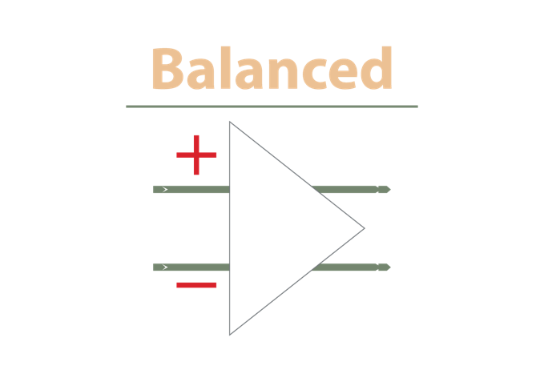

From PCM 768kHz to DSD 512 and full MQA decoding, it ensures that every nuance of your music is faithfully reproduced with remarkable clarity and detail. Furthermore, enhancements such as improved DC offset and USB-C input overvoltage protection guarantee peace of mind while enjoying your favorite tunes, ensuring reliable and safe operation.

Additional features such as XBass+ and PowerMatch analogue processing modes empowers you to customize your listening experience with precision and finesse.

Key features of the iFi ZEN DAC 3 include:
- Ultra-res audio: PCM 768kHz, DSD 512 and Full MQA Decoding
- Improved DC offset and USB-C input overvoltage protection
- USB-C input for plug-and-play connectivity
- 4.4mm balanced headphone and line outputs
- Fixed or variable output gain for optional preamp functionality
- XBass+ and PowerMatch analogue processing modes
Pricing & Availability
The iFi ZEN DAC 3 is available to purchase from ifi-audio.com and selected retailers for $229.

About iFi
iFi is the sister-brand of Abbingdon Music Research (AMR) and is headquartered in Southport, UK. The two brands respectively design and manufacture portable, desktop and lifestyle audio products and high-end hi-fi components. Combined in-house hardware and software development teams and a ‘music first’ approach enable iFi and AMR to create advanced audio products that deliver new levels of design, functionality and performance at their respective price points. Since iFi’s formation in 2012, its products have earned many awards around the world, helping it to become one of the fastest-growing brands in its field. For more information, please visit— https://ifi-audio.com/

Media Contacts
Shelby Coppola
Hummingbird Media
+1 (203) 598-8167
shelby@hummingbirdmedia.com

Jeff Touzeau
Hummingbird Media
+1 (914) 602-2913
jeff@hummingbirdmedia.com

