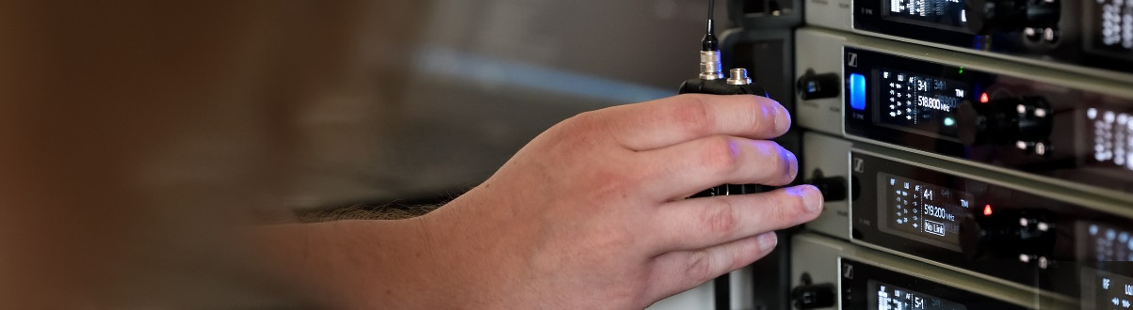#DontStopTheEducation

Crew Calls with Mahalia’s touring team and Harford Sound, RF wireless expertise, pro headphones and a look at 8D audio

Sydney/Wedemark, 24 June, 2020 – Sennheiser’s #DontStopTheEducation series continues with two Crew Call panel discussions: On 24 June, you can meet the live touring team of singer-songwriter Mahalia, and on June 30, the team from Harford Sound will discuss how their production company adapted to the Covid-19 situation. Also coming up in June is a new edition of the live RF Expert Round Table, as well as live webinars on pro headphones, multi-zone antenna systems and 8D audio. As always, all panellists and hosts in the live webinars are very much looking forward to answering your questions.

Live Round-Table Discussion
Tuesday, 24 June, 2020, at 1:00 a.m. AEST
Crew Call – Mahalia
Sennheiser hosts Andy Egerton and Tim Moore welcome members from the touring team of singer-songwriter Mahalia, Nominee for Best Female Solo Artist at the 2020 BRIT Awards. Guests include Mahalia’s musical director and touring bass player Charlie Fowler, tour manag-er Carl Lewis, front-of-house engineer Luigi Buccarello, monitor engineer Alice Asbury, guitar technician Jamie Hicks and merchandise manager and trainee backline technician Chris Bunt.

This webinar has something for everyone: If you are looking to get into the touring industry as a career, this webinar will highlight some key touring roles and requirements. If you’re already in the industry, this is a great way to gain insights into the life of another tour crew – and an opportunity to catch up with some of the tour banter you might be missing during lockdown! Just sign up at https://zoom.us/webinar/register/WN_b5k12pzvRt6976KZ-FRfRA, tune in and remember to ask questions via the live Q&A section.

The Crew Call panellists: Charlie Fowler, Carl Lewis, Jamie Hicks, Luigi Buccarello, Alice Asbury and Chris Bunt (from left to right)

For your social media channels
Join Sennheiser’s live round-table discussion with members of Mahalia’s touring team on 24 June at 1:00 a.m. AEST. #Don’tStopTheEducation

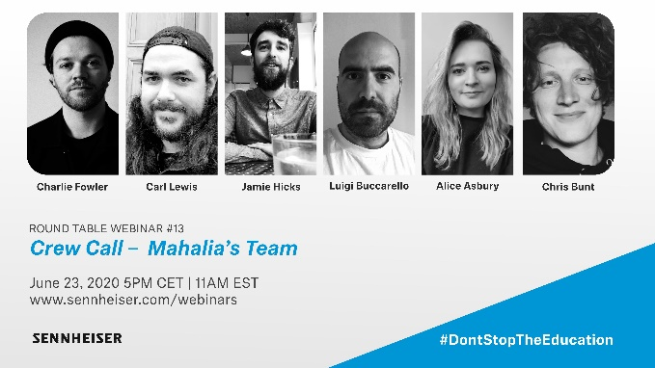 | Meet members of Mahalia’s touring team and gain insights on key roles and requirements in touring
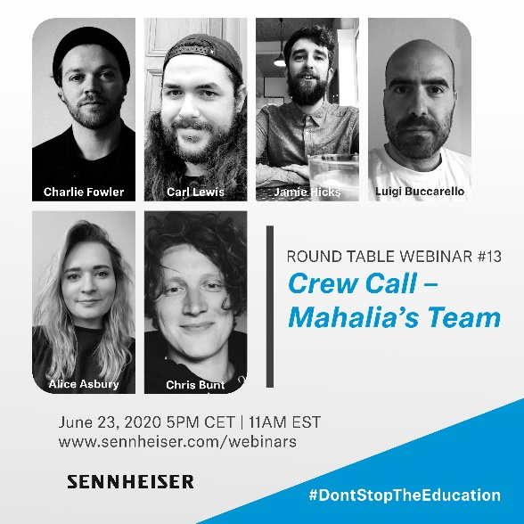 | 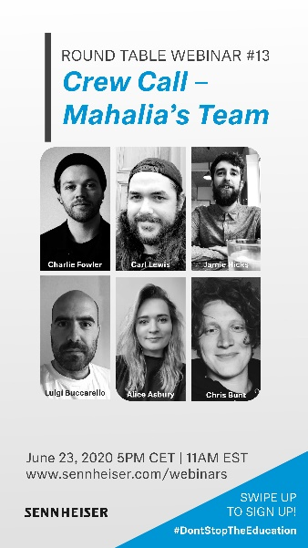

Live Round-Table Discussion
Tuesday, 1 July, 2020, at 1:00 a.m. AEST
Crew Call – Harford Sound
Sennheiser hosts Tim Moore and Andy Egerton welcome the team from Harford Sound, who discuss their approach as a production company and explain how they have adapted during the Covid-19 shutdown. Guests include Evan Kirkendall (CEO), Steve Wozniak (Director of Sales and Marketing), Kyle Ryman (Director of Operations) and Zack Slater (Warehouse Manager). Please visit https://www.sennheiser.com/webinars for the registration link.

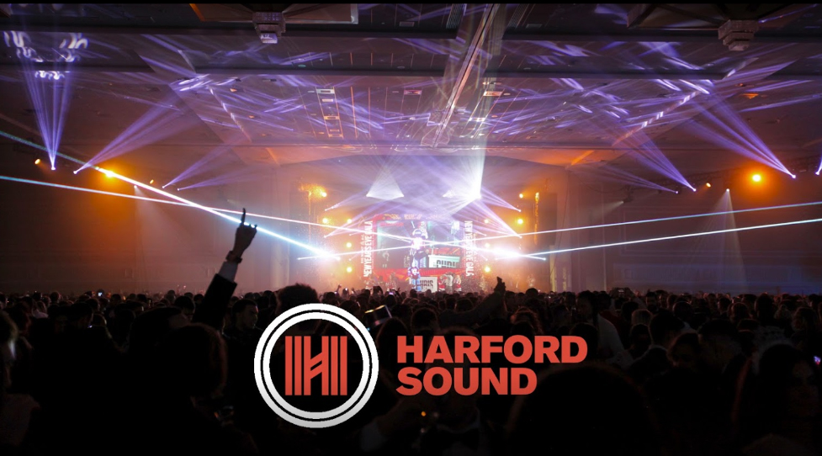

Live Round-Table Discussion
26 June, 2020, 12:00 a.m. to 1:30 a.m. AEST (and 2 July, 12:00 a.m. to 1:30 a.m. AEST)

Meet Your RF Expert
Due to the massive success of the first edition of this webinar, RF experts Volker Schmitt, Jonas Naesby and Vincent Tilgenkamp return to the round table – ready to answer your questions about challenges when working with RF wireless microphone and monitoring systems. The team has experience with the biggest international live events and will share their concepts and best practice with you. Please register at https://zoom.us/webinar/register/WN_VVqd6T-1R7yrdydeMX32yg

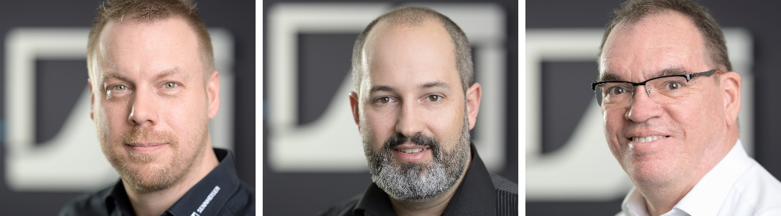
Sennheiser RF Wireless Experts Jonas Naesby, Vincent Tilgenkamp and Volker Schmitt (from left to right)

Live Webinar
Three time slots:
- 24 June, 4:30 p.m. to 5:30 p.m. AEST
- 24 June, 9:30 p.m. to 10:30 p.m. AEST
- 25 June, 2:00 a.m. to 3:00 a.m. AEST

Sennheiser Pro Headphones
Webinar presenter John McGregor invites you to take a closer look at the Sennheiser pro headphone series. He will take you through the development and history of the iconic HD 25 headphones and introduce you to some of the latest developments in pro headphone technology, including the new IE PRO in-ears.
Please register at
24 June, 4:30 to 5:30 – https://zoom.us/webinar/register/WN_HDCOB4IsTB-eaqPu1OiLAQ
24 June, 9:30 to 10:30 – https://zoom.us/webinar/register/WN_-WRhkiwER4OcdHDlXYyrLw
25 June, 2:00 to 3:00 – https://zoom.us/webinar/register/WN_M2xlpYzuTqm9_ETwztiqVA

John McGregor will take you through Sennheiser’s pro headphone portfolio

Live Webinar
Three time slots:
- 25 June, 12:00 a.m. to 1:30 a.m. AEST
- 25 June, 4:00 a.m. to 5:30 a.m. AEST
- 25 June, 9:30 a.m. to 11:00 a.m. AEST

Multi-Zone Antenna Systems
In situations where wide area wireless coverage is required, such as large venues or broadcast studios, an array of many antennas must be deployed to ensure proper reception. In this 90-minute webinar, Andrew Kornstein will explain the process of site surveys and planning, design, and implementation of multi-zone antenna systems.
Please register at:
24 June 16:00 to 17:30 – https://zoom.us/webinar/register/WN_Wei1jie_QtSDw7x81EpgAw
24 June, 20:00 to 21:30 – https://zoom.us/webinar/register/WN_DT8HqMu2RcyxSd1VxG7blw
25 June, 9:30 to 11:00 – https://zoom.us/webinar/register/WN_pXJYN5x1TuiqMcppPsGqLw

Andrew Kornstein will look at the design and implementation of multi-zone antenna systems | 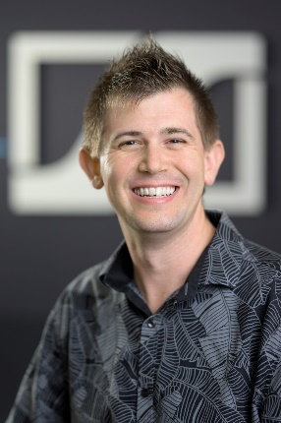

Live Webinar
30 June, 2020, 5:00 p.m. AEST

Immersive Music Mixing – First steps into 8D music and binaural audio productions
Christian Sander and Kai Detlefsen of Sennheiser partner Dear Reality and Johannes Kares from the Sennheiser AMBEO team will provide you with a solid technical background into the current and much hyped field of 8D music. Typical 8D productions are generated by binaurally rendering the stereo mixdown of a song – but there are certain limitations. The Sennheiser/Dear Reality team will show you how you can bring your 8D productions to a whole new level by positioning the instruments in the virtual space in your binaural mixes. Besides demoing binaural production workflows, they will also discuss the hype around 8D technologies and its impact on music production in general.
Please register at https://zoom.us/webinar/register/WN_joQMWHAtQfqNJZmv6Zf2Kg

The 8D Audio presenters: Kai Detlefsen, Johannes Kares and Christian Sander (from left to right)

Please visit https://www.sennheiser.com/webinars for a full, up-to-date list and to register free of charge for a SoundAcademy webinar of your choice. The free training sessions are often offered at several different times to allow as many people from around the globe to tune in as possible.

The high-resolution images accompanying this press release can be downloaded at https://sennheiser-brandzone.com/c/181/czs9rGiT.

About Sennheiser
Founded in 1945, Sennheiser is celebrating its 75th anniversary this year. Shaping the future of audio and creating unique sound experiences for customers – this aim unites Sennheiser employees and partners worldwide. The independent family company, which is managed in the third generation by Dr. Andreas Sennheiser and Daniel Sennheiser, is today one of the world’s leading manufacturers of headphones, loudspeakers, microphones and wireless transmission systems. In 2018, the Sennheiser Group generated turnover totalling €710.7 million. www.sennheiser.com

Global Press Contact

Stephanie Schmidt
Stephanie.schmidt@sennheiser.com
+49 (5130) 600 – 1275

Local Press Contact

Gabby Wallace
gabby.wallace@hausmann.com.au
0431 945 932

