A New Era In Monitoring For AES67-Based Environments:
Neumann Presents The KH 750 AES67 Subwoofer
Berlin, July 15, 2021 – German studio specialist Neumann.Berlin presents the KH 750 AES67 subwoofer, a product variant of the highly acclaimed KH 750 DSP for AES67-based environments. Thanks to its DSP power, the KH 750 AES67, too, is far more than “just” a subwoofer of technical perfection. It also provides access to Neumann's revolutionary Automatic Monitor Alignment MA 1, thus allowing for room adaptive correction of the entire monitoring system, including even the connected analog Neumann loudspeakers – in amplitude and phase!

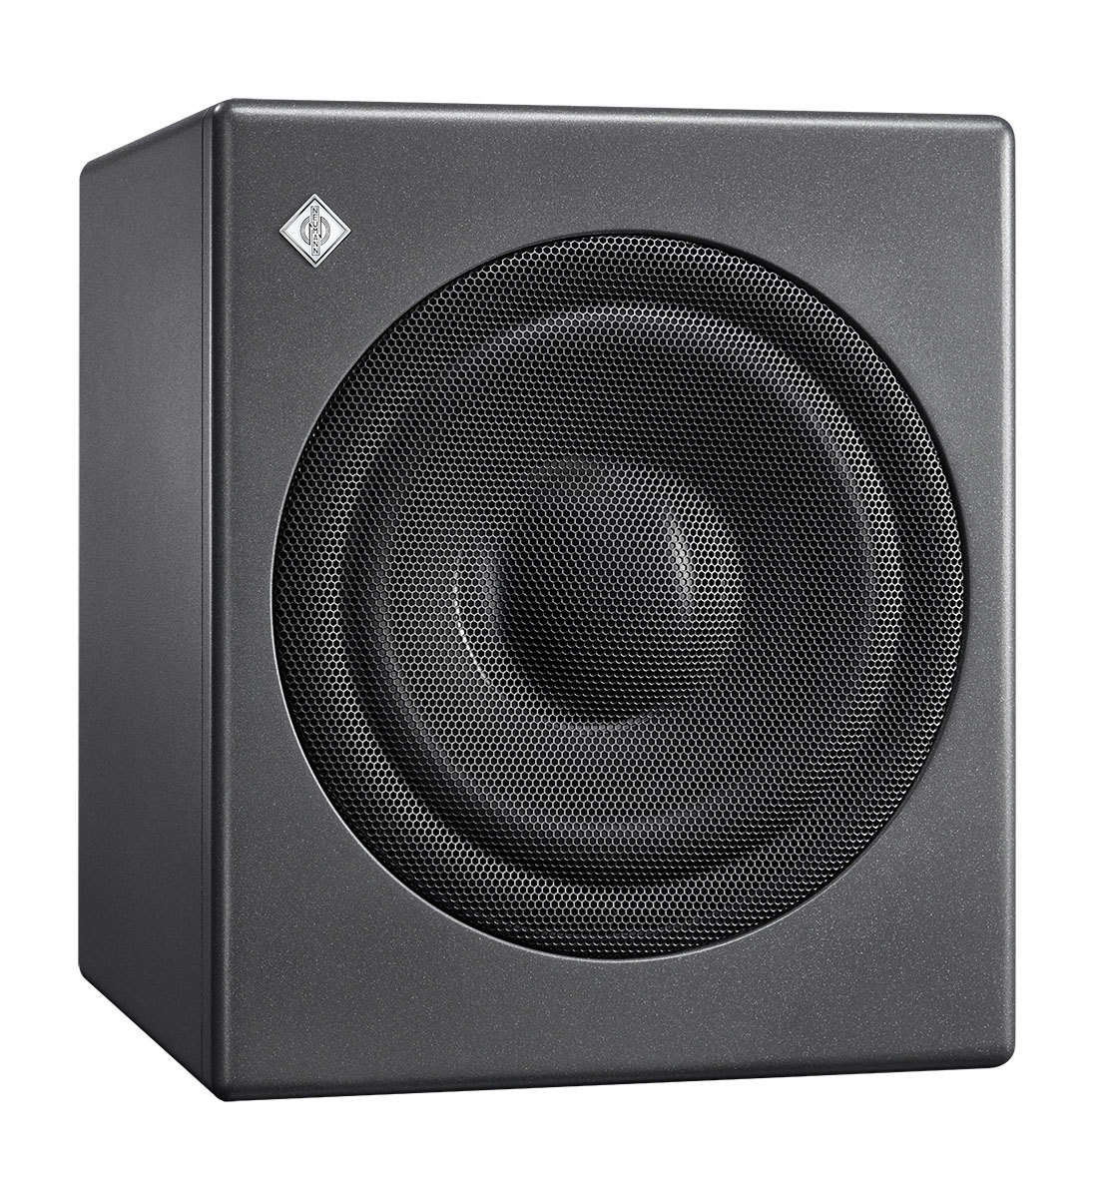
The interface between AES67 and all KH-Line Monitors
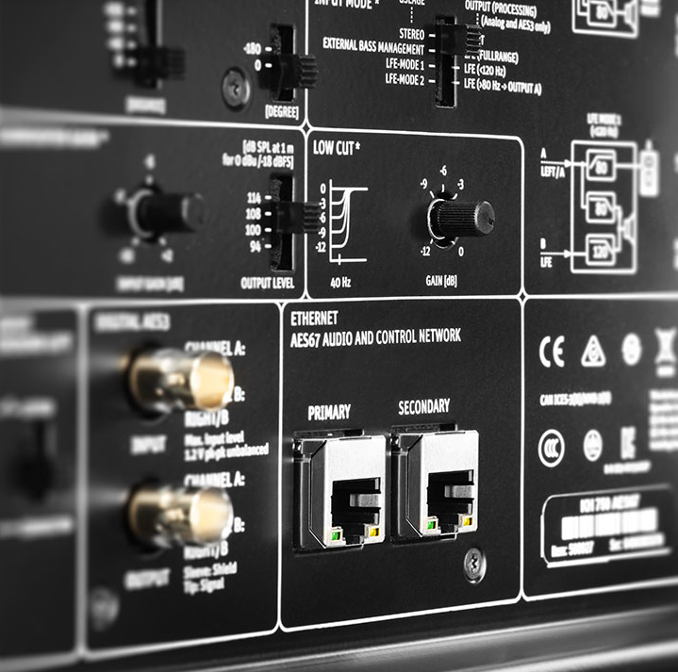
“The compact KH 750 AES67 is the ideal subwoofer for all areas in which audio over IP in existing AES67 infrastructure is to be routed all the way to the loudspeakers in a redundant and lossless manner. Its AES67 interface allows to address not only the subwoofer but the entire stereo system, including the speakers connected to the KH 750 AES67,” explains Portfolio Manager Markus Wolff. “Its dual AES67 audio network connections are fully compliant with broadcast standards such as ST 2110 and ST 2022-7 redundancy. At the same time, the KH 750 AES67 is also compatible with DANTE®-generated AES67 network streams.”
The outstanding acoustic properties of the successful KH 750 DSP have been retained, as well all other features, such as the unique Bass Manager with four routing modes, flexible acoustical controls for a wide range of configurations and setup conditions, as well as analog and digital inputs and outputs. Of course, the KH 750 AES67, too, features a powerful DSP engine.

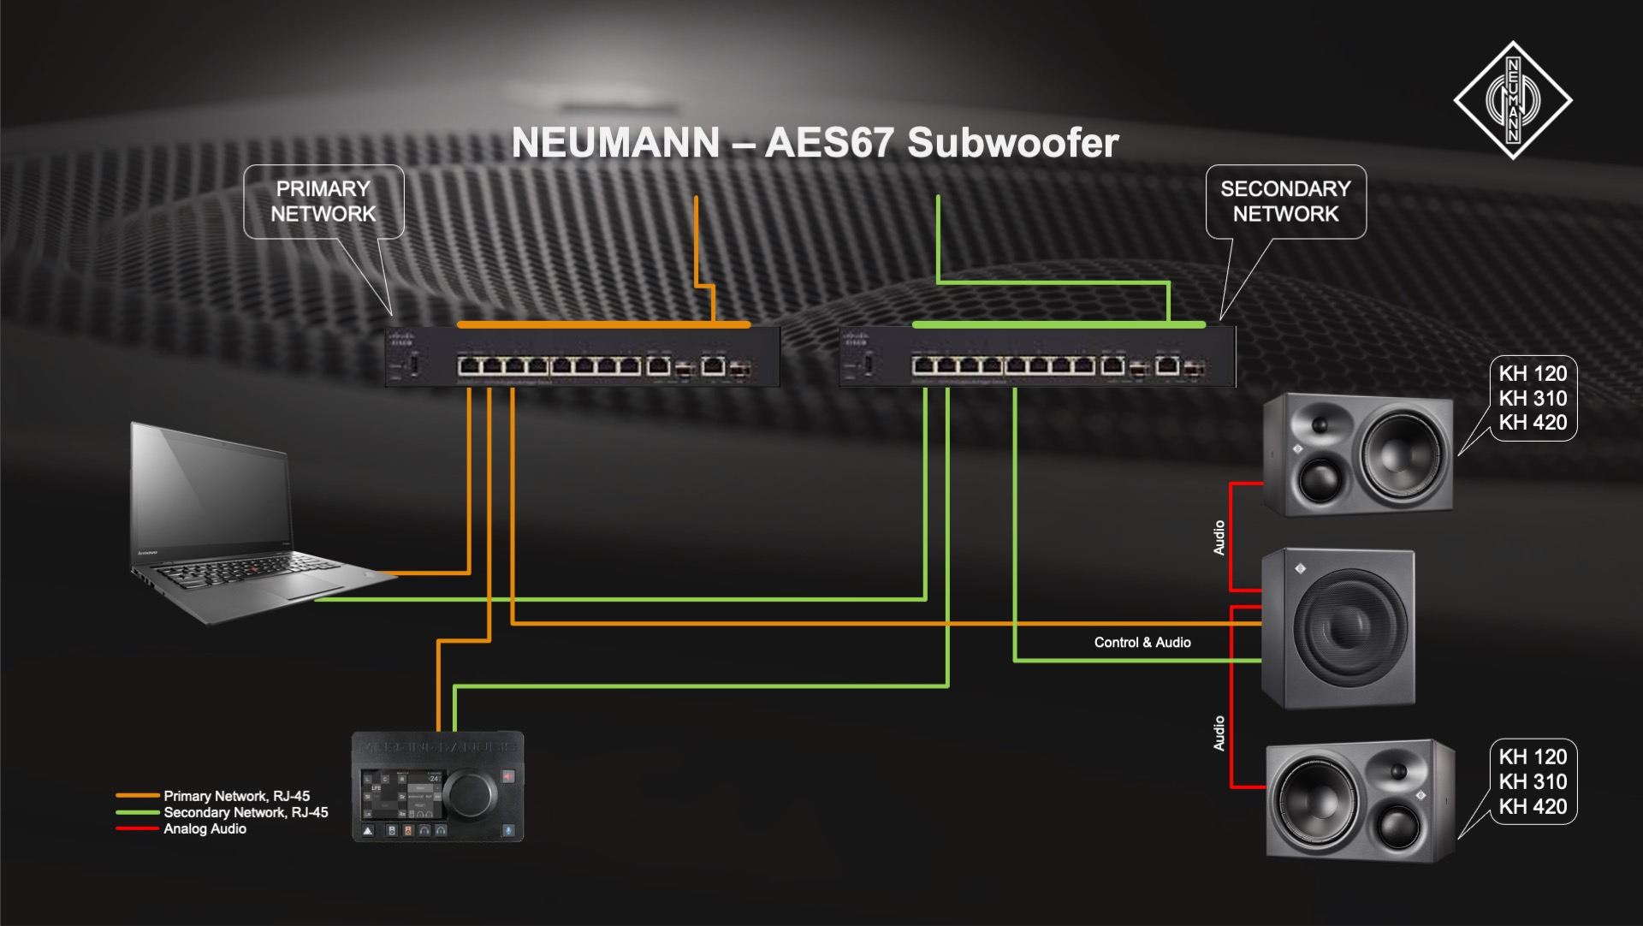
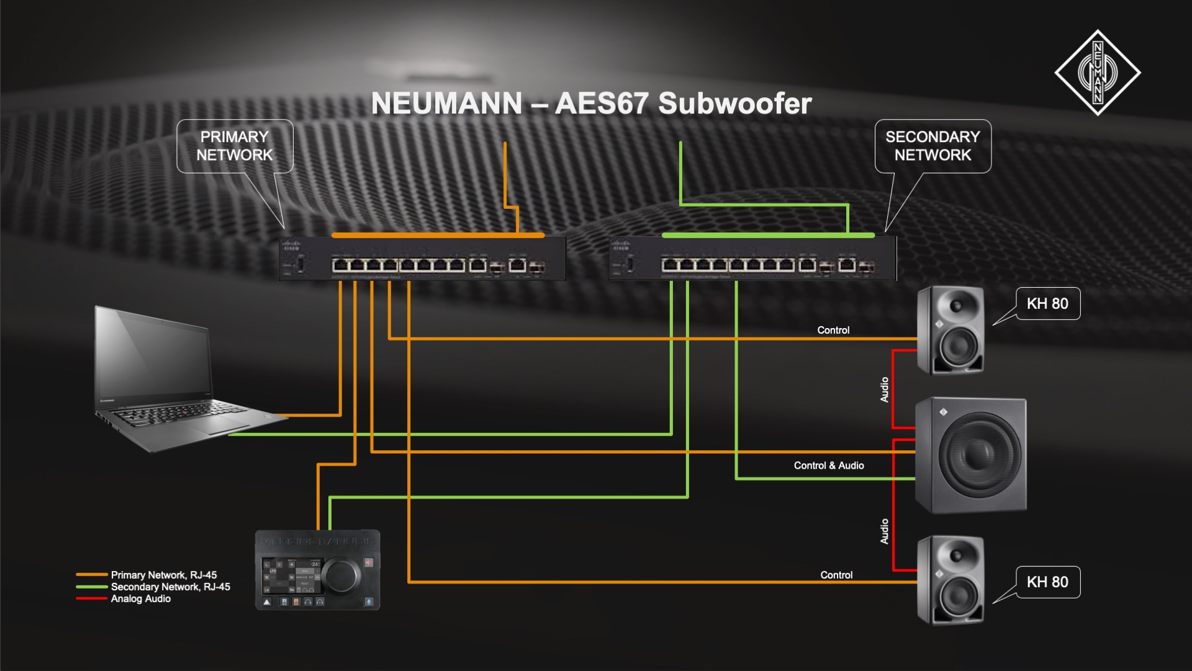
In combination with the Automatic Monitor Alignment - MA 1, which is available for Mac and PC, the entire monitoring system can be precisely calibrated to suit the specific room character. This also includes the monitors connected to it, whose amplitude and phase frequency responses are perfectly corrected and adapted to the monitoring environment. This makes the KH 750 AES67 the ideal complement to all KH-Line analog monitors such as the KH 120, KH 310, and KH 420, as well as to Neumann's DSP-based monitors such as the KH 80 DSP.

Deep Bass in a Small Space
Of course, the acoustic design, too, is of Neumann-typical perfection: The newly developed 10-inch ultra-long excursion woofer features a powerful, extremely linear magnet system with ELFF™ technology (Extremely Linear Force Factor™). Despite its compact dimensions, the KH 750 AES67 provides bass extension down to 18 Hz. Because the subwoofer relieves the connected monitors of much of the low frequency reproduction, intermodulation distortion is drastically reduced, and the maximum sound pressure level is increased. By adding another KH 750 AES67, even larger systems may be realized.

“The new KH 750 AES67 is Neumann's entry into the continuous support of AES67 networks. It raises the entire monitor system to a new level: deeper bass, higher SPL capability, and even greater sound transparency. In addition, the integrated DSP engine makes it possible to linearize and room-align amplitude and phase via the revolutionary MA 1 system for sound reproduction with unprecedented precision,” summarizes Neumann's CEO Ralf Oehl. “It is, without exaggeration, the beginning of a new era in Neumann monitoring – which is finally making its way into AES67-based environments such as broadcast studios. More products are to follow.”
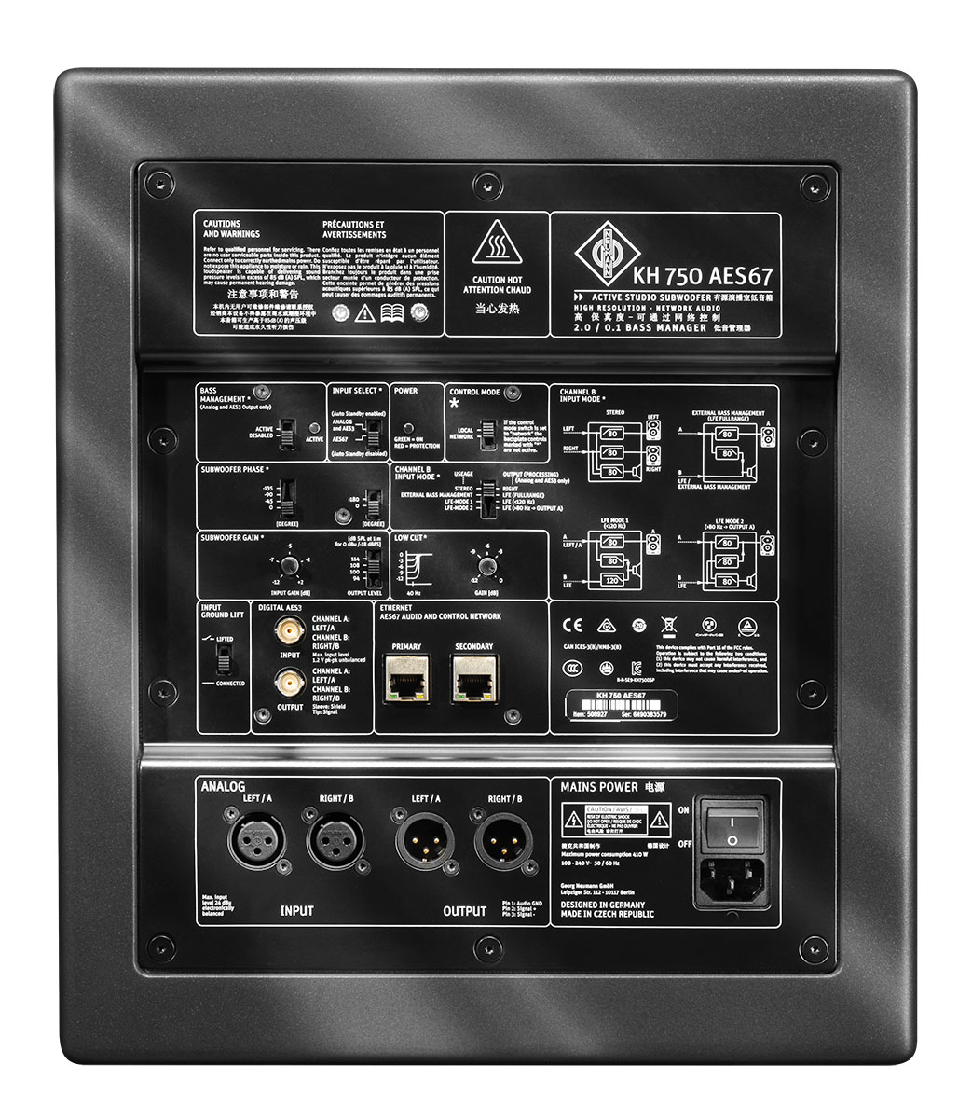

Features
- Bass extension of a stereo monitor system
- Increased maximum sound pressure level
- Reduced harmonic and intermodulation distortion
- Powerful DSP for room alignment of the entire system in amplitude and phase
- Fully redundant AES67 ST 2110 compliant audio network interface
- Physical redundant network for ST 2022-7 environments
- DANTE-compatible mode for receiving DANTE AES67 streams

Key Data
- Low frequency cutoff: 18 Hz
- Speaker configuration: 10-inch ultra-long excursion woofer with ELFF™ technology.
- Dimensions: 383 x 330 x 383 mm (15 1/8" x 13" x 15 1/8")
- Weight: 19.5 kg (43 lbs)
- MSRP: 1.695,-- EUR
Further product information at:
https://en-de.neumann.com/kh-750-aes67

About Neumann
Georg Neumann GmbH, known as “Neumann.Berlin”, is one of the world’s leading manufacturers of studio-grade audio equipment and the creator of recording microphone legends including the U 47, M 49, U 67 and U 87. Founded in 1928, the company has been recognized with numerous international awards for its technological innovations. Since 2010, Neumann.Berlin has expanded its expertise in electro-acoustic transducer design to also include the studio monitor market, mainly targeting TV and radio broadcasting, recording, and audio production. The first Neumann studio headphone was introduced at the beginning of 2019. Georg Neumann GmbH has been part of the Sennheiser Group since 1991, and is represented worldwide by the Sennheiser network of subsidiaries and long-standing trading partners. www.neumann.com

Press Contact Neumann:
Andreas Sablotny
andreas.sablotny@neumann.com
T +49 (030) 417724-19

LEWIS
Lynn Van de Velde
Tel : +32 473 38 37 85
lynn.vandevelde@teamlewis.com

