Wireless freedom for gamers
Sennheiser introduces the GSP 670

Sydney, June 12, 2019 – If you want to enjoy wireless technology while gaming an unnoticeable latency is key. Sennheiser introduces the GSP 670, Sennheiser's first wireless gaming headset. The GSP 670 gives gamers significantly more freedom of movement than wired models. The audio specialist has integrated a proprietary low-latency connection that guarantees a reliable and stable transmission with near-zero delay. In addition, the GSP 670 offers Sennheiser’s renowned wearing comfort and premium audio performance.

The wireless technology used by the GSP 670 is based on a low-latency connection developed by Sennheiser. Paired with the included GSA 70 compact USB dongle users will experience a transmission with near-zero delay. This proprietary connectivity is compatible with PC and Sony PlayStation® 4. The headset also features Bluetooth to simultaneously pair it to compatible devices, such as smartphones and tablets. Users can pick up calls at the touch of a button and seamlessly switch back to the low-latency connection of their game when they hang up.

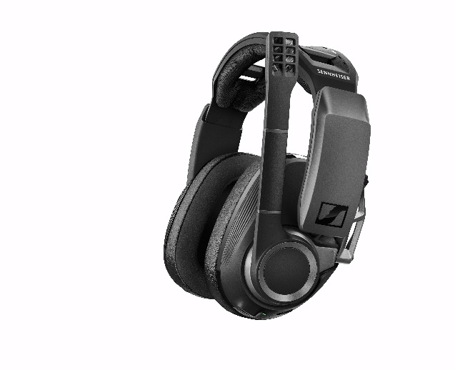 | The new Sennheiser GSP 670 uses a self-developed low-latency connection and features Sennheiser’s renowned wearing comfort and premium audio performance.

Sennheiser Gaming Suite enables personalized sound on PC
Users will enjoy Sennheiser’s renowned sound quality: the closed acoustic design provides a warm, deep bass without compromising the mid-range and high frequencies, so you can enjoy high-fidelity audio to the fullest. For an even more personal sound, Sennheiser offers its Gaming Suite for Windows®. This tool gives you access to various surround sound modes, an equalizer, microphone options, and ready-to-use presets for typical genres and occasions, allowing you to adjust the audio to your own preferences.

The GSP 670 microphone can be muted by simply  lifting the boom arm. | 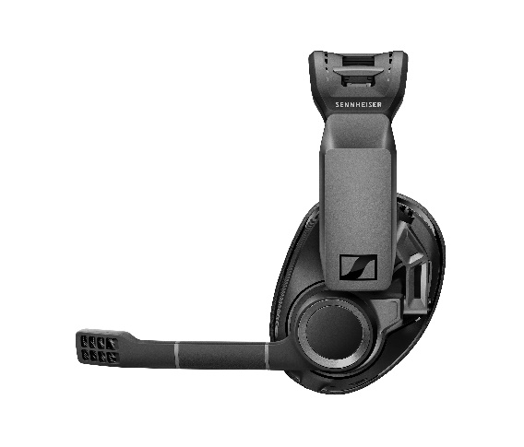

Independent control over game and chat audio
The GSP 670 features a broadcast-quality noise-cancelling microphone, which actively minimizes background noise and can be muted by simply lifting the boom arm. The gaming headset also provides the ability to independently control the chat audio and game audio to ensure the communication never goes down. Simply use the two integrated volume wheels to balance the levels between gameplay and voice communication.

Long battery life and quick charging via USB
The battery life of up to 20 hours via Bluetooth® and up to 16 hours over the low-latency connection allow for long gaming sessions. Intelligent battery management detects when the headset is used and automatically powers the headset on and off to maximize battery life. The GSP 670 supports quick charging over USB: after a 7-minute charge the headset can be used for 2 hours. The headset can also be used while charging. It even works solely via USB cable without the USB dongle connected to the system.

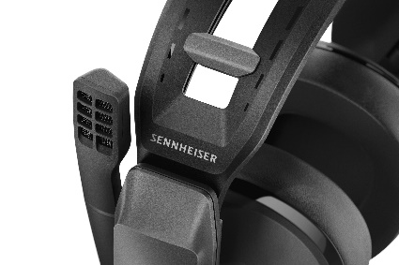 | The GSP 670 headband features adjustable contact pressure.

For total comfort during long gaming sessions, the ear pads feature a cooling suede-like material that prevents the ear pad from sticking to your skin, combined with leatherette around the edges to passively reduce ambient noise.The headband features adjustable contact pressure; in combination with a clever metal hinge system, the GSP 670 adapts perfectly to any head size and face shape.

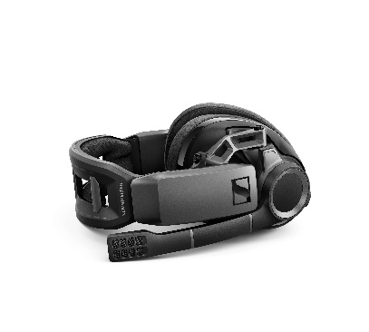 | The GSP 670 also comes with an advanced, solid metal hinge system, adapting the headset to any head shape and guaranteeing a perfect fit.

"The Sennheiser GSP 670 is the result of years of development and is not only our first wireless headset, but also the best wireless headset for gamers to date. It combines all the strengths for which Sennheiser is well-known all over the world: maximum wearing comfort, audio performance of the highest level, and clever features that you couldn't do without," says Andreas Jessen, Director of Product Management Gaming at Sennheiser Communications A/S.

This makes the GSP 670 the ideal solution for gamers who don't want to compromise, but still want to enjoy all the flexibility of wireless gaming headsets.

Price and availability
The Sennheiser GSP 670 has a recommended retail price of AUD$499.95 and NZD$549.95 and will be shipped from July 1st, 2019. In Australia if you purchase the gaming headset from the Sennheiser webshop, you will also receive the GSA 50 headset hanger (RRP: $54.95) free of charge.

about Sennheiser
Shaping the future of audio and creating unique sound experiences for customers – this aim unites Sennheiser employees and partners worldwide. Founded in 1945, Sennheiser is one of the world’s leading manufacturers of headphones, microphones and wireless transmission systems. With 21 sales subsidiaries and long-established trading partners, the company is active in more than 50 countries and operates its own production facilities in Germany, Ireland, Romania and the USA. Since 2013, Sennheiser has been managed by Daniel Sennheiser and Dr. Andreas Sennheiser, the third generation of the family to run the company. As part of the Sennheiser Group, Sennheiser Communications A/S is a joint venture specialized in wireless and wired headsets and speakerphones for contact centers, offices and Unified Communications environments as well as headsets for gaming and mobile devices. In 2017, the Sennheiser Group generated turnover totaling €667.7 million. www.sennheiser.com

Global Press Contact Local Press Contact
Anna Bornemann Heather Reid
Sennheiser Communication A/S Sennheiser Australia & New Zealand
Head of Marketing, Gaming Communications Manager
T: +45 5618 0323 T: +61 448 119 609
abor@senncom.com heather.reid@sennheiser.com

