For more information, please contact Marta de Paco
On +34 670 780 664 or email press@comunicahair.com

Important:
These images are only available for editorial content.
Credits must be included.
Notification of their publication is expected.

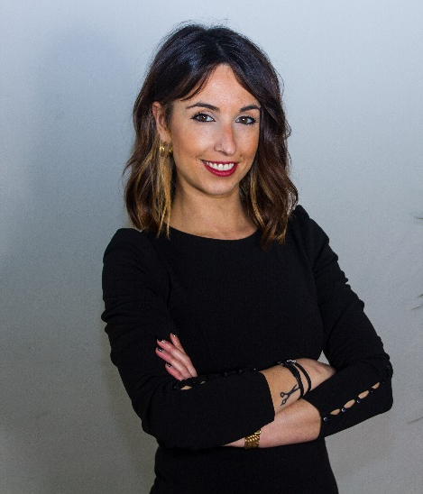
LIDIA RIAL
WOMEN’S FLAT Collection

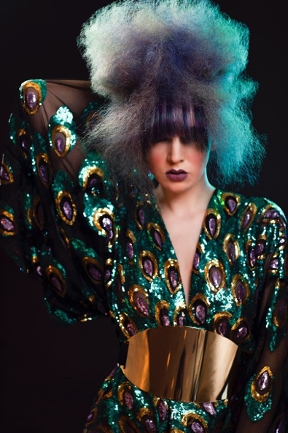
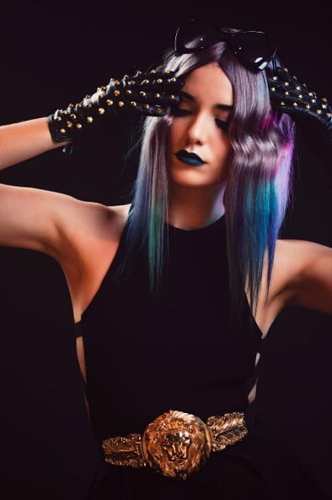

Hair: Lidia Rial @lyestilo
Photography: Irene Suárez @_irenesuarez_
Retouche: Irene Suárez @_irenesuarez_
MUA: Aduho Avilés @aduho_aviles
Styling: Lyestilo @lyestilo
Designers: Lyestilo @lyestilo
Shooting Life @shootinglife.es
Models: Andrea González @andreagonzalezfernandez
Anaïs Np @anaisnp
Sara Naveiro @saritanaveiro
Products: Redken @redken
Revlon Professional @revlonprofessional_es

LIDIA RIAL
WOMEN’S FLAT Collection

Hair: Lidia Rial @lyestilo
Hair Assistant: Yolanda Núñez @yoli.dani.7 and Lourdes López
Photography & Retouche: Sergio González
MUA: Lyestilo @lyestilo
Styling: Lyestilo @lyestilo
Designers: Lyestilo @lyestilo
Shooting Life @shootinglife.es
Models: Andrea González @andreagonzalezfernandez
Anaïs Np @anaisnp
Sara Naveiro @saritanaveiro
Products: Redken @redken
Revlon Professional @revlonprofessional_es

LIDIA RIAL
WOMEN’S FLAT Collection

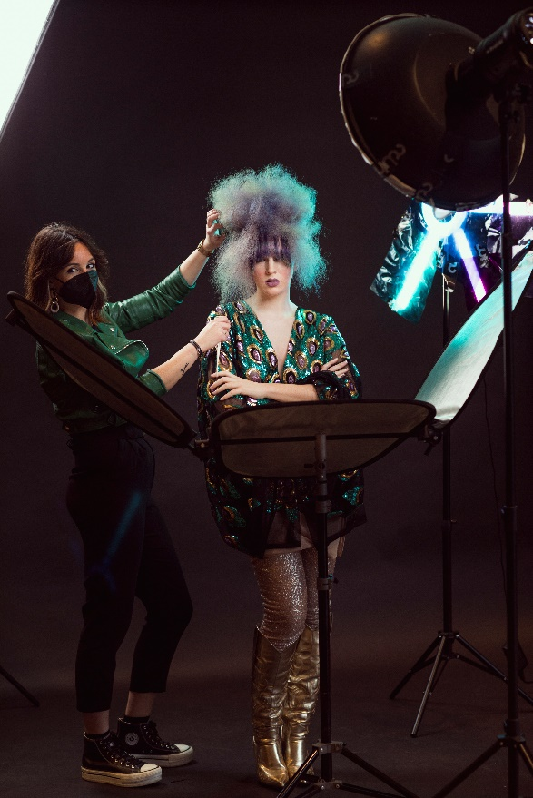

We receive very attractive stimuli from remote places and we use that exoticism for our image, mixing it with elements of our culture. In this collection, the oriental takes on a new body when it coexists with the disruptive aesthetics of the seventies, showing that the whole world is part of us. These are eclectic looks that present a new inspiring modernity and in continuous transformation.

A whole research process that started from a training, Shootinglive, and that culminated in the creation of this collection, which was completed in the salon and for which the same wig was reused. This work has been her first shooting, a creative starting point for other projects that are already in progress.

