Press Release

EVOC SPRING/SUMMER 2019
GROUNDBREAKING PROTECTION TECHNOLOGY MEETS HIGH-END BACKPACK: THE NEO 16l WITH REVOLUTIONARY AIRSHIELD SYSTEM

FOR ITS 10-YEAR ANNIVERSARY, THE LEADING GLOBAL MANUFACTURER OF PROTECTOR BACKPACKS CONTINUES TO DEMONSTRATE ITS KNOW-HOW WHEN IT COMES TO TECHNOLOGY AND DESIGN. PERFECTLY TIMED FOR THE 2019 BIKE SEASON, EVOC IS LAUNCHING ITS NEW NEO 16l PROTECTOR BACKPACK WITH THE SPECIALLY DEVELOPED AIRSHIELD SYSTEM, THEREBY REVOLUTIONISING THE DEFINITION OF BACK PROTECTOR TECHNOLOGY IN THE BIKE INDUSTRY. THE NEO 16l’S EXCLUSIVE AIRSHIELD BACK PROTECTOR COMBINES MAXIMUM IMPACT PROTECTION, ERGO-DYNAMIC FLEXIBILITY AND INNOVATIVE 360° VENTILATION. THE NEO 16l WILL BE AVAILABLE IN SPRING 2019, AND COMES IN GOLD AND IN CARBON GREY.

PROTECTION 2.0 – THE NEW AIRSHIELD SYSTEM
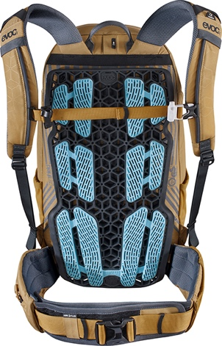
For the 2019 bike season, experience the benefits of exceptional SOFT PROTECTION with the new NEO 16l. EVOC’s integrated AIRSHIELD SYSTEM with its characteristic lattice structure is positioned between the pack and the rider and visible on the exterior of the backpack. This combined unit makes sure the protector is as close as possible to the entire thoracic and lumbar spine.
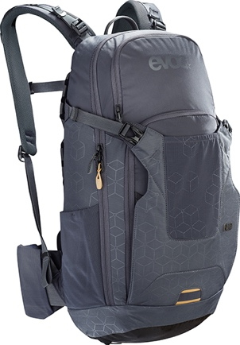
Made of a highly resilient nanotech elastomer, the back protector can deform if exposed to tension or pressure, but then returns to its original form. This material also guarantees ergo-dynamic flexibility and optimum adaptation to the shape of the spine. In addition, hexagonal elements ensure optimum distribution of the impact force and 95% shock absorption. Plus, the elastomer maintains its qualities in temperatures from -20 to + 40 degrees Celsius.
Twelve elastomer pads with mesh structure form part of the lattice layer. Strategic positioning of the pads provides for maximum carrying comfort, minimal contact points on the back and yet a snug fit is a result of the strong grip. This makes slipping of the backpack in case of a fall even more unlikely.
Thanks to the unique construction of the AIRSHIELD SYSTEM, the NEO 16l allows 360° ventilation and effective moisture wicking from the back – even on really strenuous bike rides.
The AIRSHIELD BACK PROTECTOR is made in Europe, is certified according to TÜV test standard PSA 1621-2, and can be replaced at no charge as part of EVOC’s FREE CRASH REPLACEMENT after a fall that caused damage to the protector.

THE NEO 16l SHOWS TRUE GREATNESS – FOR MORE CARRYING COMFORT
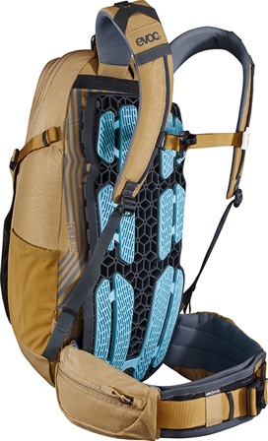
The NEO 16l is available in two sizes: S/M for a recommended body height of 155 to 180 cm and a torso length of 41 to 48 cm, and L/XL for a height of 180 to 200 cm and a torso length of 48 to 53 cm. Together with the height-adjustable hip belt (which allows for adjustment of up to five centimetres), the backpack can be perfectly adapted to riders’ body measurements – for both optimised back protection and ideal weight distribution to the hips.
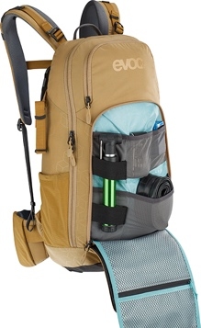
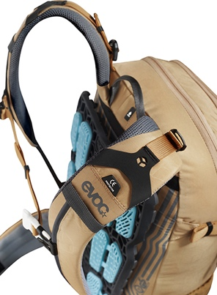
Extra-wide, well-padded hip wings make for a firm yet comfortable fit. With an integrated zip pocket and a flexible, quick-access mesh pocket, the hip-wings also offer additional storage space that is easy to reach even while riding. The highly elastic AIROFLEX material on the wide hip belt allows for freedom of movement and maximum breathability. Inward-facing seams together with soft airmesh fabric minimise potential pressure or rubbing. The material used for the hip wings and shoulder straps has been treated with antibacterial POLYGIENE®, preventing unpleasant odours.
The main compartment of this EVOC pack provides space for a rider’s equipment as well as a 3-litre hydration bladder. A fleece-lined goggle pocket, a quick-access external tool compartment, two side pockets made from elastic mesh and the integrated helmet holder make the NEO 16l the number one partner for demanding freeriders. The premium backpack also features a magnetic clip for keeping the hydration hose in position and a built-in rain cover with reflective print for additional visibility and safety.

NEW MATERIAL, NEW COLOURS – THE NEO LOOK
For the NEO 16l, EVOC is for the first time making use of exceptionally water-repellent and durable taslan nylon. This high-quality, tear-resistant fabric boasts an extremely smooth surface, which enhances the visibility of the partially reflective 3D-embossed NEO pattern – tone in tone, either in classy GOLD or in clean CARBON GREY.

The NEO 16l is completely TÜV-certified and will be available onwards from spring 2019.

SPECIFICATIONS

NEO 16l
Volume: 16 l
Dimensions: 27 x 52 x 11 cm*
Weight: 1580 g*
Colours: Gold, Carbon Grey
Price: 250.00 € / 300.00 USD / 385.00 CAD /

* In size S/M

#evocsports #coloursoftravelling

Media Contact: Dani Odesser | press@evocsports.com | +49 (0)170 3131812

