Please note that this information is embargoed until 7 April 2021, 9:00 CET

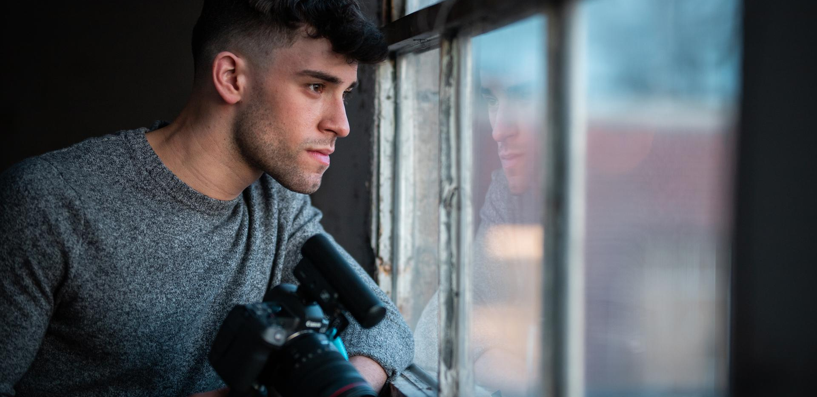

Create powerful content
Sennheiser re-invents the MKE 400 – a compact shotgun mic that delivers the professional features you demand from a camera microphone

Wedemark, 7 April 2021 – For vloggers, videographers and mobile journalists, storytelling is equal parts art and craft. Perhaps more than anything else, it is sound that makes a story come to life. Whether interviews, commentary or ambience, sound is the key to captivating and drawing in an audience. To provide creators with a tool to explore their sonic horizons, Sennheiser has launched the new MKE 400 – a highly directional compact shotgun microphone that brings compelling audio to DSLR/Ms and mobile devices alike.

“Much has been said about the importance of good audio for video,” says Kai Lange, Senior Product Manager at Sennheiser. “Now, the new MKE 400 lets users experience how vastly it improves in-camera audio, lifting storytelling to the next level and wowing audiences. We’re replacing the well-known and much loved MKE 400 with this new model, and even die-hard fans will agree that the latest version surpasses the original in many ways. The new MKE 400 now also features a headphone monitoring output with volume control, has a rugged internal shock-mount, clever internal windscreen and automatic on/off function, plus it comes with ample accessories included.”

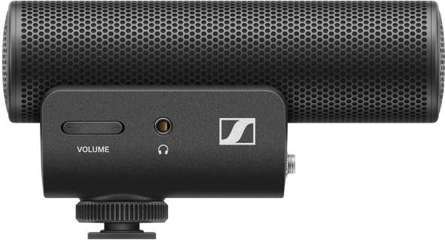 | Your audio upgrade: the MKE 400 compact shotgun microphone enhances in-camera audio for vloggers, videographers and mobile journalists

Everything you need to capture compelling audio
- A highly directional microphone to focus on your subject and eliminate background noise
The MKE 400 achieves its directionality with an acoustic interference tube, providing a super-cardioid polar pattern that ensures pick-up from the direction in which the camera is facing while cancelling out distracting noise from the sides. The result: dialogue recordings with presence and clarity that will help bring your content to life.

- Protection from wind and handling noise
The MKE 400’s shock-mounted capsule minimizes handling noise, while the cleverly designed microphone housing doubles as a standard windscreen. For outdoor use, a furry windshield is included: Simply place it over the integrated windscreen for maximum wind protection while recording. The microphone’s low-cut filter also does its part in removing problematic low frequencies like the hum from air-conditioning systems or the rumble from wind.

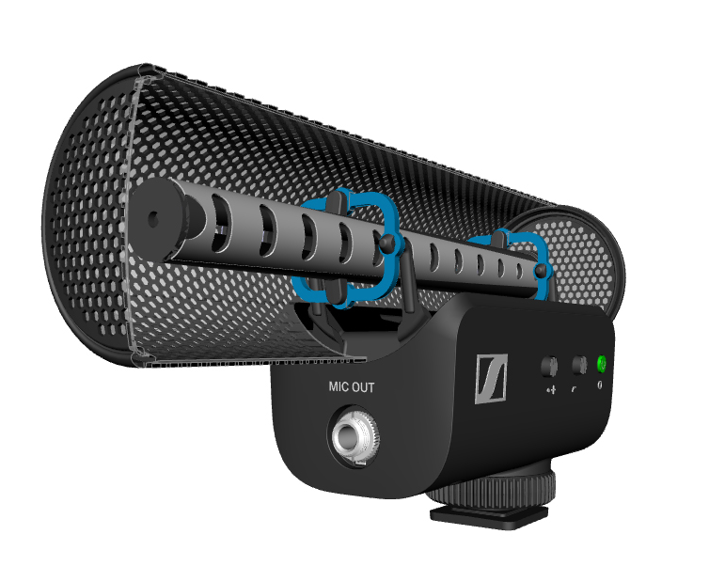 | A look inside the MKE 400 reveals the acoustic interference tube, which is shock-mounted (blue elements) to prevent handling noise from transferring to the capsule. The mic housing doubles as a standard windscreen, saving space and hassle.

- Flexible adaptation to any sound source
In your creation process, you will come across loud and confident speakers – but you will also want to catch those softer voices. The 3-step sensitivity switch adjusts the audio level to the mic input of the camera, helping you to address all the differences in dynamics that you encounter on a shoot.

- Full control over the sound
One of the most important things when recording audio is to check levels and monitor your sound. Therefore, the MKE 400 is not only fitted with a low-cut filter and three-step sensitivity switch to fine-tune your sound but also with a headphone monitoring output and integrated 8-step digital volume control, as not every camera has its own audio output. You can plug any headphone with a 3.5 mm (1/8”) jack directly into the MKE 400 and conveniently check levels and audio performance while rolling.

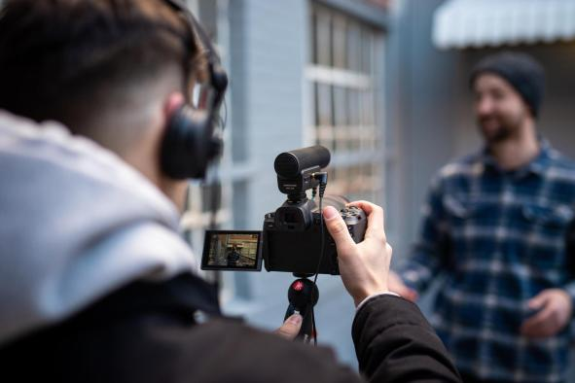 | Full control: conveniently check levels and audio performance via the MKE 400’s built-in headphone monitoring output with volume control

- Versatility
Your video recording is most likely not confined to one device, and your microphone doesn’t have to be either. The MKE 400 includes 3.5 mm TRS and TRRS locking cables to be used with DSLR/M cameras or mobile devices, ensuring that switching from one device to another is accomplished with ease. The mic’s cold-shoe mount with ¼-20 thread allows for universal mounting atop of cameras, gimbals or even at the end of a boom pole.

Accessories included with the MKE 400

- The luxury of a small package
A wise saying is that the best mic is the one you actually have at hand. The MKE 400 helps you stay ready by being so compact and lightweight that you can take it anywhere. The microphone housing doubles as a standard windscreen, and the shock-mount is inside it – this not only leaves valuable space in the camera bag but also on the camera itself, providing room for other accessories. Speaking of accessories – the MKE 400’s cables are coiled and locking so they stay out of your way and stay securely connected while shooting.

- Generous operating time
It takes just two AAA batteries to power the microphone for up to 100 hours of continuous audio capture. A low battery indicator will reliably warn you three hours before the batteries run flat – more than enough time to finish the shot you’re working on.

- Manual or automatic power on/off
When connected to DSLR/M cameras, the MKE 400 automatically powers on/off with the camera. So your mic is ready the instant your camera is, and helps you save energy when you’re not rolling. Power detection also works with many smartphone models: if you remove the MKE 400, it will automatically turn off. A manual power button is provided too, featuring an off-delay to avoid any accidental operation.

The MKE 400 Mobile Kit in action | 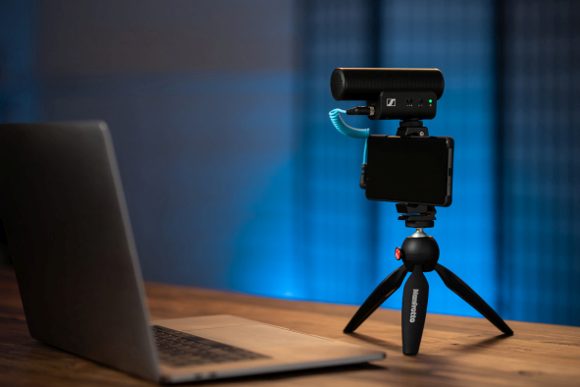

The Mobile Kit – an ideal option to get started on great sound
The MKE 400 is also available as “MKE 400 Mobile Kit” which additionally includes a Sennheiser Smartphone Clamp and Manfrotto PIXI Mini Tripod in a convenient package for your camera bag or mobile set-up.

Contents of the MKE 400 Mobile Kit | 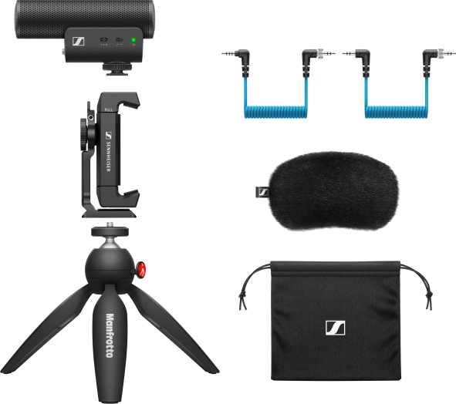

Kai Lange adds: “As a creator, you need tools that can keep up with your pace and empower you to design engaging content for your audience. The MKE 400 is the solution you’ve been looking for: a camera microphone from the brand that audio professionals trust.”

The MKE 400 retails at EUR 199 (MSRP), GBP 179 (MSRP), USD 199.95 (MAP).
The MKE 400 Mobile Kit is available at EUR 229 (MSRP), GBP 199 (MSRP), USD 229.95 (MAP).

For your social media channels:
Sennheiser launches the new MKE 400 on-camera mic – a compact shotgun with plenty of features for demanding content creators.

For the techies among you
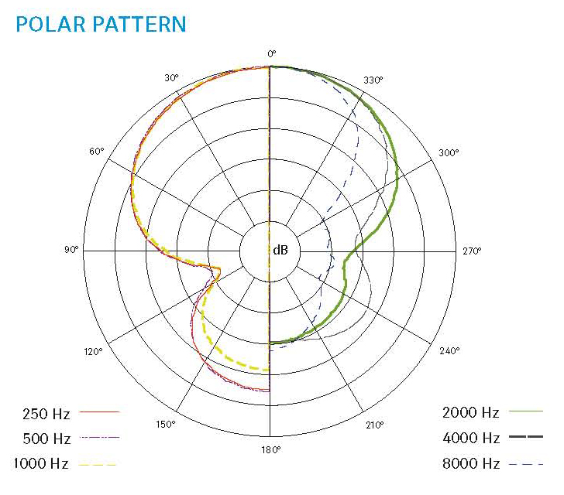  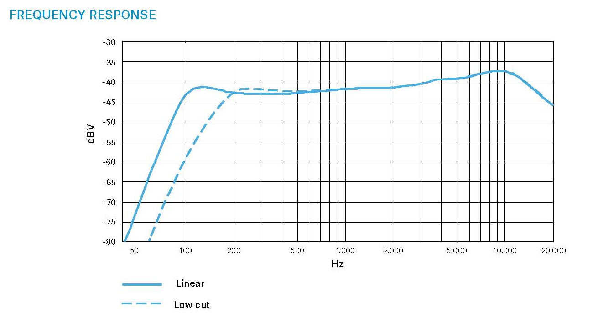 | 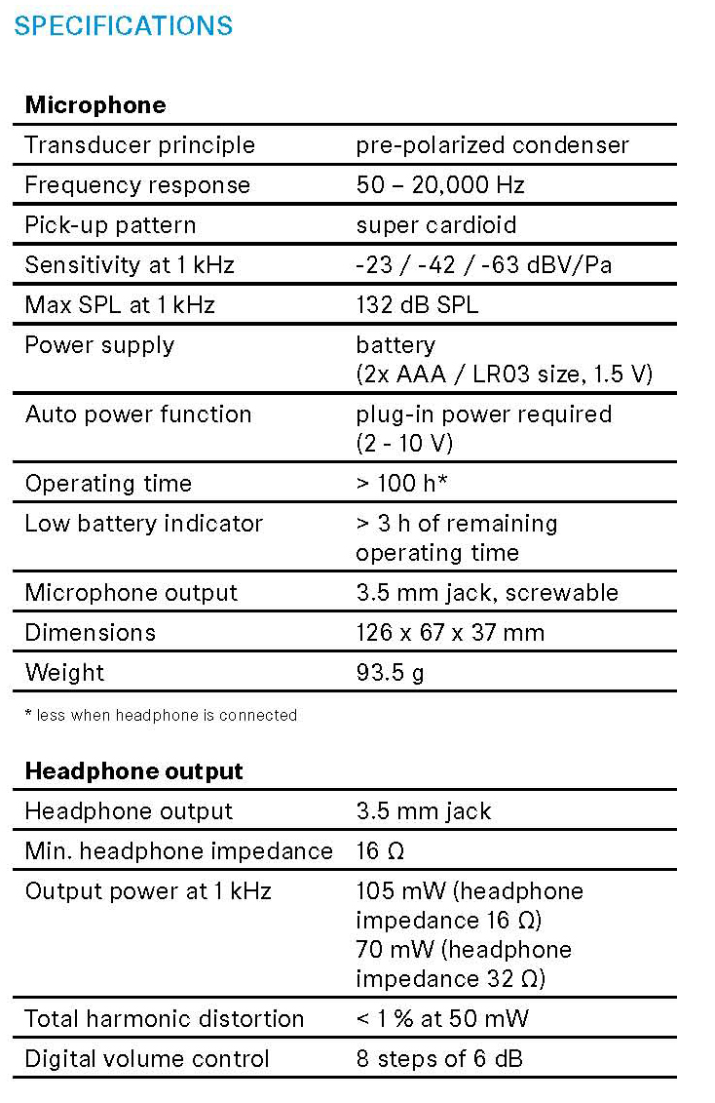

Useful links
Videos:
Watch Dave Carls of Exmag creating music from sounds – all recorded with the MKE 400
Watch an introduction to the features of the new MKE 400

Pictures:
Download high-resolution product photos
Download high-resolution application photos

About Sennheiser
Shaping the future of audio and creating unique sound experiences for customers – this aim unites Sennheiser employees and partners worldwide. Founded in 1945, Sennheiser is one of the world’s leading manufacturers of headphones, loudspeakers, microphones and wireless transmission systems. Since 2013, Sennheiser has been managed by Daniel Sennheiser and Dr. Andreas Sennheiser, the third generation of the family to run the company. In 2019, the Sennheiser Group generated turnover totaling €756.7 million. www.sennheiser.com

Global Press Contact

Stephanie Schmidt
Stephanie.schmidt@sennheiser.com
+49 (5130) 600 – 1275

