For more information, please contact Marta de Paco
On +34 670 780 664 or email press@comunicahair.com

Important:
These images are only available for editorial content.
Credits must be included.
Notification of their publication is expected.

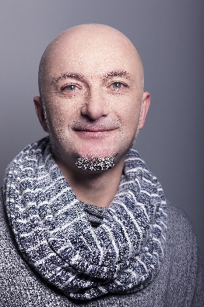
ROBERTO DALLO
BACK TO THE PRESENT Collection

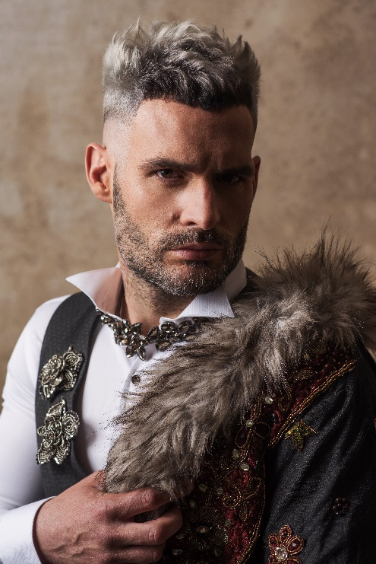
Hair: Roberto Dallo Lafuente @ Roberto Peluqueros
Instagram: @robertopeluqueros
Hair Assistant: Eva Fernandes and María Carmona
Instagram: @sanchezmariacarmencarmona and @eva_fernandes_fon
Photography: Estudio Kentaro | Instagram: @estudio_kentaro_lifestyle
Retouche: Estudio Kentaro | Instagram: @estudio_kentaro_lifestyle
Makeup: Eva Fernandes | Instagram: @eva_fernandes_fon
Styling: Francisco Javier Moral | Instagram: @fco_javier_moral
Designer: Roberto Dallo Lafuente | Instagram: @robertopeluqueros
Products: Revlon y American Crew | Instagram: @revlonprofessional_es and @americancrew_spain
Video: Estudio Kentaro | Instagram: @estudio_kentaro_lifestyle
Models: Iñigo Asiain Devora, David Iriarte, Adur Lafuente Jerico, Roberto Teiga Ruedas, Imanol Aranguren Iracheta. Instagram: @mr.pupilas, @davidiriarte7, @apdurio, @rober010, @imanolarangureniracheta2

ROBERTO DALLO
BACK TO THE PRESENT Collection
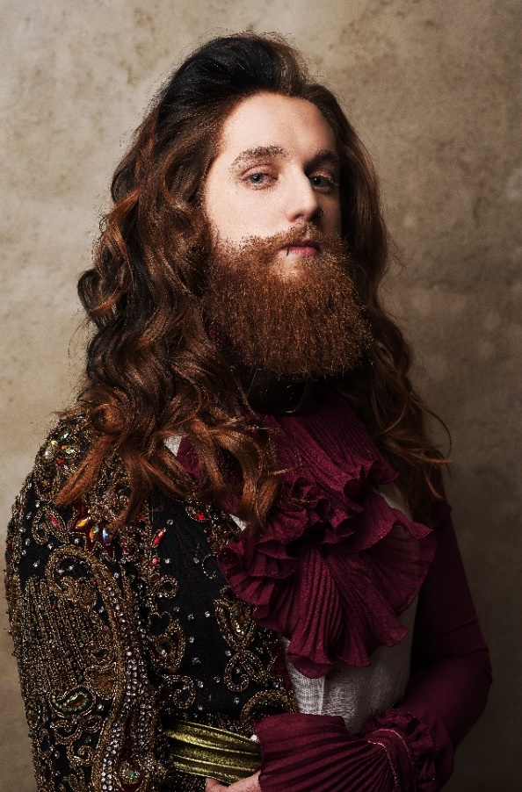

Future is based on our past and our essence, what we are, is dressed up with all these details. But what are we? We are the present, with a mixture of longings with which we look at the future and all the experience that the lived identity offers us.
Back to the present is inspired by the Baroque, the climax of our culture and our way of being, but it does not recreate it, but brings new nuances of colour and haircut to it, it updates it, because we will no longer be what we were nor will we be what we are. We are only certainty, present.

Back to the present
Past and present, futures with a taste of eternity, records that are timeless and almost intact, that ‘’re-generate’’ history and endow it with a new, renewed and different character. The word remember comes from Latin "recordari" formed by the prefix "re" which means "again" and "cordis", "heart". Remembering, therefore, means much more than having something or someone present in memory, it means "getting back to the heart" with all that that implies. Beating with a past but current awareness, weakening the distance imposed by time to lead to a contemporary aesthetic with a unique flavour that only experience can provide.

We are only a certainty, present, an essence that transforms.

